UNITED STATES
SECURITIES AND EXCHANGE COMMISSION
Washington, D.C. 20549
FORM 8-K
CURRENT REPORT
PURSUANT TO SECTION 13 OR 15(d) OF THE SECURITIES EXCHANGE ACT OF 1934
Date of report (Date of earliest event reported):
August 13, 2026
CALIBERCOS INC.
(Exact Name of Registrant as Specified in Its Charter)
Delaware
(State or Other Jurisdiction of Incorporation)
001-41703 |  |  |  |  |  | 47-2426901
(Commission File Number) |  |  |  |  |  | (IRS Employer Identification No.)
8901 E. Mountain View Rd. Ste. 150, Scottsdale, AZ |  |  |  |  |  | 85258
(Address of Principal Executive Offices) |  |  |  |  |  | (Zip Code)
(480) 295-7600
(Registrant’s Telephone Number, Including Area Code)
N/A
(Former Name or Former Address, if Changed Since Last Report)
Check the appropriate box below if the Form 8-K filing is intended to simultaneously satisfy the filing obligation of the registrant under any of the following provisions (see General Instruction A.2. below):
o |  |  | Written communications pursuant to Rule 425 under the Securities Act (17 CFR 230.425)
o |  |  | Soliciting material pursuant to Rule 14a-12 under the Exchange Act (17 CFR 240.14a-12)
o |  |  | Pre-commencement communications pursuant to Rule 14d-2(b) under the Exchange Act (17 CFR 240.14d-2(b))
o |  |  | Pre-commencement communications pursuant to Rule 13e-4(c) under the Exchange Act (17 CFR 240.13e-4(c))
Securities registered pursuant to Section 12(b) of the Act:
Title of each class |  |  | Trading Symbols |  |  | Name of each exchange on which registered
Class A Common Stock, par value $0.001 |  |  | CWD |  |  | The Nasdaq Stock Market LLC
Indicate by check mark whether the registrant is an emerging growth company as defined in Rule 405 of the Securities Act of 1933 (17 CFR §230.405) or Rule 12b-2 of the Securities Exchange Act of 1934 (17 CFR §240.12b-2).
Emerging growth company x
If an emerging growth company, indicate by check mark if the registrant has elected not to use the extended transition period for complying with any new or revised financial accounting standards provided pursuant to Section 13(a) of the Exchange Act. o

Item 2.02. Results of Operations and Financial Condition.
On August 13, 2026, CaliberCos Inc. (the “Company”) issued a press release and earnings supplemental reporting second quarter financial results. The Company also released supplemental financial results for its asset management “Platform” business. A copy of the press release, earnings supplemental, and Platform supplemental financial results are attached hereto as Exhibit 99.1, Exhibit 99.2, and Exhibit 99.3 and the information therein is incorporated herein by reference.

The information contained in this Item 2.02 and in the accompanying Exhibit 99.1, Exhibit 99.2, Exhibit 99.3 shall not be deemed filed for purposes of Section 18 of the Securities Exchange Act of 1934, as amended (the “Exchange Act”), or incorporated by reference in any filing under the Exchange Act or the Securities Act of 1933, as amended (the “Securities Act”), except as shall be expressly set forth by specific reference in such filing.

Item 7.01. Regulation FD Disclosure.

The information under Item 2.02, above, is incorporated herein by reference.
The information reported under Items 2.02 and 7.01 in this Current Report on Form 8-K, including Exhibit 99.1 and Exhibit 99.2 attached hereto, shall not be deemed filed for purposes of Section 18 of the Exchange Act or otherwise subject to the liabilities of that section, nor shall it be deemed incorporated by reference in any filing under the Securities Act or the Exchange Act, regardless of any general incorporation language in such filing.

Item 9.01. Financial Statements and Exhibits.
(d)Exhibits
Exhibit  No. |  |  |  |  |  | Exhibit
99.1 |  |  |  |  |  | Press release dated August 13, 2026 relating to second quarter financial results and related matters
99.2 |  |  |  |  |  | Earnings supplemental related to the second quarter financial results and related matters
99.3 |  |  |  |  |  | Platform supplemental financial results with second quarter financial results
104 |  |  |  |  |  | Cover Page Interactive Data File (embedded within the Inline XBRL document)

SIGNATURES
Pursuant to the requirements of the Securities Exchange Act of 1934, the registrant has duly caused this report to be signed on its behalf by the undersigned hereunto duly authorized.
 |  |  | CaliberCos Inc.
August 13, 2026
 |  |  | By: |  |  | /s/ John C. Loeffler, II
 |  |  | Name: |  |  | John C. Loeffler, II
 |  |  | Title: |  |  | Chairman and Chief Executive Officer

Exhibit 99.1


Caliber Reports Second Quarter 2026 Financial Results

2026 Full-Year Guidance Reaffirmed; Completion of First Tokenization of Asset

SCOTTSDALE, Ariz., August 13, 2026. Caliber (Nasdaq: CWD), a real estate focused alternative asset manager, today reported results for the second quarter ended on June 30, 2026. Second quarter Platform revenue and Adjusted EBITDA were in line with management's internal expectations and reflect progress against the Company's previously announced 2026 plan, as Adjusted EBITDA turned positive in the quarter.

Second Quarter 2026 Platform Financial Results (compared to Second Quarter 2025)

•Platform revenue of $3.7 million, compared to $4.1 million.
◦The $0.4 million decrease was driven primarily by a $0.7 million decline in development and construction fees, partially offset by a $0.4 million increase in hospitality service revenue.
•Platform net loss of $3.4 million, or $0.39 per diluted share, compared to Platform net loss of $4.9 million, or $3.87 per diluted share.
•Platform Adjusted EBITDA of $0.3 million, compared to Platform Adjusted EBITDA loss of $0.1 million.

Second Quarter 2026 Digital Asset Treasury Financial Highlights

As of June 30, 2026, Caliber’s digital asset treasury held 229,203 LINK tokens (LINK, the token underlying Chainlink) with a fair value of $1.7 million.

•Caliber completes the tokenization of the first of two real estate projects, supporting the Company’s strategy to integrate blockchain infrastructure into its real estate fund offerings.

•During the second quarter, the Company sold 278,357 LINK for proceeds of $2.5 million, with proceeds redeployed into the Company's real estate platform to support the closing of project-level financings, including the Steamboat Hyatt Studios development.

Management Commentary

“Our second quarter results continue to be in line with the internal plan we built for 2026,” said Chris Loeffler, CEO of Caliber. “Positive Platform Adjusted EBITDA positions us well for our projected 2026 profitability and our efforts in the second half of 2026 are focused on converting Caliber’s project pipeline into planned revenue growth.

We have experienced meaningful progress on our Hyatt Studios developments, with a recent groundbreaking at Steamboat Springs, CO and the recent closing on Hyatt Studios land at our Phoenix, AZ development adjacent to the $265 billion Taiwan Semiconductor (TSMC) facility.

We are also excited share that, as of this morning, we have gone live on the tokenization of the Pure Pickleball & Padel development in Scottsdale, AZ. This is our first fund tokenization, now in production, which represents a portion of the initial $100 million in Caliber Managed Assets we have slated for tokenization.”

2026 Outlook and Path to Profitability

Caliber today reaffirmed its previously issued 2026 financial guidance:

•Total revenue in the range of $18.0 million to $22.0 million
•Positive net operating income
•Adjusted EBITDA profitability

As previously disclosed, Caliber expects approximately 60% of its anticipated 2026 revenue growth to be driven by debt financing-related activities within its existing portfolio, with the remaining 40% driven by capital formation and asset management activities.

Consistent with the milestone-driven nature of the Company's revenue model, management continues to expect 2026 revenue to be weighted toward the back half of the year as additional project-level financings close and reach revenue-generating milestones.

Business Update

The following are key milestones completed both during and after the second quarter ended June 30, 2026.

•On April 13, 2026, Caliber announced that PURE Pickleball & Padel, its co-developed 196,000-square-foot indoor pickleball and padel facility adjacent to Scottsdale, Arizona at Riverwalk on the Salt River Pima-Maricopa Indian Community, has recently received all required building permits, clearing the final regulatory hurdle and positioning the project for groundbreaking.

•On April 14, 2026, Caliber announced continued progress in its corporate debt reduction strategy through the completion of the second round of Noteholder Conversion Program, which resulted in the repayment of approximately $1.9 million of unsecured corporate notes with shares of Caliber’s Class A common stock in a voluntary conversion program elected by the individual noteholders. In addition, approximately $1.5 million of notes were repaid with the issuance of Series AAA Convertible Preferred Stock.
2

•On April 22, 2026, Caliber announced that it continues to execute on its multi-market Hyatt Studios development platform, advancing three hospitality projects across high-conviction markets: Steamboat Springs, CO; Riverwalk/Scottsdale, AZ; and Georgetown, TX. The first project in Steamboat Springs closed acquisition and construction financing in April 2026 and is expected to break ground during the second quarter of 2026. The platform represents a focused effort to capitalize on supply-constrained markets and growing demand for extended-stay hospitality.

•On July 02, 2026 Caliber announced the next phase of its real estate fund tokenization strategy, building on Chainlink, the industry-standard oracle platform, as part of a broader effort to modernize how private real estate assets and funds are financed, owned, administered, and accessed.

•On July 16, 2026 Caliber announced that it has broken ground on its Hyatt Studios extended stay hotel in Steamboat Springs, Colorado. Company executives, development partners, and community leaders gathered to celebrate the start of construction of the approximately 114-room extended-stay hotel at 1801 Lincoln Avenue in Steamboat Springs. The four-story, 57,971-square-foot property is expected to open in the second half of 2027 and will help address the growing demand for modern extended-stay accommodations in one of Colorado's premier four-season destinations.

Second Quarter 2026 Consolidated Financial Results (compared to Second Quarter 2025)

•Total consolidated revenue of $4.2 million, compared to $5.1 million reflecting the deconsolidation of DoubleTree by Hilton Tucson Convention Center in Q2 2025 and the consolidations of Riverwalk in Q4 2025 and Commons Fundco LLC in Q1 2026, following the refinance of the assets.
•Consolidated net loss attributable to Caliber of $3.4 million, or $0.38 per diluted share, compared to net loss attributable to Caliber of $5.3 million or $4.15 per diluted share.
•Consolidated Adjusted EBITDA of $23.0 thousand, compared to Consolidated Adjusted EBITDA of $57.0 thousand.

Conference Call Information

Caliber will host a conference call today, Thursday, August 13, 2026, at 5:00 p.m. Eastern Time (ET) to discuss its second quarter 2026 financial results and business outlook.

To access this call, Investors and interested parties can access the live earnings call by dialing (800) 715-9871 (domestic) or (646) 307-1963 (international) and ask to join the Caliber call or use conference ID 9678789.
3
A live webcast of the conference call will be available via the investor relations section of Caliber’s website under “Financial Results.” The webcast replay of the conference call will be available on Caliber’s website shortly after the call concludes.

Platform Definition

Within this earnings release, we refer to performance results of the ‘Platform’. Platform refers to the performance of CWD itself, excluding the performance of certain assets & funds that are included in our consolidated results, as required by the United States generally accepted accounting principles (“GAAP”). Management believes that Platform performance offers the most meaningful information needed to understand the value of CWD. The assets and funds that are consolidated into our GAAP presentation are included because Caliber is a guarantor of debt held by these assets and funds.

While GAAP consolidation rules require CWD to include the performance and cash flows of these assets & funds in our consolidated financial information, CWD does not benefit from the performance of those assets & funds, except to the extent that CWD earns fees from managing the assets and funds (which are included in the Platform results). Management believes presenting Platform results, which exclude consolidated assets, directly shows the business performance that CWD stockholders benefit from.

About Caliber (CaliberCos Inc.)

Caliber (Nasdaq: CWD) is a real estate-focused alternative asset manager with over $2.6 billion in Managed Assets and a 17-year track record investing in middle-market hospitality and multifamily real estate. The Company pairs an institutional-quality asset management platform with a boutique, hands-on investment approach focused on value creation in underserved market segments. Investors can participate in Caliber through its publicly traded equity (Nasdaq: CWD), and through its private real estate investment funds for accredited investors and financial professionals. For more information, visit caliberco.com.

Forward Looking Statements

This press release contains “forward-looking statements” that are subject to substantial risks and uncertainties. All statements, other than statements of historical fact, contained in this press release are forward-looking statements. Forward-looking statements contained in this press release may be identified by the use of words such as “anticipate,” “believe,” “contemplate,” “could,” “estimate,” “expect,” “intend,” “seek,” “may,” “might,” “plan,” “potential,” “predict,” “project,” “target,” “aim,” “should,” "will” “would,” or the negative of these words or other similar expressions, although not all forward-looking statements contain these words. Forward-looking statements are based on the Company’s current expectations and are subject to inherent uncertainties, risks and assumptions that are difficult to predict. Further, certain forward-looking statements are based on assumptions as to future events that may not prove to be accurate. These and other risks and uncertainties are described more fully in the section titled “Risk Factors” in the Company’s Annual Report on Form 10-K for the year ended December 31, 2026, filed with the SEC on March 26, 2026, and other reports filed with the SEC thereafter. Forward-looking statements contained in this announcement are made as of this date, and the Company undertakes no duty to update such information except as required under applicable law.
4
CONTACTS:

Caliber Investor Relations:
Ilya Grozovsky
+1 480-214-1915
Ilya@CaliberCo.com

Media Relations:
Philip Robertson
+1 917-498-4711
PRobertson@impactpartners.llc

NON-GAAP RECONCILIATIONS
5

The following information reconciles the performance of the Platform to the consolidated GAAP presentation. Management believes that the Platform view of Caliber’s performance is more meaningful to a CWD shareholder as it includes all revenues and expenses generated by Caliber and its wholly-owned subsidiaries.

ASSET MANAGEMENT PLATFORM(1)
(AMOUNTS IN THOUSANDS, EXCEPT PER SHARE DATA) (UNAUDITED)

 |  |  | Three Months Ended June 30, 2026
 |  |  | Platform |  |  |  |  |  | Impact of Consolidated Funds and Eliminations |  |  |  |  |  | Consolidated
Revenues
Asset management |  |  | $ | 3,741 |  |  |  |  | $ | (536) |  |  |  |  | $ | 3,205
Performance allocations |  |  | (83) |  |  |  |  |  | — |  |  |  |  |  | (83)
Consolidated funds – other revenue |  |  | — |  |  |  |  |  | 1,072 |  |  |  |  |  | 1,072
Total revenues |  |  | 3,658 |  |  |  |  |  | 536 |  |  |  |  |  | 4,194
Expenses
Operating costs |  |  | 4,744 |  |  |  |  |  | (203) |  |  |  |  |  | 4,541
General and administrative |  |  | 854 |  |  |  |  |  | (10) |  |  |  |  |  | 844
Marketing and advertising |  |  | 145 |  |  |  |  |  | — |  |  |  |  |  | 145
Depreciation and amortization |  |  | 175 |  |  |  |  |  | (6) |  |  |  |  |  | 169
Consolidated funds – other expenses |  |  | — |  |  |  |  |  | 2,646 |  |  |  |  |  | 2,646
Total expenses |  |  | 5,918 |  |  |  |  |  | 2,427 |  |  |  |  |  | 8,345
Other loss, net |  |  | 176 |  |  |  |  |  | (191) |  |  |  |  |  | (15)
Unrealized loss on digital assets |  |  | (324) |  |  |  |  |  | — |  |  |  |  |  | (324)
Interest income |  |  | 291 |  |  |  |  |  | — |  |  |  |  |  | 291
Interest expense |  |  | (1,313) |  |  |  |  |  | — |  |  |  |  |  | (1,313)
Net loss before income taxes |  |  | (3,430) |  |  |  |  |  | (2,082) |  |  |  |  |  | (5,512)
Provision for income taxes |  |  | — |  |  |  |  |  | — |  |  |  |  |  | —
Net loss |  |  | (3,430) |  |  |  |  |  | (2,082) |  |  |  |  |  | (5,512)
Net loss attributable to noncontrolling interests |  |  | — |  |  |  |  |  | (2,154) |  |  |  |  |  | (2,154)
Net (loss) income attributable to CaliberCos Inc. |  |  | $ | (3,430) |  |  |  |  | $ | 72 |  |  |  |  | $ | (3,358)
Basic and diluted net loss per share |  |  | $ | (0.39) |  |  |  |  |  |  |  |  |  |  | $ | (0.38)
Weighted average common shares outstanding:
Basic and diluted |  |  | 8,816 |  |  |  |  |  |  |  |  |  |  |  | 8,816
(1) Represents the results of our asset management platform, which are presented on a basis that deconsolidates our consolidated funds (intercompany eliminations) and eliminate noncontrolling interest.

6
 |  |  | Three Months Ended June 30, 2025
 |  |  | Platform |  |  |  |  |  | Impact of Consolidated Funds and Eliminations |  |  |  |  |  | Consolidated
Revenues
Asset management |  |  | $ | 4,103 |  |  |  |  | $ | (357) |  |  |  |  | $ | 3,746
Performance allocations |  |  | 23 |  |  |  |  |  | (1) |  |  |  |  |  | 22
Consolidated funds – hospitality revenue |  |  | — |  |  |  |  |  | 1,138 |  |  |  |  |  | 1,138
Consolidated funds – other revenue |  |  | — |  |  |  |  |  | 167 |  |  |  |  |  | 167
Total revenues |  |  | 4,126 |  |  |  |  |  | 947 |  |  |  |  |  | 5,073
Expenses
Operating costs |  |  | 3,841 |  |  |  |  |  | (170) |  |  |  |  |  | 3,671
General and administrative |  |  | 1,183 |  |  |  |  |  | (10) |  |  |  |  |  | 1,173
Marketing and advertising |  |  | 147 |  |  |  |  |  | — |  |  |  |  |  | 147
Depreciation and amortization |  |  | 174 |  |  |  |  |  | (8) |  |  |  |  |  | 166
Consolidated funds – hospitality expenses |  |  | — |  |  |  |  |  | 1,278 |  |  |  |  |  | 1,278
Consolidated funds – other expenses |  |  | — |  |  |  |  |  | 466 |  |  |  |  |  | 466
Total expenses |  |  | 5,345 |  |  |  |  |  | 1,556 |  |  |  |  |  | 6,901
Other income (loss), net |  |  | (2,014) |  |  |  |  |  | (150) |  |  |  |  |  | (2,164)
Interest income |  |  | 30 |  |  |  |  |  | — |  |  |  |  |  | 30
Interest expense |  |  | (1,738) |  |  |  |  |  | — |  |  |  |  |  | (1,738)
Net loss before income taxes |  |  | (4,941) |  |  |  |  |  | (759) |  |  |  |  |  | (5,700)
Provision for income taxes |  |  | — |  |  |  |  |  | — |  |  |  |  |  | —
Net loss |  |  | (4,941) |  |  |  |  |  | (759) |  |  |  |  |  | (5,700)
Net loss attributable to noncontrolling interests |  |  | — |  |  |  |  |  | (401) |  |  |  |  |  | (401)
Net loss attributable to CaliberCos Inc. |  |  | $ | (4,941) |  |  |  |  | $ | (358) |  |  |  |  | $ | (5,299)
Basic and diluted net loss per share |  |  | $ | (3.87) |  |  |  |  |  |  |  |  |  |  | $ | (4.15)
Weighted average common shares outstanding:
Basic and diluted |  |  | 1,278 |  |  |  |  |  |  |  |  |  |  |  | 1,278
(1) Represents the results of our asset management platform, which are presented on a basis that deconsolidates our consolidated funds (intercompany eliminations) and eliminate noncontrolling interest.

PLATFORM REVENUE(1)
7
(AMOUNTS IN THOUSANDS) (UNAUDITED)

 |  |  | Three Months Ended June 30,
 |  |  | 2026 |  |  |  |  |  | 2025
Fund management fees |  |  | $ | 3,077 |  |  |  |  | $ | 2,739
Financing fees |  |  | 305 |  |  |  |  |  | 292
Development and construction fees |  |  | 292 |  |  |  |  |  | 979
Brokerage fees |  |  | 67 |  |  |  |  |  | 93
Total asset management |  |  | 3,741 |  |  |  |  |  | 4,103
Performance allocations |  |  | (83) |  |  |  |  |  | 23
Total revenue |  |  | $ | 3,658 |  |  |  |  | $ | 4,126
___________________________________________
(1) Represents the results of our asset management platform, which are presented on a basis that deconsolidates our consolidated funds (intercompany eliminations) and eliminates noncontrolling interest.

FV AUM and Managed Capital (UNAUDITED)
8

The following information summarizes management’s estimates of fair value related to the entire portfolio of investments that Caliber manages and the total amount of capital that is being managed across the portfolio. The fair value of our AUM conveys an indication of the overall health of our investments and potentially how much performance allocation Caliber would earn if those assets were sold. Managed Capital is used to evaluate, among other things, the amount of asset management fees we generate from the portfolio.

FV AUM
(AMOUNTS IN THOUSANDS) (UNAUDITED)

Balances as of December 31, 2025 |  |  | $ | 779,730
Assets acquired(1) |  |  | 4,150
Construction and net market appreciation |  |  | (4,675)
Assets sold(2) |  |  | (10,275)
Credit(3) |  |  | (29,403)
Other(4) |  |  | (3,176)
Balances as of March 31, 2026 |  |  | $ | 736,351
Construction and net market depreciation |  |  | (441)
Assets sold(2) |  |  | (659)
Credit(1) |  |  | 622
Other(2) |  |  | 1,316
Balances as of June 30, 2026 |  |  | 737,189

 |  |  | June 30, 2026 |  |  |  |  |  | December 31, 2025
Real Estate
Hospitality |  |  | $ | 51,100 |  |  |  |  | $ | 55,600
Caliber Hospitality Trust |  |  | 189,700 |  |  |  |  |  | 191,900
Residential |  |  | 160,600 |  |  |  |  |  | 165,900
Commercial |  |  | 280,100 |  |  |  |  |  | 280,000
Total Real Estate |  |  | 681,500 |  |  |  |  |  | 693,400
Credit(3) |  |  | 53,382 |  |  |  |  |  | 82,163
Other(4) |  |  | 2,307 |  |  |  |  |  | 4,167
Total |  |  | $ | 737,189 |  |  |  |  | $ | 779,730
___________________________________________
(1) Assets acquired during the six months ended June 30, 2026 include one land parcel intended for hotel development in Colorado.
(2) Assets sold during the six months ended June 30, 2026 include one multi-family residential asset and a portion of a land asset.
(3) Credit FV AUM represents loans made to our investment funds by our diversified credit fund.
(4) Other FV AUM represents undeployed capital held in our diversified funds.

MANAGED CAPITAL
9
(AMOUNTS IN THOUSANDS) (UNAUDITED)

Balance as of December 31, 2025 |  |  |  |  |  |  |  |  |  |  |  | $ | 517,186
Originations |  |  |  |  |  |  |  |  |  |  |  | 10,478
Return of capital |  |  |  |  |  |  |  |  |  |  |  | (316)
Investment write-offs (1) |  |  |  |  |  |  |  |  |  |  |  | (37,764)
Balance as of March 31, 2026 |  |  |  |  |  |  |  |  |  |  |  | $ | 489,584
Originations |  |  |  |  |  |  |  |  |  |  |  | 6,400
Return of capital |  |  |  |  |  |  |  |  |  |  |  | (23)
Investment write-offs (1) |  |  |  |  |  |  |  |  |  |  |  | (355)
Balances as of June 30, 2026 |  |  |  |  |  |  |  |  |  |  |  | 495,606
 |  |  |  |  |  | June 30, 2026 |  |  |  |  |  | December 31, 2025
Real Estate
Hospitality |  |  |  |  |  | $ | 49,347 |  |  |  |  | $ | 49,289
Caliber Hospitality Trust(2) |  |  |  |  |  | 97,031 |  |  |  |  |  | 97,037
Residential |  |  |  |  |  | 108,485 |  |  |  |  |  | 103,961
Commercial |  |  |  |  |  | 185,054 |  |  |  |  |  | 180,569
Total Real Estate(3) |  |  |  |  |  | 439,917 |  |  |  |  |  | 430,856
Credit(4) |  |  |  |  |  | 53,382 |  |  |  |  |  | 82,163
Other(5) |  |  |  |  |  | 2,307 |  |  |  |  |  | 4,167
Total |  |  |  |  |  | $ | 495,606 |  |  |  |  | $ | 517,186
_________________________________________
(1) Decrease driven by the sale of assets by our investment funds, as well as the recording of an impairment reserve related to an investment held by one of our diversified funds while recoverability is being evaluated.
(2) The Company earns a fund management fee of 0.70% of the Caliber Hospitality Trust’s enterprise value and is reimbursed for certain costs incurred on behalf of the Caliber Hospitality Trust.
(3) Beginning during the year ended December 31, 2023, the Company includes capital raised from investors in CaliberCos Inc. through corporate note issuances that was further invested in our funds in Managed Capital. At June 30, 2026 and December 31, 2025, the Company had invested $11.4 million and $11.6 million in our funds.
(4) Credit managed capital represents loans made to Caliber’s investment funds by the Company and our diversified funds. At June 30, 2026 and December 31, 2025, the Company had loaned $11.3 million and $8.5 million to our funds.
(5) Other managed capital represents unemployed capital held in our diversified funds.

Consolidated GAAP Results
10

The following information presents our consolidated GAAP results which includes the performance of certain entities we manage where Caliber is the guarantor of debt owed by those entities, despite not having significant equity at risk. As a result of these guarantor commitments, Caliber is required under GAAP to include the assets, liabilities, revenues and expenses of those entities even though a shareholder of CWD stock is neither entitled to nor exposed by those entities’ benefits or obligations. This accounting outcome also removes revenues that we earn from those entities, which a shareholder of CWD stock would be entitled to. See discussion elsewhere related to CWD’s Platform performance.

CALIBERCOS INC. AND SUBSIDIARIES
11
CONDENSED CONSOLIDATED STATEMENTS OF OPERATIONS
(AMOUNTS IN THOUSANDS, EXCEPT PER SHARE DATA)

 |  |  | Three Months Ended June 30,
 |  |  | 2026 |  |  |  |  |  | 2025
 |  |  | (unaudited)
Revenues
Asset management revenues |  |  | $ | 3,205 |  |  |  |  | $ | 3,746
Performance allocations |  |  | (83) |  |  |  |  |  | 22
Consolidated funds – hospitality revenues |  |  | — |  |  |  |  |  | 1,138
Consolidated funds – other revenues |  |  | 1,072 |  |  |  |  |  | 167
Total revenues |  |  | 4,194 |  |  |  |  |  | 5,073
Expenses
Operating costs |  |  | 4,541 |  |  |  |  |  | 3,671
General and administrative |  |  | 844 |  |  |  |  |  | 1,173
Marketing and advertising |  |  | 145 |  |  |  |  |  | 147
Depreciation and amortization |  |  | 169 |  |  |  |  |  | 166
Consolidated funds – hospitality expenses |  |  | — |  |  |  |  |  | 1,278
Consolidated funds – other expenses |  |  | 2,646 |  |  |  |  |  | 466
Total expenses |  |  | 8,345 |  |  |  |  |  | 6,901
Other loss, net |  |  | (15) |  |  |  |  |  | (2,164)
Unrealized loss on digital assets |  |  | (324) |  |  |  |  |  | —
Interest income |  |  | 291 |  |  |  |  |  | 30
Interest expense |  |  | (1,313) |  |  |  |  |  | (1,738)
Net loss before income taxes |  |  | (5,512) |  |  |  |  |  | (5,700)
Benefit from income taxes |  |  | — |  |  |  |  |  | —
Net loss |  |  | (5,512) |  |  |  |  |  | (5,700)
Net loss attributable to noncontrolling interests |  |  | (2,154) |  |  |  |  |  | (401)
Net loss attributable to CaliberCos Inc. |  |  | $ | (3,358) |  |  |  |  | $ | (5,299)
Basic and diluted net loss per share attributable to common stockholders |  |  | $ | (0.38) |  |  |  |  | $ | (4.15)
Weighted average common shares outstanding:
Basic and diluted |  |  | 8,816 |  |  |  |  |  | 1,278
CALIBERCOS INC. AND SUBSIDIARIES
12
CONDENSED CONSOLIDATED BALANCE SHEETS
(AMOUNTS IN THOUSANDS, EXCEPT FOR SHARE AND PER SHARE DATA)
 |  |  | June 30, 2026 |  |  |  |  |  | December 31, 2025
 |  |  | (unaudited)
Assets
Cash |  |  | $ | 1,444 |  |  |  |  | $ | 2,538
Restricted cash |  |  | 2,367 |  |  |  |  |  | 2,628
Real estate investments, net |  |  | 21,699 |  |  |  |  |  | 21,689
Digital assets |  |  | 1,650 |  |  |  |  |  | 6,850
Notes receivable - related parties, allowance of $871 and $909, respectively |  |  | 10,235 |  |  |  |  |  | 7,348
Due from related parties, net of allowance of $4,361 and $4,071, respectively |  |  | 10,374 |  |  |  |  |  | 10,086
Investments in unconsolidated entities |  |  | 11,443 |  |  |  |  |  | 11,624
Operating lease - right of use assets |  |  | — |  |  |  |  |  | 98
Prepaid and other assets |  |  | 2,105 |  |  |  |  |  | 2,368
Assets of consolidated funds
Cash |  |  | 382 |  |  |  |  |  | 326
Restricted cash |  |  | 912 |  |  |  |  |  | 524
Real estate investments, net |  |  | 50,571 |  |  |  |  |  | 10,807
Notes receivable - related parties |  |  | 5,991 |  |  |  |  |  | 936
Due from related parties |  |  | 1,291 |  |  |  |  |  | 220
Operating lease - right of use assets |  |  | 10,756 |  |  |  |  |  | 10,757
Prepaid and other assets |  |  | 473 |  |  |  |  |  | 267
Total assets |  |  | $ | 177,659 |  |  |  |  | $ | 135,396
LIABILITIES AND STOCKHOLDERS' EQUITY
Notes payable, net |  |  | $ | 42,801 |  |  |  |  | $ | 46,347
Accounts payable and accrued expenses |  |  | 7,462 |  |  |  |  |  | 7,325
Series AA cumulative redeemable preferred stock, net of issuance costs, $25.00 per share stated value, 800,000 shares authorized, 359,215 and 221,434 shares issued and outstanding as of June 30, 2026 and December 31, 2025, respectively |  |  | 8,387 |  |  |  |  |  | 5,101
Due to related parties |  |  | 193 |  |  |  |  |  | 186
Operating lease liabilities |  |  | 48 |  |  |  |  |  | 64
Other liabilities |  |  | 707 |  |  |  |  |  | 771
Liabilities of consolidated funds
Notes payable, net |  |  | 66,347 |  |  |  |  |  | 33,605
Notes payable - related parties |  |  | 2,484 |  |  |  |  |  | 2,330
Accounts payable and accrued expenses |  |  | 2,703 |  |  |  |  |  | 1,719
Due to related parties |  |  | 905 |  |  |  |  |  | 861
Operating lease liabilities |  |  | 10,756 |  |  |  |  |  | 10,757
Other liabilities |  |  | 147 |  |  |  |  |  | 99
Total liabilities |  |  | 142,940 |  |  |  |  |  | 109,165
Commitments and Contingencies (Note 11)
CALIBERCOS INC. AND SUBSIDIARIES
13
CONDENSED CONSOLIDATED BALANCE SHEETS
(AMOUNTS IN THOUSANDS, EXCEPT FOR SHARE AND PER SHARE DATA)
 |  |  | June 30, 2026 |  |  |  |  |  | December 31, 2025
Series A non-cumulative convertible preferred stock, $0.001 par value; $22,500,000 shares authorized, and $5,875 shares issued and outstanding as of June 30, 2026 and December 31, 2025 |  |  | — |  |  |  |  |  | —
Series B convertible preferred stock, $0.001 par value; 50,000 shares authorized, and zero and 15,868 shares issued and outstanding as of June 30, 2026 and December 31, 2025, respectively |  |  | — |  |  |  |  |  | —
Series AAA convertible preferred stock, $0.001 par value; 40,000 shares authorized, and 1,529 and zero shares issued and outstanding as of June 30, 2026 and December 31, 2025, respectively |  |  | — |  |  |  |  |  | —
Common stock Class A, $0.001 par value; 100,000,000 shares authorized, 8,876,843 and 6,534,319 shares issued and outstanding as of June 30, 2026 and December 31, 2025, respectively |  |  | 9 |  |  |  |  |  | 7
Common stock Class B, $0.001 par value; 15,000,000 shares authorized, zero and 370,822 shares issued and outstanding as of June 30, 2026 and December 31, 2025, respectively |  |  | — |  |  |  |  |  | —
Paid-in capital |  |  | 84,210 |  |  |  |  |  | 79,731
Accumulated deficit |  |  | (85,660) |  |  |  |  |  | (78,405)
Stockholders’ (deficit) equity attributable to CaliberCos Inc. |  |  | (1,441) |  |  |  |  |  | 1,333
Stockholders’ equity attributable to noncontrolling interests |  |  | 36,160 |  |  |  |  |  | 24,898
Total stockholders’ equity |  |  | 34,719 |  |  |  |  |  | 26,231
Total liabilities and stockholders’ equity |  |  | $ | 177,659 |  |  |  |  | $ | 135,396

Definitions
14

Assets Under Management

AUM refers to the assets we manage or sponsor. We monitor two types of information with regard to our AUM:

i.Managed Capital – we define this as the total capital we fundraise from our customers as investments in our funds. It also includes fundraising into our corporate note program, the proceeds of which were used, in part, to invest in or loan to our funds. We use this information to monitor, among other things, the amount of ‘preferred return’ that would be paid at the time of a distribution and the potential to earn a performance fee over and above the preferred return at the time of the distribution. Our fund management fees are based on a percentage of managed capital or a percentage of assets under management, and monitoring the change and composition of managed capital provides relevant data points for Caliber management to further calculate and predict future earnings.

ii.Fair Value (“FV”) AUM – we define this is as the aggregate fair value of the real estate assets we manage and from which we derive management fees, performance revenues and other fees and expense reimbursements. We estimate the value of these assets quarterly to help make sale and hold decisions and to evaluate whether an existing asset would benefit from refinancing or recapitalization. This also gives us insight into the value of our carried interest at any point in time. We also utilize FV AUM to predict the percentage of our portfolio which may need development services in a given year, fund management services (such as refinance), and brokerage services. As we control the decision to hire for these services, our service income is generally predictable based upon our current portfolio AUM and our expectations for AUM growth in the year forecasted.

Non-GAAP Measures

We use non-GAAP financial measures to evaluate operating performance, identify trends, formulate financial projections, make strategic decisions, and for other discretionary purposes. We believe that these measures enhance the understanding of ongoing operations and comparability of current results to prior periods and may be useful for investors to analyze our financial performance because they provide investors a view of the performance attributable to CaliberCos Inc. When analyzing our operating performance, investors should use these measures in addition to, and not as an alternative for, their most directly comparable financial measure calculated and presented in accordance with U.S. GAAP. Our presentation of non-GAAP measures may not be comparable to similarly identified measures of other companies because not all companies use the same calculations. These measures may also differ from the amounts calculated under similarly titled definitions in our debt instruments, which amounts are further adjusted to reflect certain other cash and non-cash charges and are used by us to determine compliance with financial covenants therein and our ability to engage in certain activities, such as incurring additional debt and making certain restricted payments.

Asset Management Platform or Platform
15

Platform refers to the performance of the Caliber asset management platform, which generates revenues and expenses from managing our investment portfolio, which does not include any consolidated assets or funds. These activities include asset management, transaction services, and performance allocations. Management believes that this is an important view of the Company because it communicates performance of the Company that would be most useful for understanding the value of CWD.

Fee-Related Earnings and Related Components

Fee-Related Earnings is a supplemental non-GAAP performance measure used to assess our ability to generate profits from fee-based revenues, focusing on whether our core revenue streams, are sufficient to cover our core operating expenses. Fee- Related Earnings represents the Company’s net income (loss) before income taxes adjusted to exclude depreciation and amortization, stock-based compensation, interest expense and extraordinary or non-recurring revenue and expenses, including performance allocation revenue and gain (loss) on extinguishment of debt, public registration direct costs related to aborted or delayed offerings and our Reg A+ offering, litigation settlements, and expenses recorded to earnings relating to investment deals which were abandoned or closed. Fee-Related Earnings is presented on a basis that deconsolidates our consolidated funds (intercompany eliminations) and eliminates noncontrolling interest. Eliminating the impact of consolidated funds and noncontrolling interest provides investors a view of the performance attributable to CaliberCos Inc. and is consistent with performance models and analysis used by management.

Distributable Earnings

Distributable Earnings is a supplemental non-GAAP performance measure equal to Fee-Related Earnings plus performance allocation revenue and less interest expenses and provision for income taxes. We believe that Distributable Earnings can be useful as a supplemental performance measure to our GAAP results assessing the amount of earnings available for distribution.

Platform Earnings

Platform Earnings represents the performance of our asset management platform, which generates revenues and expenses from managing our investment portfolio, excluding any consolidated assets or funds.

Platform Earnings per Share

Platform Earnings per Share is calculated as Platform Earnings divided by weighted average CWD common shares outstanding.

Platform Adjusted EBITDA
16

Platform Adjusted EBITDA represents our Distributable Earnings adjusted for interest expense, other income (expense), and provision for income taxes on a basis that deconsolidates our consolidated funds (intercompany eliminations), and eliminates noncontrolling interest. Eliminating the impact of consolidated funds and noncontrolling interest provides investors a view of the performance attributable to the Platform and is consistent with performance models and analysis used by management.

Consolidated Adjusted EBITDA

Consolidated Adjusted EBITDA represents the Company’s and the consolidated funds’ earnings before net interest expense, income taxes, depreciation and amortization, further adjusted to exclude stock-based compensation, transaction fees, expenses and other public registration direct costs related to aborted or delayed offerings and our Reg A+ offering, litigation settlements, expenses recorded to earnings relating to investment deals which were abandoned or closed, any other non-cash expenses or losses, as further adjusted for extraordinary or non-recurring items.

17

NON-GAAP ADJUSTED EBITDA
(AMOUNTS IN THOUSANDS) (UNAUDITED)

 |  |  | Three Months Ended June 30,
 |  |  | 2026 |  |  |  |  |  | 2025
Net loss attributable to CaliberCos Inc. |  |  | $ | (3,358) |  |  |  |  | $ | (5,299)
Net loss attributable to noncontrolling interests |  |  | (2,154) |  |  |  |  |  | (401)
Net loss |  |  | (5,512) |  |  |  |  |  | (5,700)
Provision for income taxes |  |  | — |  |  |  |  |  | —
Net loss before income taxes |  |  | (5,512) |  |  |  |  |  | (5,700)
Depreciation and amortization |  |  | 176 |  |  |  |  |  | 174
Consolidated funds' impact on fee-related earnings |  |  | 1,891 |  |  |  |  |  | 609
Stock-based compensation |  |  | 367 |  |  |  |  |  | 369
Severance |  |  | 393 |  |  |  |  |  | 454
Performance allocations |  |  | 83 |  |  |  |  |  | (22)
Other income, net |  |  | (1,329) |  |  |  |  |  | (783)
Investments impairment |  |  | 176 |  |  |  |  |  | 2,037
Change in fair value of digital assets |  |  | 324 |  |  |  |  |  | —
Bad debt expense |  |  | 977 |  |  |  |  |  | 106
Interest expense, net |  |  | 1,022 |  |  |  |  |  | 1,708
Fee-related earnings |  |  | (1,432) |  |  |  |  |  | (1,048)
Performance allocations |  |  | (83) |  |  |  |  |  | 22
Interest expense, net |  |  | (1,022) |  |  |  |  |  | (1,708)
Distributable earnings |  |  | (2,537) |  |  |  |  |  | (2,734)
Interest expense |  |  | 1,313 |  |  |  |  |  | 1,738
Other income, net |  |  | 1,329 |  |  |  |  |  | 783
Consolidated funds' impact on Platform adjusted EBITDA |  |  | 191 |  |  |  |  |  | 159
Platform adjusted EBITDA |  |  | 296 |  |  |  |  |  | (54)
Consolidated funds' EBITDA adjustments |  |  | (273) |  |  |  |  |  | 111
Consolidated adjusted EBITDA |  |  | $ | 23 |  |  |  |  | $ | 57


18
Confidential - For Internal Use Only 2Q26 Earnings Supplemental Building on a 17-year track record of profitable growth and success ©2025 Caliber

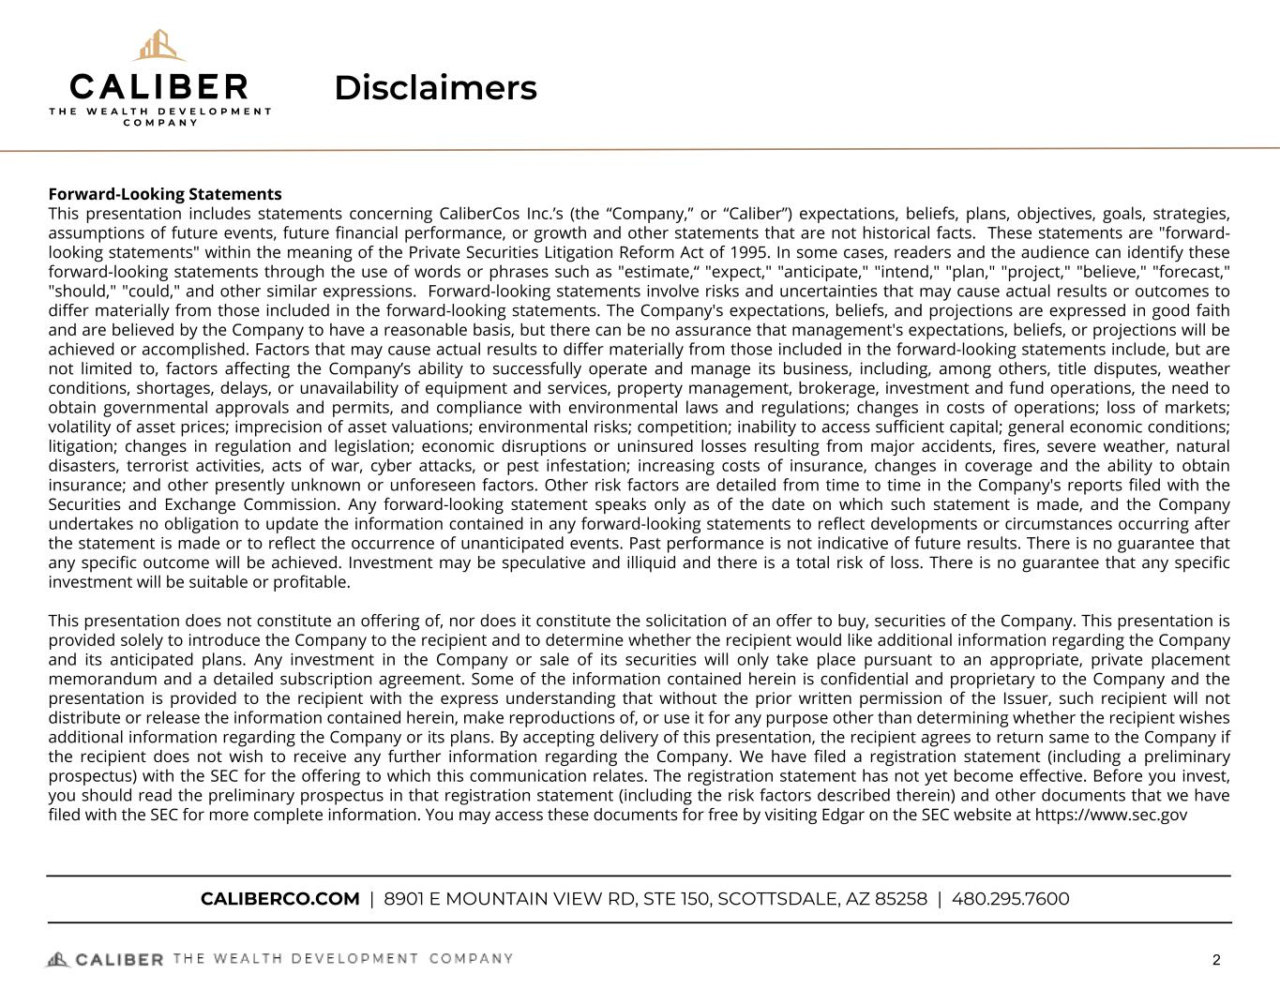
Disclaimers Forward-Looking Statements This presentation includes statements concerning CaliberCos Inc.’s (the “Company,” or “Caliber”) expectations, beliefs, plans, objectives, goals, strategies, assumptions of future events, future financial performance, or growth and other statements that are not historical facts. These statements are "forward- looking statements" within the meaning of the Private Securities Litigation Reform Act of 1995. In some cases, readers and the audience can identify these forward-looking statements through the use of words or phrases such as "estimate,“ "expect," "anticipate," "intend," "plan," "project," "believe," "forecast," "should," "could," and other similar expressions. Forward-looking statements involve risks and uncertainties that may cause actual results or outcomes to differ materially from those included in the forward-looking statements. The Company's expectations, beliefs, and projections are expressed in good faith and are believed by the Company to have a reasonable basis, but there can be no assurance that management's expectations, beliefs, or projections will be achieved or accomplished. Factors that may cause actual results to differ materially from those included in the forward-looking statements include, but are not limited to, factors affecting the Company’s ability to successfully operate and manage its business, including, among others, title disputes, weather conditions, shortages, delays, or unavailability of equipment and services, property management, brokerage, investment and fund operations, the need to obtain governmental approvals and permits, and compliance with environmental laws and regulations; changes in costs of operations; loss of markets; volatility of asset prices; imprecision of asset valuations; environmental risks; competition; inability to access sufficient capital; general economic conditions; litigation; changes in regulation and legislation; economic disruptions or uninsured losses resulting from major accidents, fires, severe weather, natural disasters, terrorist activities, acts of war, cyber attacks, or pest infestation; increasing costs of insurance, changes in coverage and the ability to obtain insurance; and other presently unknown or unforeseen factors. Other risk factors are detailed from time to time in the Company's reports filed with the Securities and Exchange Commission. Any forward-looking statement speaks only as of the date on which such statement is made, and the Company undertakes no obligation to update the information contained in any forward-looking statements to reflect developments or circumstances occurring after the statement is made or to reflect the occurrence of unanticipated events. Past performance is not indicative of future results. There is no guarantee that any specific outcome will be achieved. Investment may be speculative and illiquid and there is a total risk of loss. There is no guarantee that any specific investment will be suitable or profitable. This presentation does not constitute an offering of, nor does it constitute the solicitation of an offer to buy, securities of the Company. This presentation is provided solely to introduce the Company to the recipient and to determine whether the recipient would like additional information regarding the Company and its anticipated plans. Any investment in the Company or sale of its securities will only take place pursuant to an appropriate, private placement memorandum and a detailed subscription agreement. Some of the information contained herein is confidential and proprietary to the Company and the presentation is provided to the recipient with the express understanding that without the prior written permission of the Issuer, such recipient will not distribute or release the information contained herein, make reproductions of, or use it for any purpose other than determining whether the recipient wishes additional information regarding the Company or its plans. By accepting delivery of this presentation, the recipient agrees to return same to the Company if the recipient does not wish to receive any further information regarding the Company. We have filed a registration statement (including a preliminary prospectus) with the SEC for the offering to which this communication relates. The registration statement has not yet become effective. Before you invest, you should read the preliminary prospectus in that registration statement (including the risk factors described therein) and other documents that we have filed with the SEC for more complete information. You may access these documents for free by visiting Edgar on the SEC website at https://www.sec.gov CALIBERCO.COM | 8901 E MOUNTAIN VIEW RD, STE 150, SCOTTSDALE, AZ 85258 | 480.295.7600 2


Today’s Speakers Chris Loeffler CHIEF EXECUTIVE OFFICER Chris Loeffler has served as the CEO and Chairman of Caliber’s Board of Directors since its inception. As CEO, Chris directs and executes global strategy, oversees investments and fund management, and contributes to private and public capital formation. As a Co-Founder Chris took an early role forming the Company’s financial and operational infrastructure and navigating the vertical integration of all real estate and investment services. 3 Michael Rosales ACTING CHIEF FINANCIAL OFFICER Michael Rosales is Caliber’s Acting CFO. As Acting CFO, Michael oversees all aspects of accounting and controllership, financial planning and analysis, tax, financial reporting, and treasury functions at Caliber. Prior to joining Caliber, Michael spent 6 years with Grant Thornton LLP, and held various audit roles at PWC, Wells Fargo, Deloitte, and Greentree Financial Services. Michael is a CPA and holds a Bachelor of Science in Accounting from Arizona State University.


4THE WEALTH DEVELOPMENT COMPANY 4 CEO Commentary

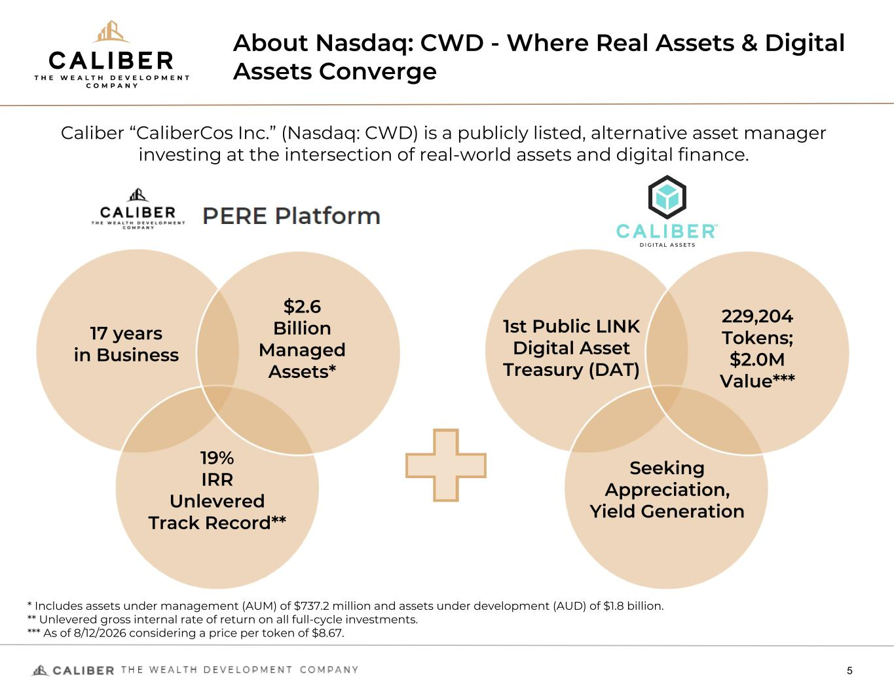
About Nasdaq: CWD - Where Real Assets & Digital Assets Converge 5 * Includes assets under management (AUM) of $737.2 million and assets under development (AUD) of $1.8 billion. ** Unlevered gross internal rate of return on all full-cycle investments. *** As of 8/12/2026 considering a price per token of $8.67. 17 years in Business $2.6 Billion Managed Assets* 19% IRR Unlevered Track Record** Caliber “CaliberCos Inc.” (Nasdaq: CWD) is a publicly listed, alternative asset manager investing at the intersection of real-world assets and digital finance. 229,204 Tokens; $2.0M Value*** 1st Public LINK Digital Asset Treasury (DAT) Seeking Appreciation, Yield Generation

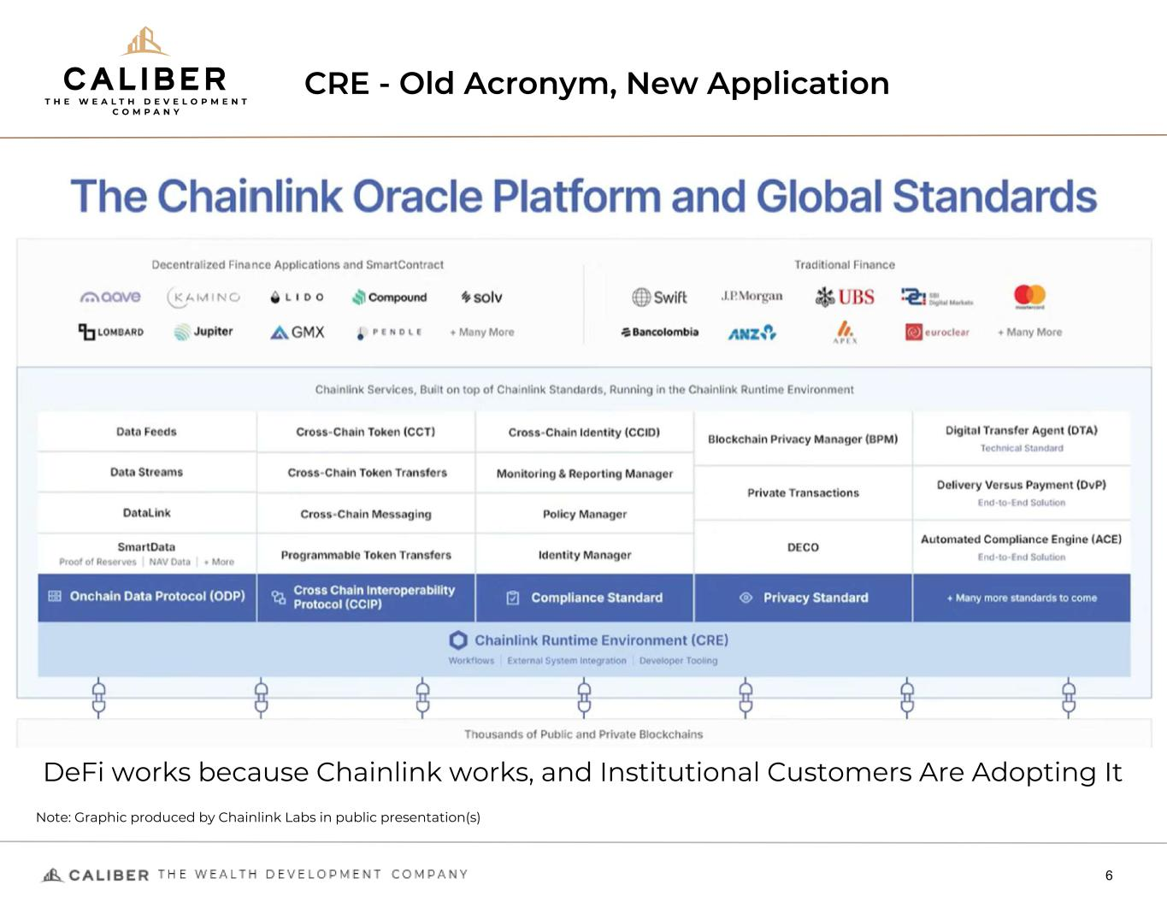
CRE - Old Acronym, New Application 6 DeFi works because Chainlink works, and Institutional Customers Are Adopting It Note: Graphic produced by Chainlink Labs in public presentation(s)

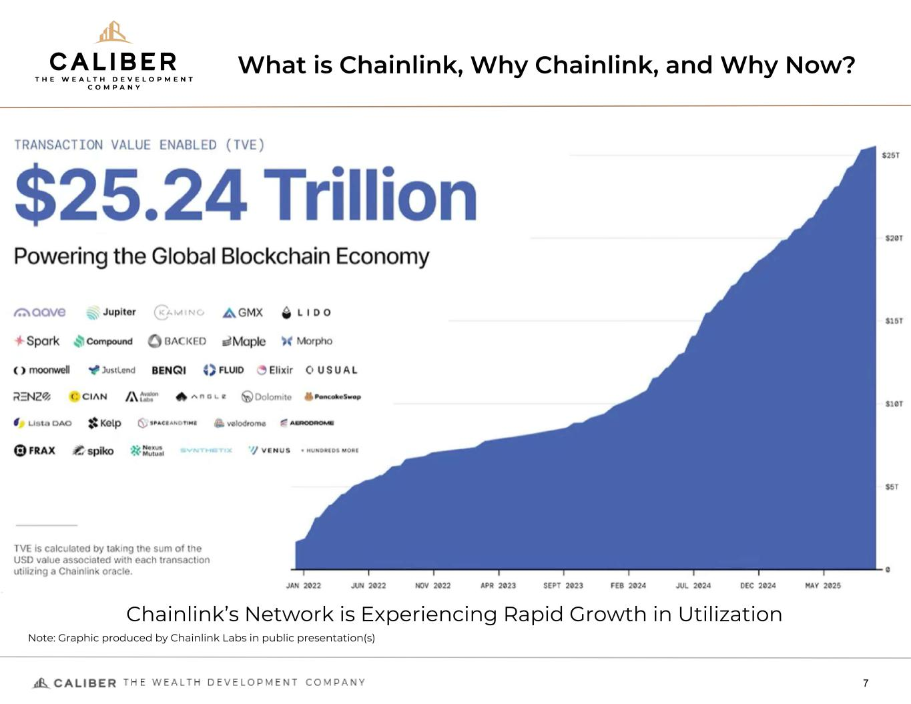
What is Chainlink, Why Chainlink, and Why Now? 7 Chainlink’s Network is Experiencing Rapid Growth in Utilization Note: Graphic produced by Chainlink Labs in public presentation(s)


Caliber’s Vision: Unlocking Value Between Real & Digital Assets 8 Combining two worlds under one public company: ◦ A proven real estate private equity platform with 17 years of track record, and ◦ A new digital asset treasury and product platform anchored in Chainlink (LINK) Leveraging Caliber’s Wall Street experience and regulatory framework to: ◦ Efficiently raise capital through public and private channels, ◦ Accumulate and stake LINK to earn yield and align with Chainlink’s growth, and ◦ Build future investment products in both digital and tokenized real assets Caliber is not just investing in Chainlink - it’s building on it. ◦ Caliber is exploring tokenization of its real estate funds and assets

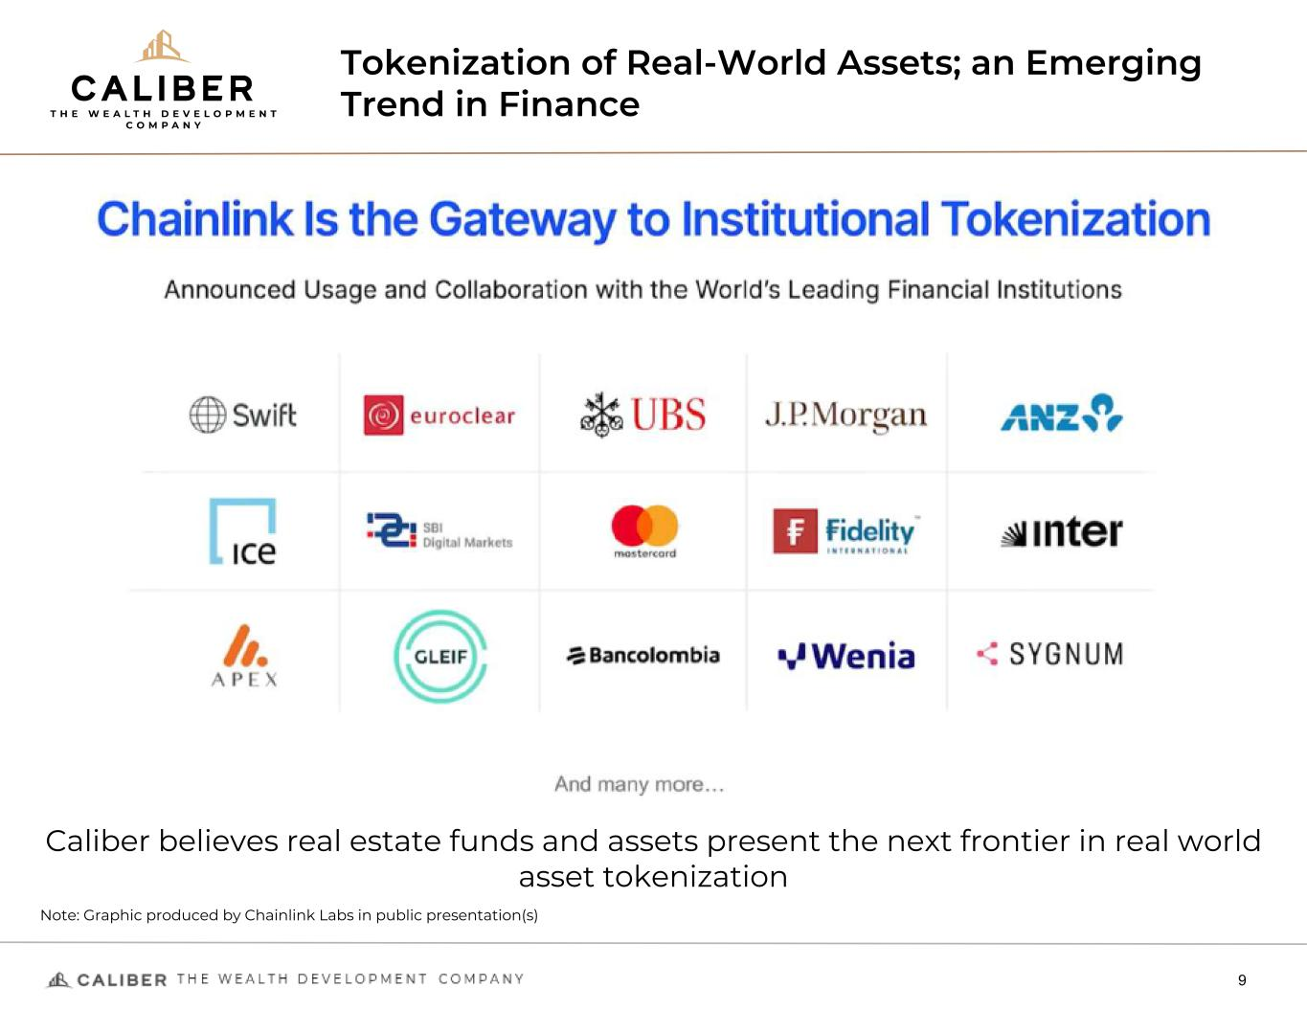
Tokenization of Real-World Assets; an Emerging Trend in Finance 9 Caliber believes real estate funds and assets present the next frontier in real world asset tokenization Note: Graphic produced by Chainlink Labs in public presentation(s)

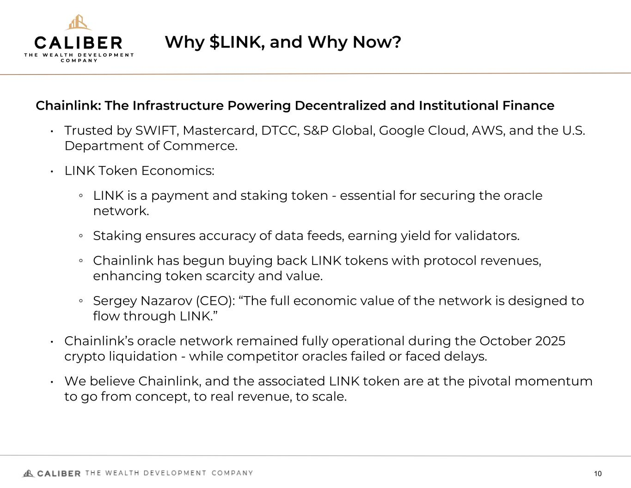
Why $LINK, and Why Now? 10 Chainlink: The Infrastructure Powering Decentralized and Institutional Finance • Trusted by SWIFT, Mastercard, DTCC, S&P Global, Google Cloud, AWS, and the U.S. Department of Commerce. • LINK Token Economics: ◦ LINK is a payment and staking token - essential for securing the oracle network. ◦ Staking ensures accuracy of data feeds, earning yield for validators. ◦ Chainlink has begun buying back LINK tokens with protocol revenues, enhancing token scarcity and value. ◦ Sergey Nazarov (CEO): “The full economic value of the network is designed to flow through LINK.” • Chainlink’s oracle network remained fully operational during the October 2025 crypto liquidation - while competitor oracles failed or faced delays. • We believe Chainlink, and the associated LINK token are at the pivotal momentum to go from concept, to real revenue, to scale.

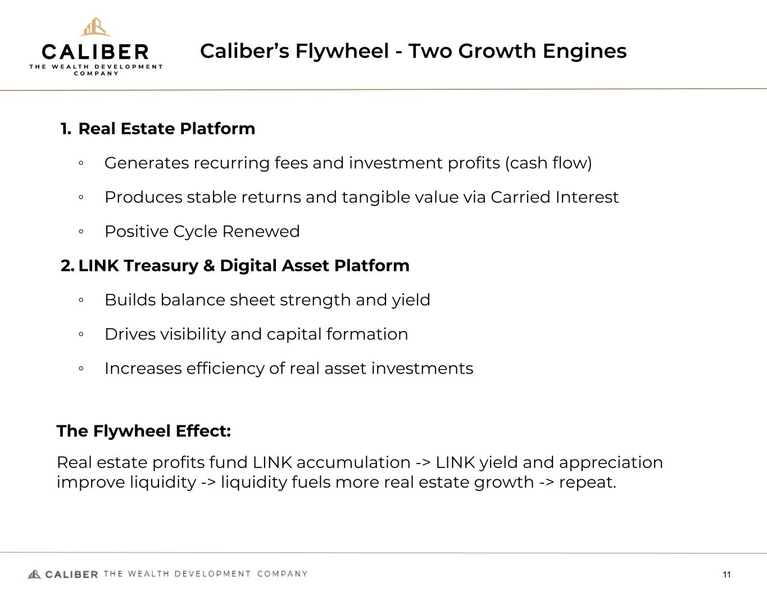
Caliber’s Flywheel - Two Growth Engines 11 1. Real Estate Platform ◦ Generates recurring fees and investment profits (cash flow) ◦ Produces stable returns and tangible value via Carried Interest ◦ Positive Cycle Renewed 2. LINK Treasury & Digital Asset Platform ◦ Builds balance sheet strength and yield ◦ Drives visibility and capital formation ◦ Increases efficiency of real asset investments The Flywheel Effect: Real estate profits fund LINK accumulation -> LINK yield and appreciation improve liquidity -> liquidity fuels more real estate growth -> repeat.

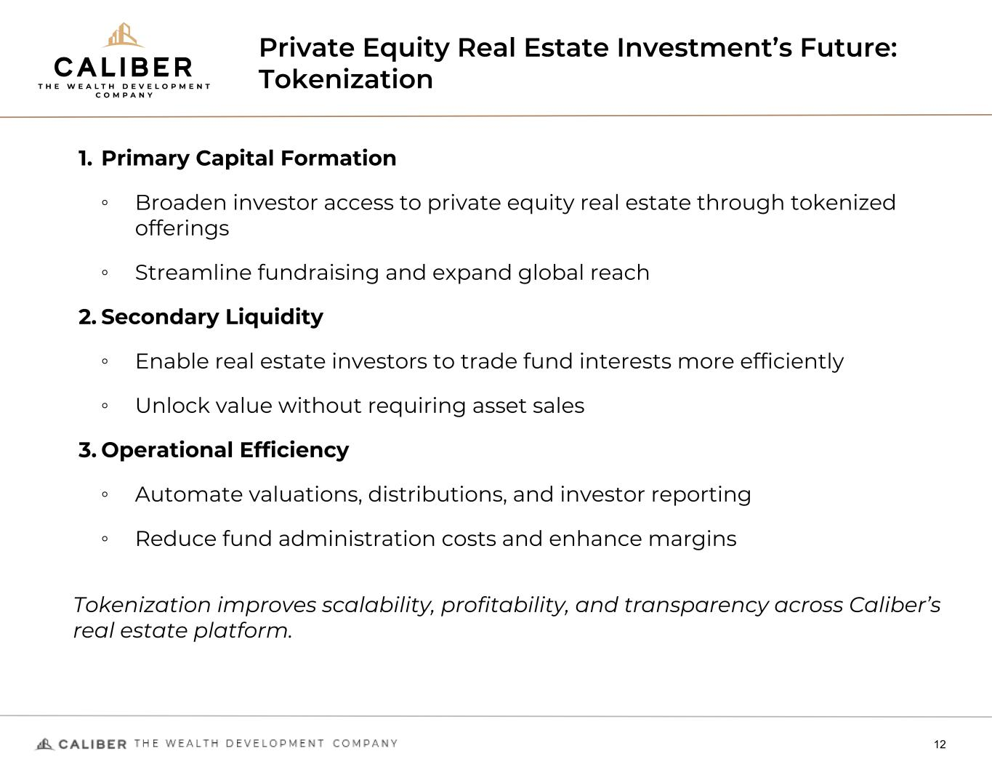
Private Equity Real Estate Investment’s Future: Tokenization 12 1. Primary Capital Formation ◦ Broaden investor access to private equity real estate through tokenized offerings ◦ Streamline fundraising and expand global reach 2. Secondary Liquidity ◦ Enable real estate investors to trade fund interests more efficiently ◦ Unlock value without requiring asset sales 3. Operational Efficiency ◦ Automate valuations, distributions, and investor reporting ◦ Reduce fund administration costs and enhance margins Tokenization improves scalability, profitability, and transparency across Caliber’s real estate platform.

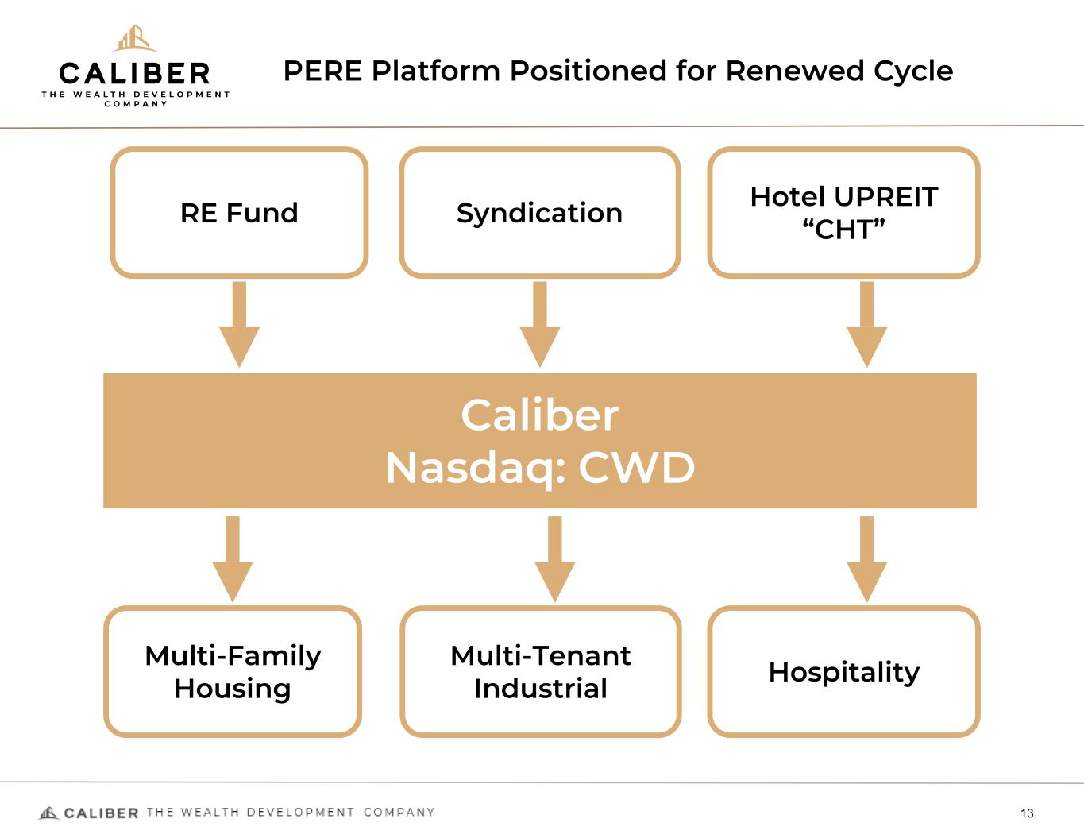
PERE Platform Positioned for Renewed Cycle 13 Caliber Nasdaq: CWD Multi-Family Housing Multi-Tenant Industrial Hospitality RE Fund Syndication Hotel UPREIT “CHT”

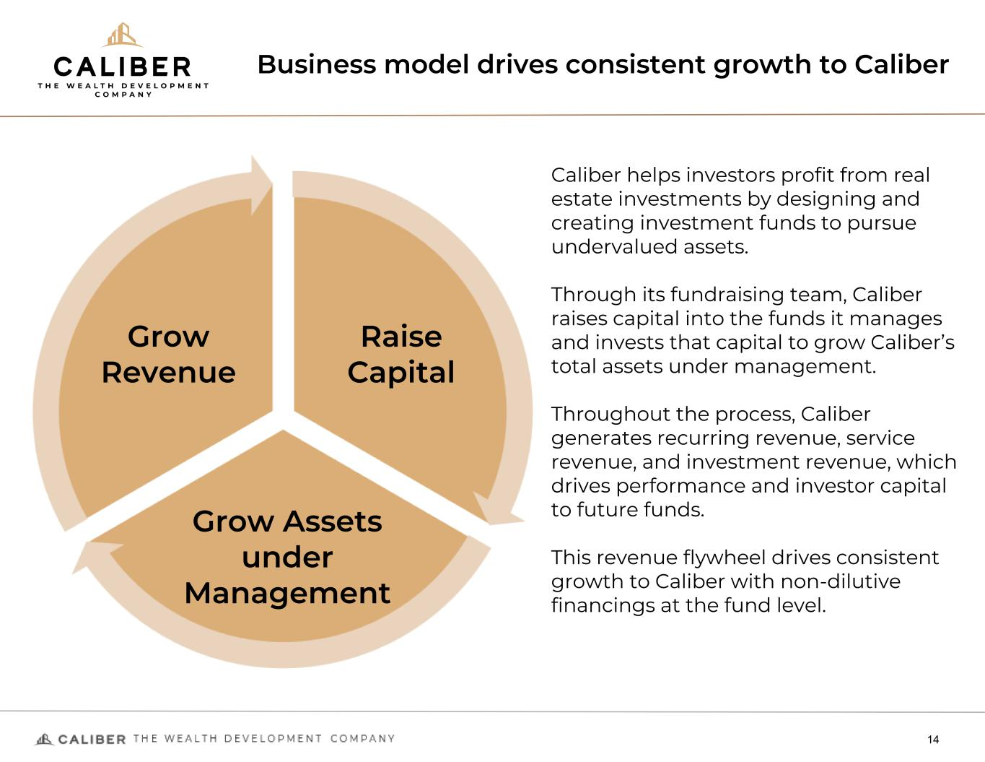
Business model drives consistent growth to Caliber 14 Grow Revenue Raise Capital Grow Assets under Management Caliber helps investors profit from real estate investments by designing and creating investment funds to pursue undervalued assets. Through its fundraising team, Caliber raises capital into the funds it manages and invests that capital to grow Caliber’s total assets under management. Throughout the process, Caliber generates recurring revenue, service revenue, and investment revenue, which drives performance and investor capital to future funds. This revenue flywheel drives consistent growth to Caliber with non-dilutive financings at the fund level.

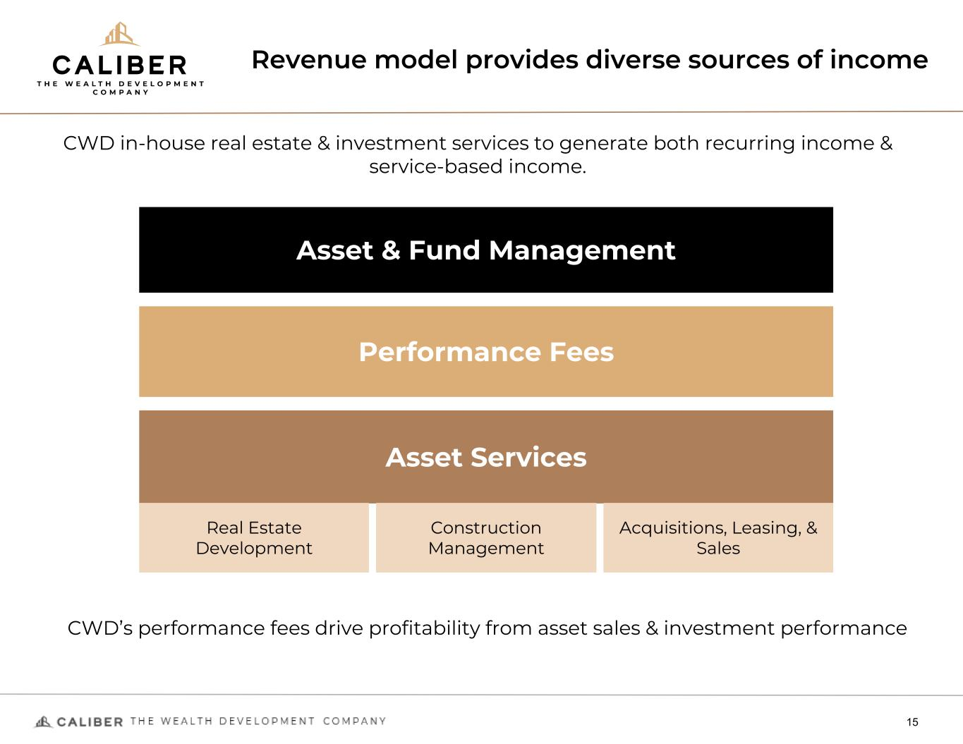
Revenue model provides diverse sources of income 15 Asset Services Asset & Fund Management Performance Fees CWD in-house real estate & investment services to generate both recurring income & service-based income. Real Estate Development Construction Management Acquisitions, Leasing, & Sales CWD’s performance fees drive profitability from asset sales & investment performance

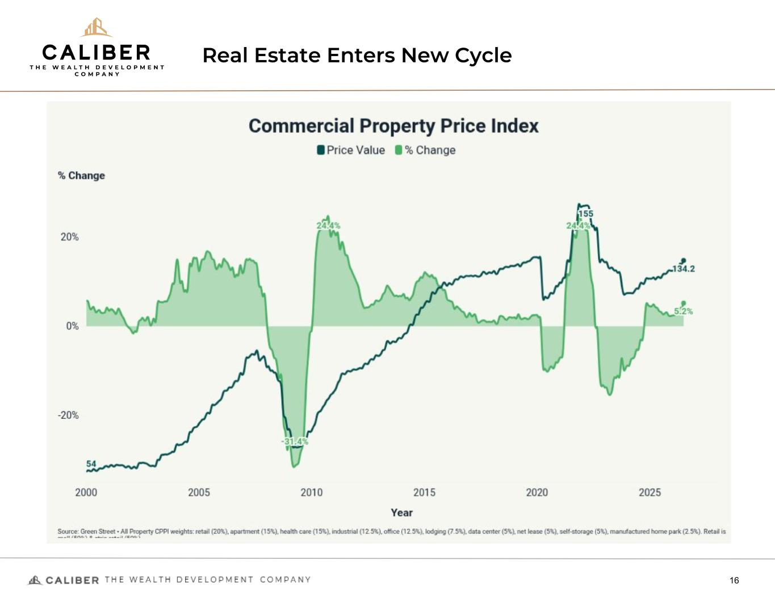
Real Estate Enters New Cycle 16

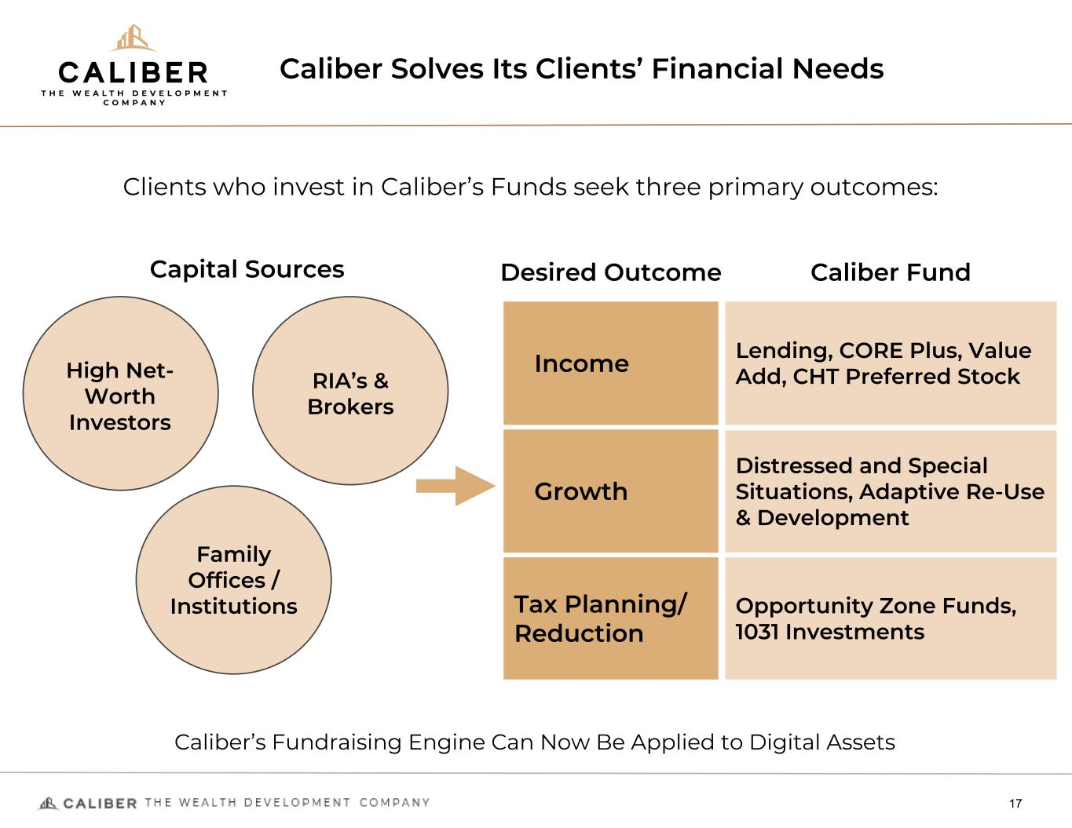
Caliber Solves Its Clients’ Financial Needs 17 Income Lending, CORE Plus, Value Add, CHT Preferred Stock Clients who invest in Caliber’s Funds seek three primary outcomes: Desired Outcome Caliber Fund Growth Distressed and Special Situations, Adaptive Re-Use & Development Tax Planning/ Reduction Opportunity Zone Funds, 1031 Investments Caliber’s Fundraising Engine Can Now Be Applied to Digital Assets High Net- Worth Investors Capital Sources RIA’s & Brokers Family Offices / Institutions

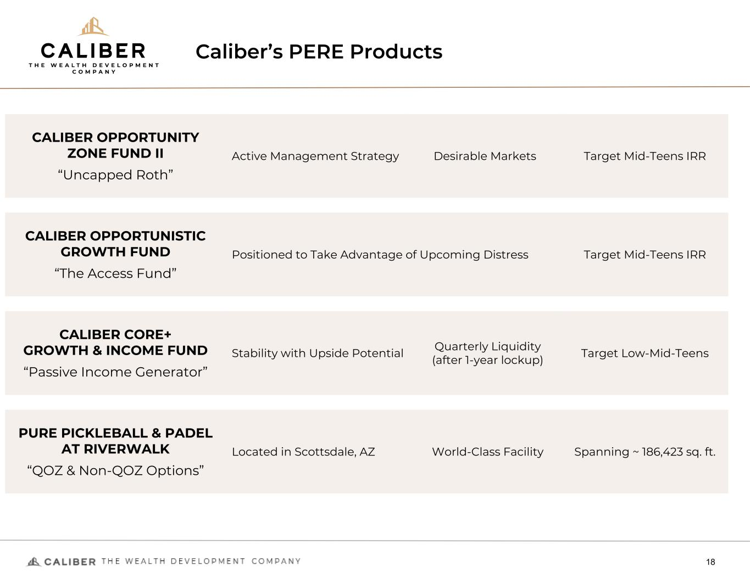
Caliber’s PERE Products 18 CALIBER OPPORTUNITY ZONE FUND II “Uncapped Roth” Active Management Strategy Desirable Markets Target Mid-Teens IRR CALIBER OPPORTUNISTIC GROWTH FUND “The Access Fund” Positioned to Take Advantage of Upcoming Distress Target Mid-Teens IRR CALIBER CORE+ GROWTH & INCOME FUND “Passive Income Generator” Stability with Upside Potential Quarterly Liquidity (after 1-year lockup) Target Low-Mid-Teens PURE PICKLEBALL & PADEL AT RIVERWALK “QOZ & Non-QOZ Options” Located in Scottsdale, AZ World-Class Facility Spanning ~ 186,423 sq. ft.

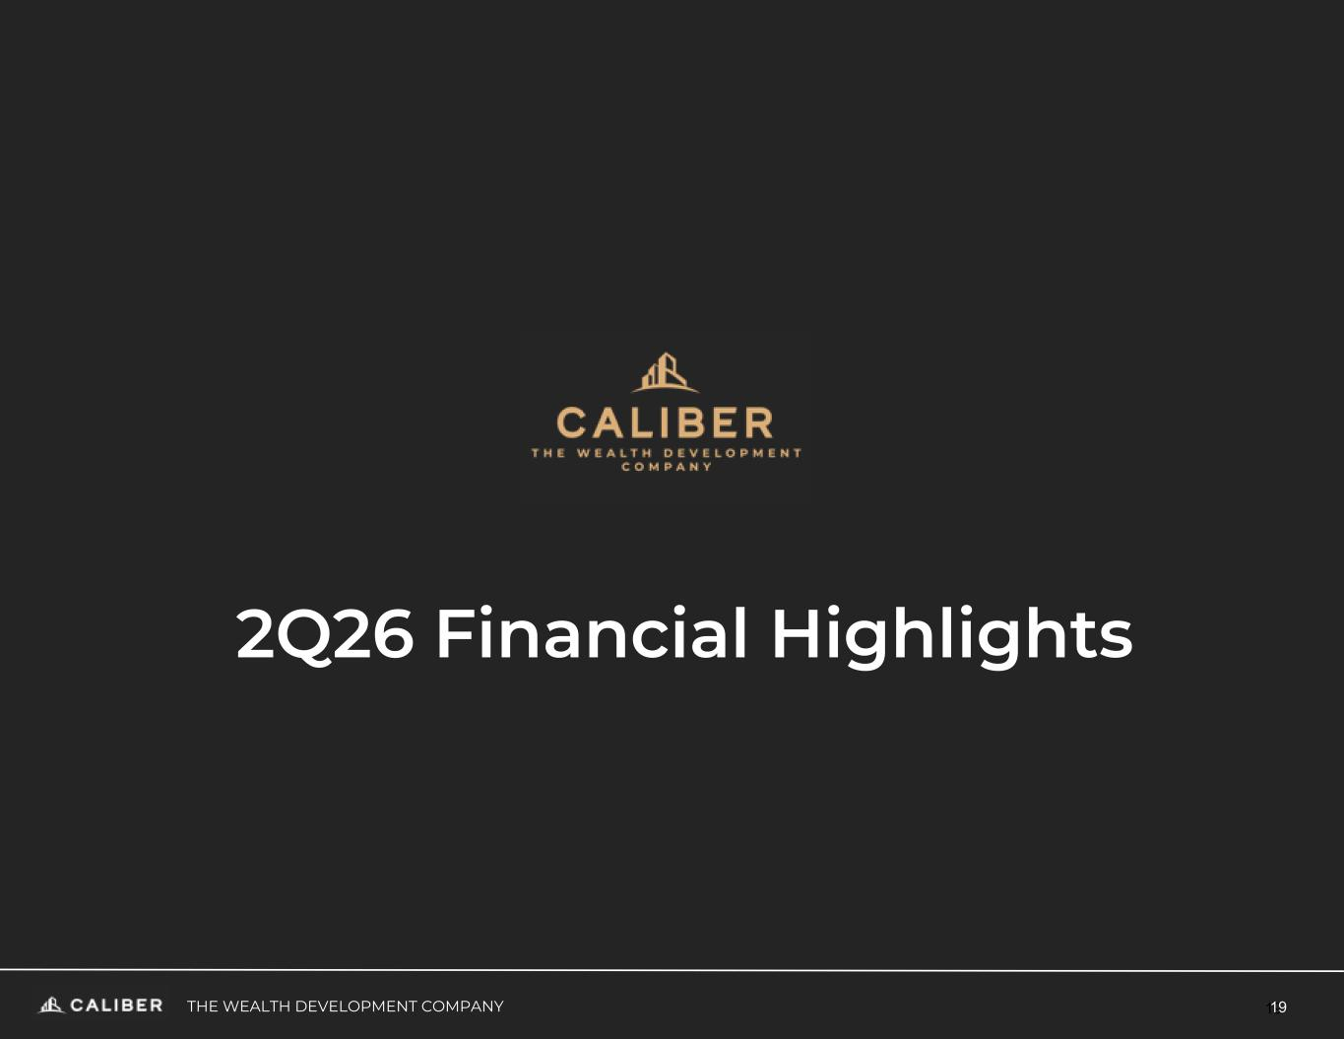
19THE WEALTH DEVELOPMENT COMPANY 19 2Q26 Financial Highlights

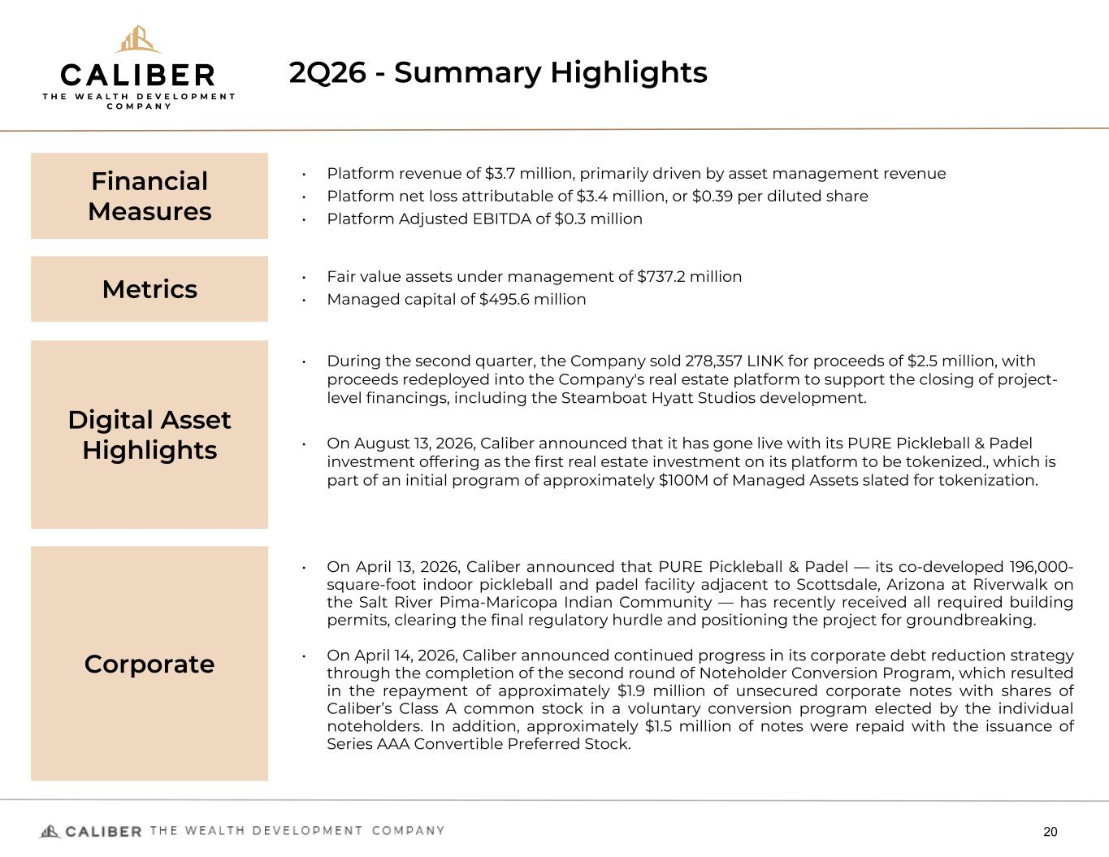
2Q26 - Summary Highlights 20 Financial Measures • Platform revenue of $3.7 million, primarily driven by asset management revenue • Platform net loss attributable of $3.4 million, or $0.39 per diluted share • Platform Adjusted EBITDA of $0.3 million Metrics • Fair value assets under management of $737.2 million • Managed capital of $495.6 million Digital Asset Highlights • Improved adjusted EBITDA profitability by $1.0 million compared to year ago quarter • Platform revenue grew 16% year over year • Continued tokenization of assets Corporate • On April 13, 2026, Caliber announced that PURE Pickleball & Padel — its co-developed 196,000- square-foot indoor pickleball and padel facility adjacent to Scottsdale, Arizona at Riverwalk on the Salt River Pima-Maricopa Indian Community — has recently received all required building permits, clearing the final regulatory hurdle and positioning the project for groundbreaking. • On April 14, 2026, Caliber announced continued progress in its corporate debt reduction strategy through the completion of the second round of Noteholder Conversion Program, which resulted in the repayment of approximately $1.9 million of unsecured corporate notes with shares of Caliber’s Class A common stock in a voluntary conversion program elected by the individual noteholders. In addition, approximately $1.5 million of notes were repaid with the issuance of Series AAA Convertible Preferred Stock. • During the second quarter, the Company sold 278,357 LINK for proceeds of $2.5 million, with proceeds redeployed into the Company's real estate platform to support the closing of project- level financings, including the Steamboat Hyatt Studios development. • On August 13, 2026, Caliber announced that it has gone live with its PURE Pickleball & Padel investment offering as the first real estate investment on its platform to be tokenized., which is part of an initial program of approximately $100M of Managed Assets slated for tokenization.

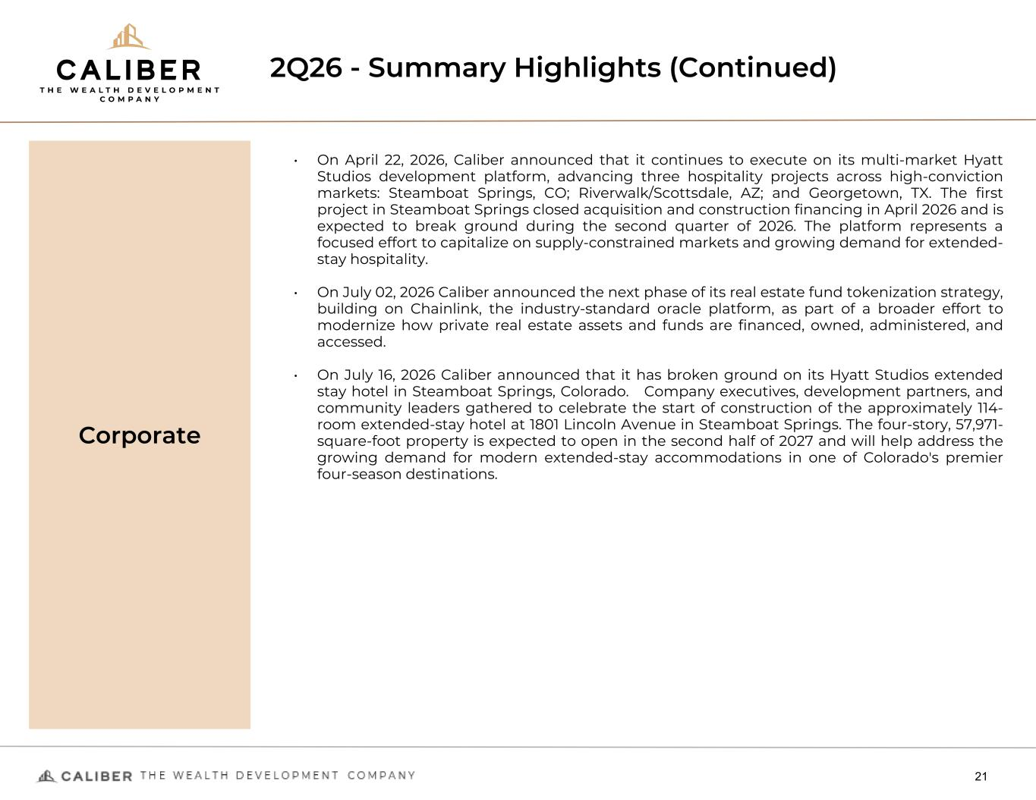
2Q26 - Summary Highlights (Continued) 21 Corporate • On April 22, 2026, Caliber announced that it continues to execute on its multi-market Hyatt Studios development platform, advancing three hospitality projects across high-conviction markets: Steamboat Springs, CO; Riverwalk/Scottsdale, AZ; and Georgetown, TX. The first project in Steamboat Springs closed acquisition and construction financing in April 2026 and is expected to break ground during the second quarter of 2026. The platform represents a focused effort to capitalize on supply-constrained markets and growing demand for extended- stay hospitality. • On July 02, 2026 Caliber announced the next phase of its real estate fund tokenization strategy, building on Chainlink, the industry-standard oracle platform, as part of a broader effort to modernize how private real estate assets and funds are financed, owned, administered, and accessed. • On July 16, 2026 Caliber announced that it has broken ground on its Hyatt Studios extended stay hotel in Steamboat Springs, Colorado. Company executives, development partners, and community leaders gathered to celebrate the start of construction of the approximately 114- room extended-stay hotel at 1801 Lincoln Avenue in Steamboat Springs. The four-story, 57,971- square-foot property is expected to open in the second half of 2027 and will help address the growing demand for modern extended-stay accommodations in one of Colorado's premier four-season destinations.

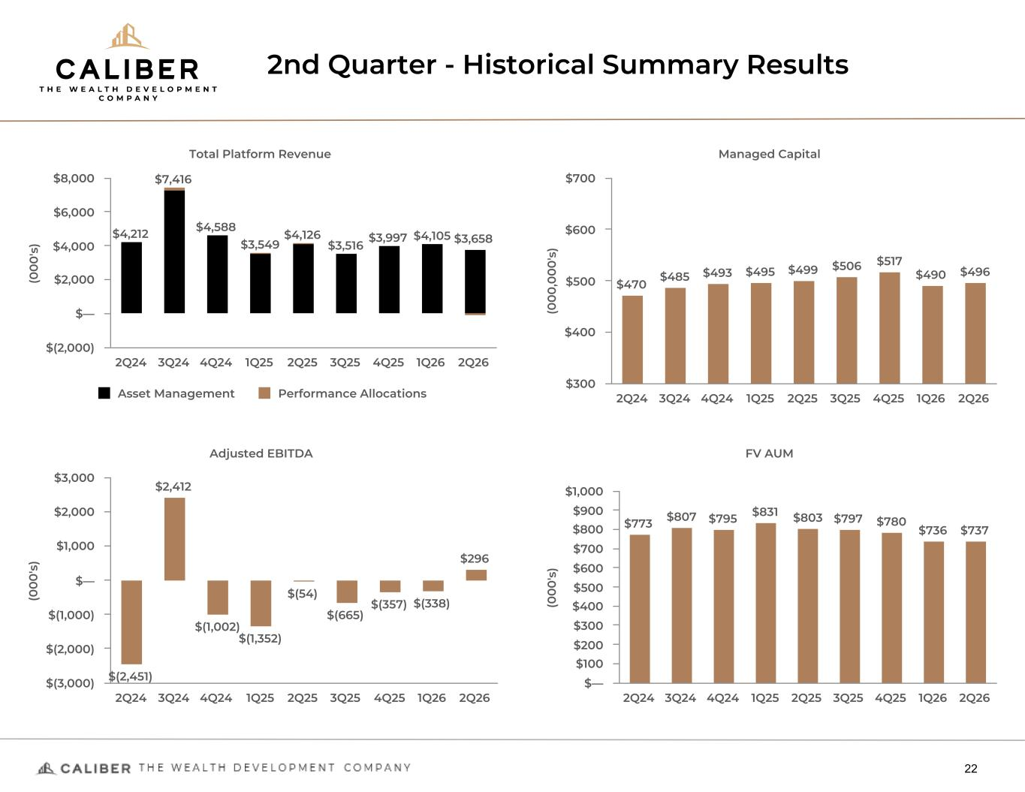
2nd Quarter - Historical Summary Results 22 (0 0 0 's ) Total Platform Revenue $4,212 $7,416 $4,588 $3,549 $4,126 $3,516 $3,997 $4,105 $3,658 Asset Management Performance Allocations 2Q24 3Q24 4Q24 1Q25 2Q25 3Q25 4Q25 1Q26 2Q26 $(2,000) $— $2,000 $4,000 $6,000 $8,000 (0 0 0 ,0 0 0 's ) Managed Capital $470 $485 $493 $495 $499 $506 $517 $490 $496 2Q24 3Q24 4Q24 1Q25 2Q25 3Q25 4Q25 1Q26 2Q26 $300 $400 $500 $600 $700 (0 0 0 's ) Adjusted EBITDA $(2,451) $(1,002) $(1,352) $(54) $(665) $(357) $(338) $2,412 $296 2Q24 3Q24 4Q24 1Q25 2Q25 3Q25 4Q25 1Q26 2Q26 $(3,000) $(2,000) $(1,000) $— $1,000 $2,000 $3,000 (0 0 0 's ) FV AUM $773 $807 $795 $831 $803 $797 $780 $736 $737 2Q24 3Q24 4Q24 1Q25 2Q25 3Q25 4Q25 1Q26 2Q26 $— $100 $200 $300 $400 $500 $600 $700 $800 $900 $1,000

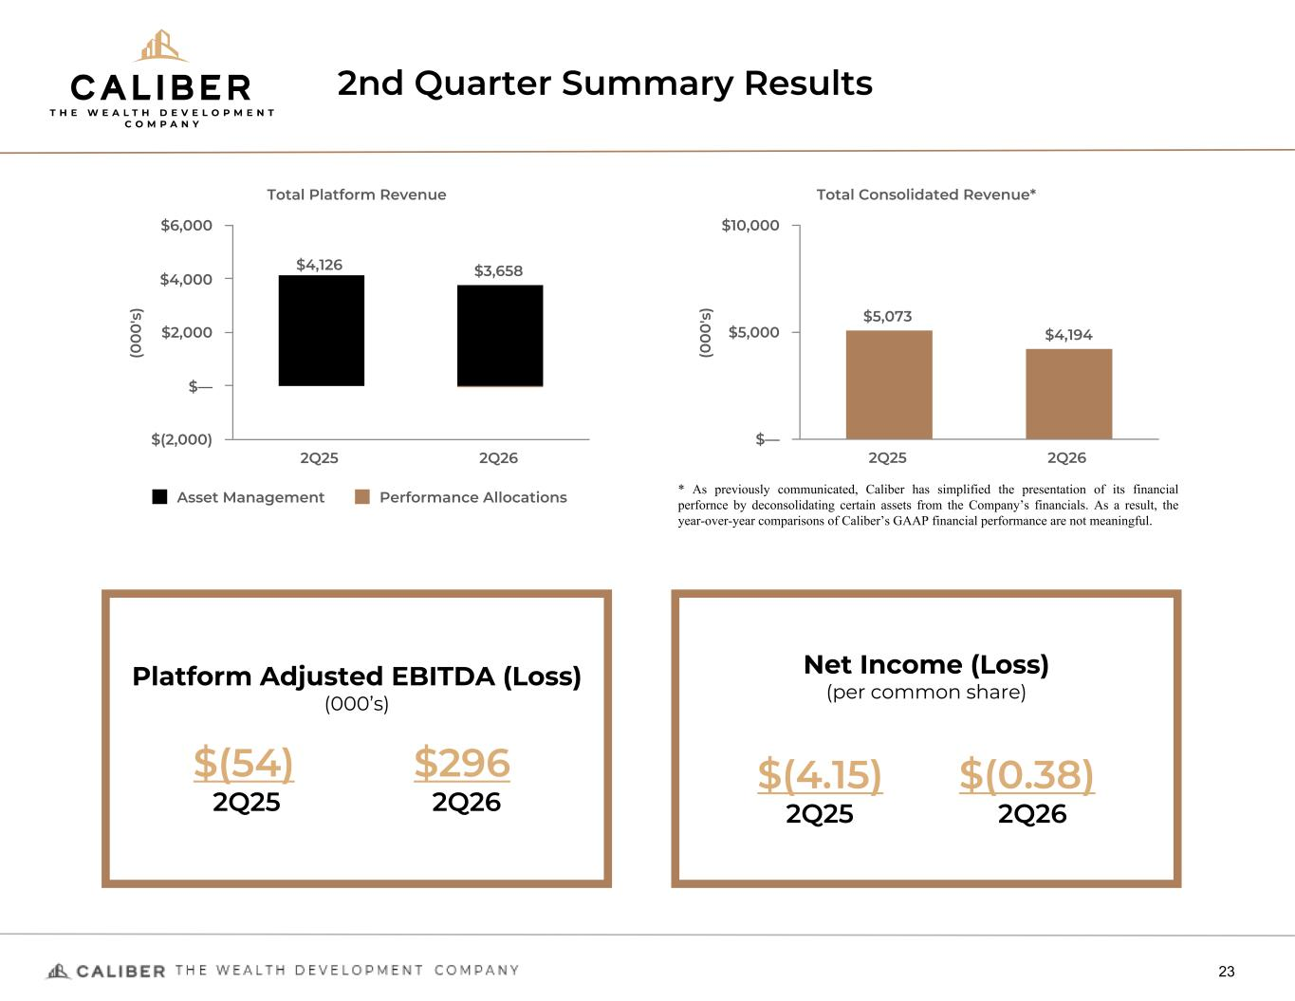
2nd Quarter Summary Results 23 Platform Adjusted EBITDA (Loss) (000’s) $(54) $296 2Q25 2Q26 Net Income (Loss) (per common share) $(4.15) $(0.38) 2Q25 2Q26 (0 0 0 's ) Total Platform Revenue $4,126 $3,658 Asset Management Performance Allocations 2Q25 2Q26 $(2,000) $— $2,000 $4,000 $6,000 (0 0 0 's ) Total Consolidated Revenue* $5,073 $4,194 2Q25 2Q26 $— $5,000 $10,000 * As previously communicated, Caliber has simplified the presentation of its financial perfornce by deconsolidating certain assets from the Company’s financials. As a result, the year-over-year comparisons of Caliber’s GAAP financial performance are not meaningful.

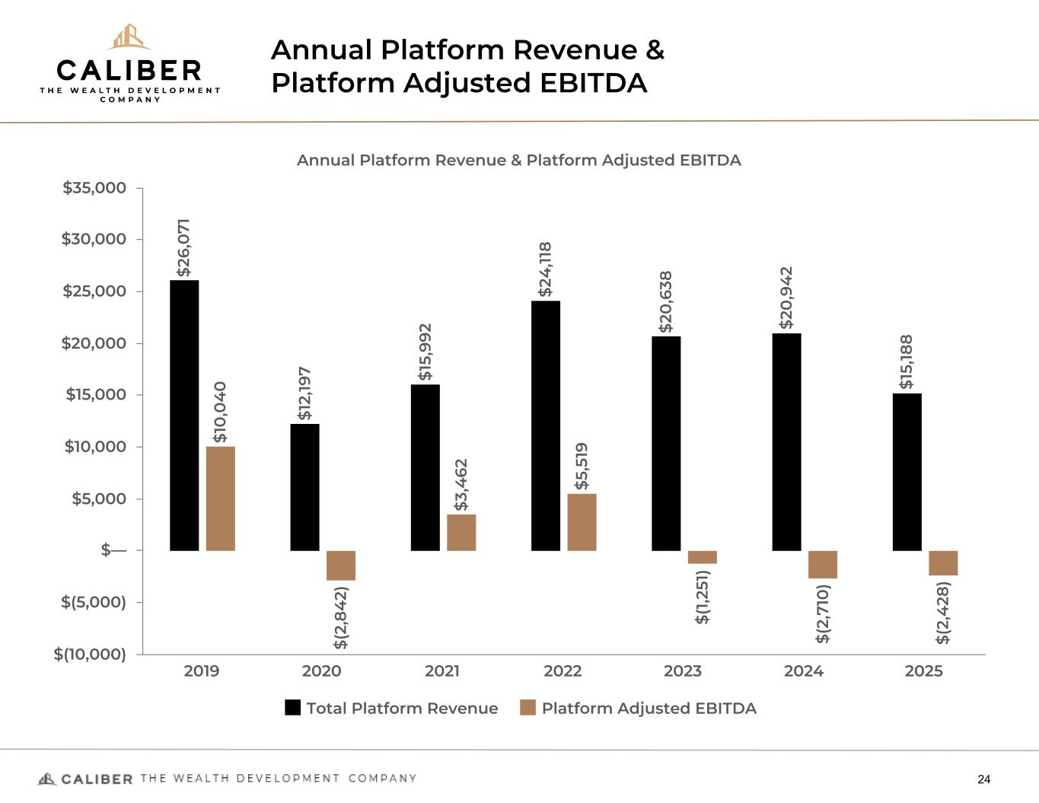
Annual Platform Revenue & Platform Adjusted EBITDA 24 Annual Platform Revenue & Platform Adjusted EBITDA $2 6, 0 71 $1 2, 19 7 $1 5, 99 2 $2 4 ,11 8 $2 0 ,6 38 $2 0 ,9 4 2 $1 5, 18 8 $1 0 ,0 4 0 $( 2, 84 2) $3 ,4 62 $5 ,5 19 $( 1,2 51 ) $( 2, 71 0 ) $( 2, 4 28 ) Total Platform Revenue Platform Adjusted EBITDA 2019 2020 2021 2022 2023 2024 2025 $(10,000) $(5,000) $— $5,000 $10,000 $15,000 $20,000 $25,000 $30,000 $35,000

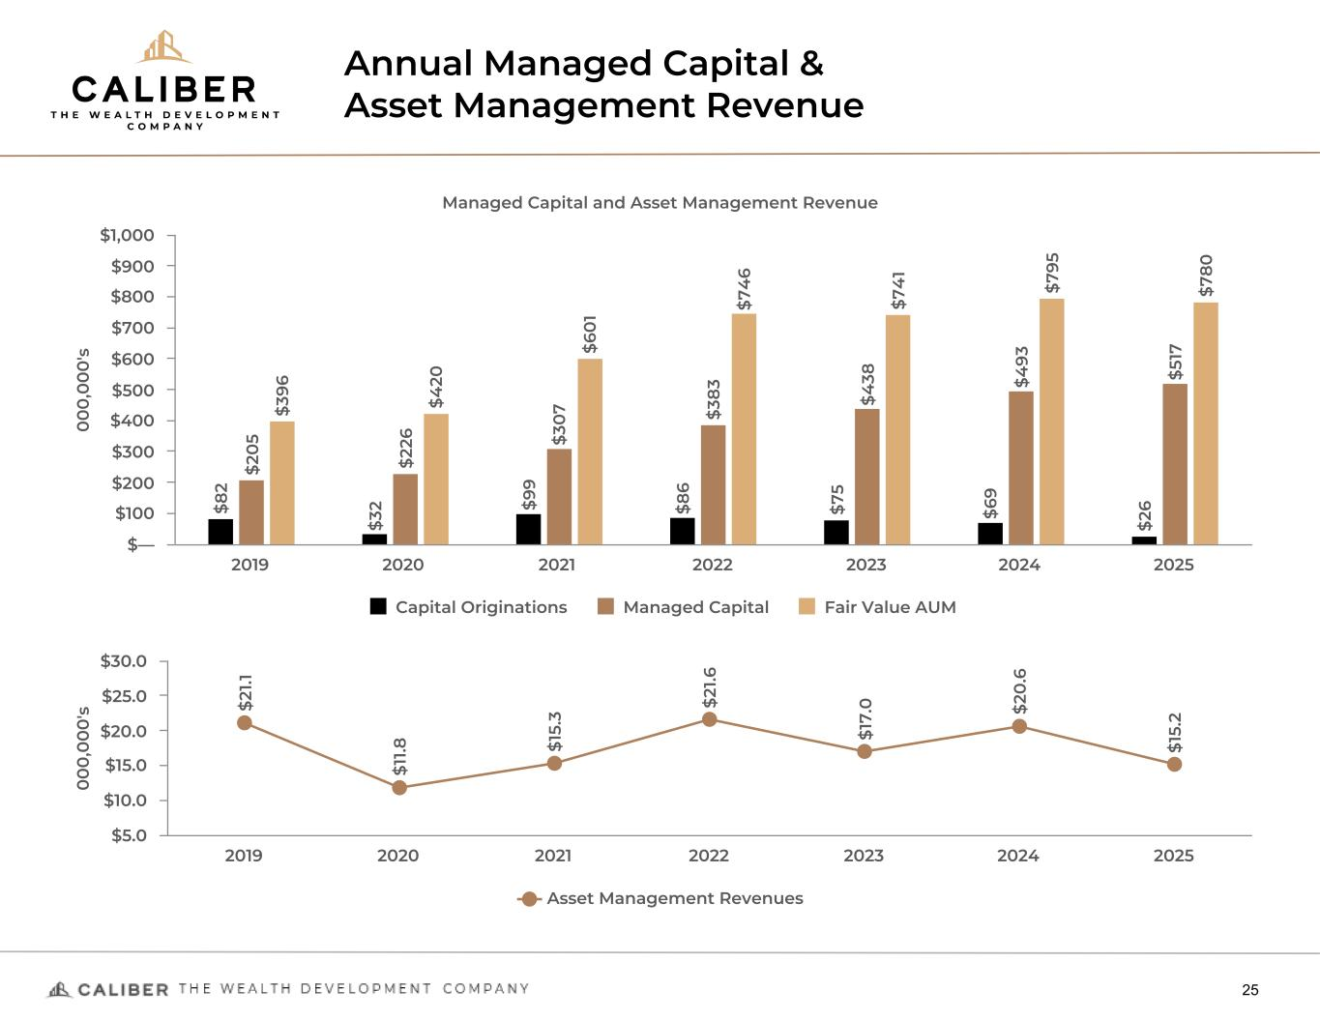
Annual Managed Capital & Asset Management Revenue 25 0 0 0 ,0 0 0 's Managed Capital and Asset Management Revenue $8 2 $3 2 $9 9 $8 6 $7 5 $6 9 $2 6 $2 0 5 $2 26 $3 0 7 $3 83 $4 38 $4 93 $5 17 $3 96 $4 20 $6 0 1 $7 4 6 $7 4 1 $7 95 $7 80 Capital Originations Managed Capital Fair Value AUM 2019 2020 2021 2022 2023 2024 2025 $— $100 $200 $300 $400 $500 $600 $700 $800 $900 $1,000 0 0 0 ,0 0 0 's $2 1.1 $1 1.8 $1 5. 3 $2 1.6 $1 7. 0 $2 0 .6 $1 5. 2 Asset Management Revenues 2019 2020 2021 2022 2023 2024 2025 $5.0 $10.0 $15.0 $20.0 $25.0 $30.0

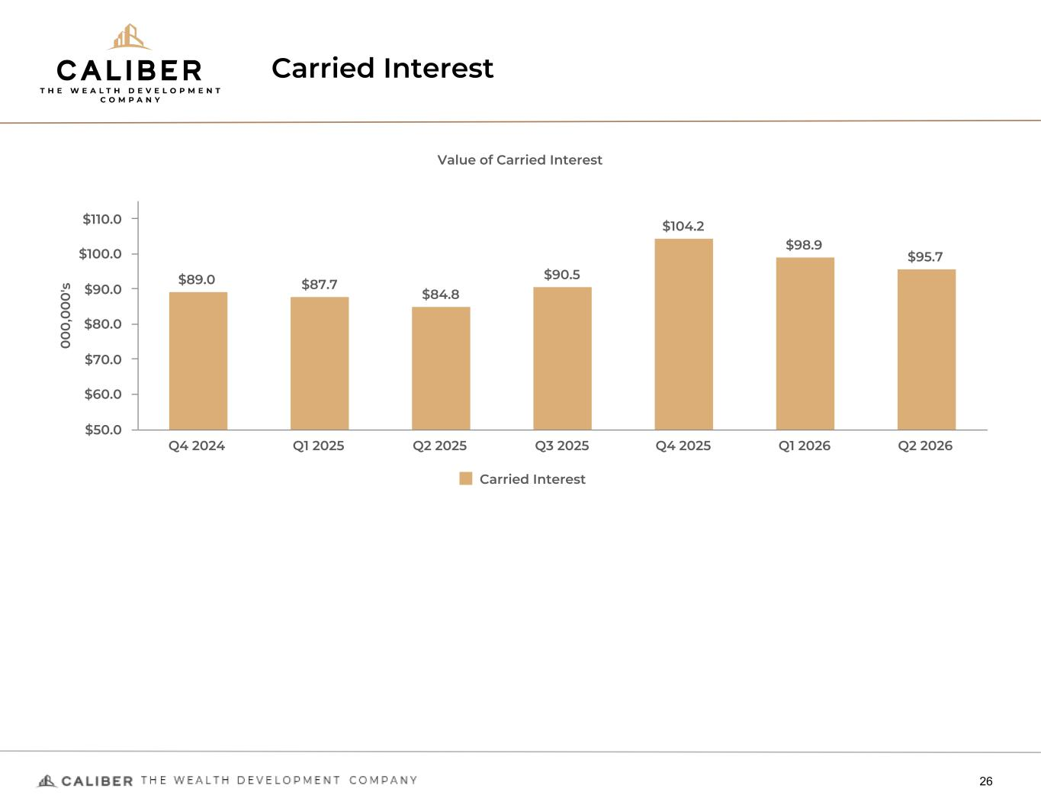
Carried Interest 26 0 0 0 ,0 0 0 's Value of Carried Interest $89.0 $87.7 $84.8 $90.5 $104.2 $98.9 $95.7 Carried Interest Q4 2024 Q1 2025 Q2 2025 Q3 2025 Q4 2025 Q1 2026 Q2 2026 $50.0 $60.0 $70.0 $80.0 $90.0 $100.0 $110.0

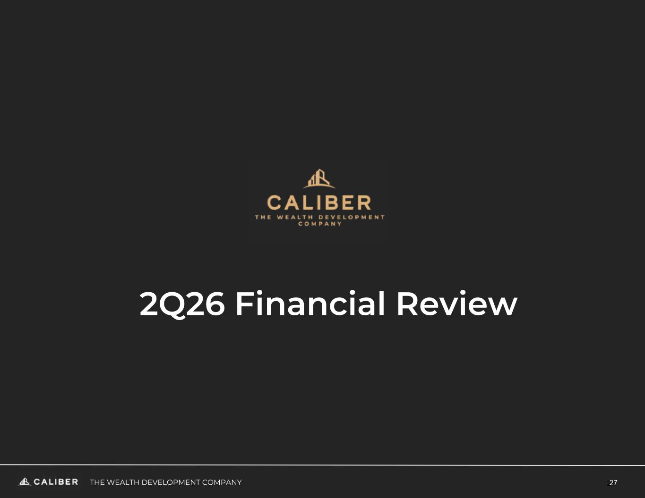
27THE WEALTH DEVELOPMENT COMPANY 27 2Q26 Financial Review

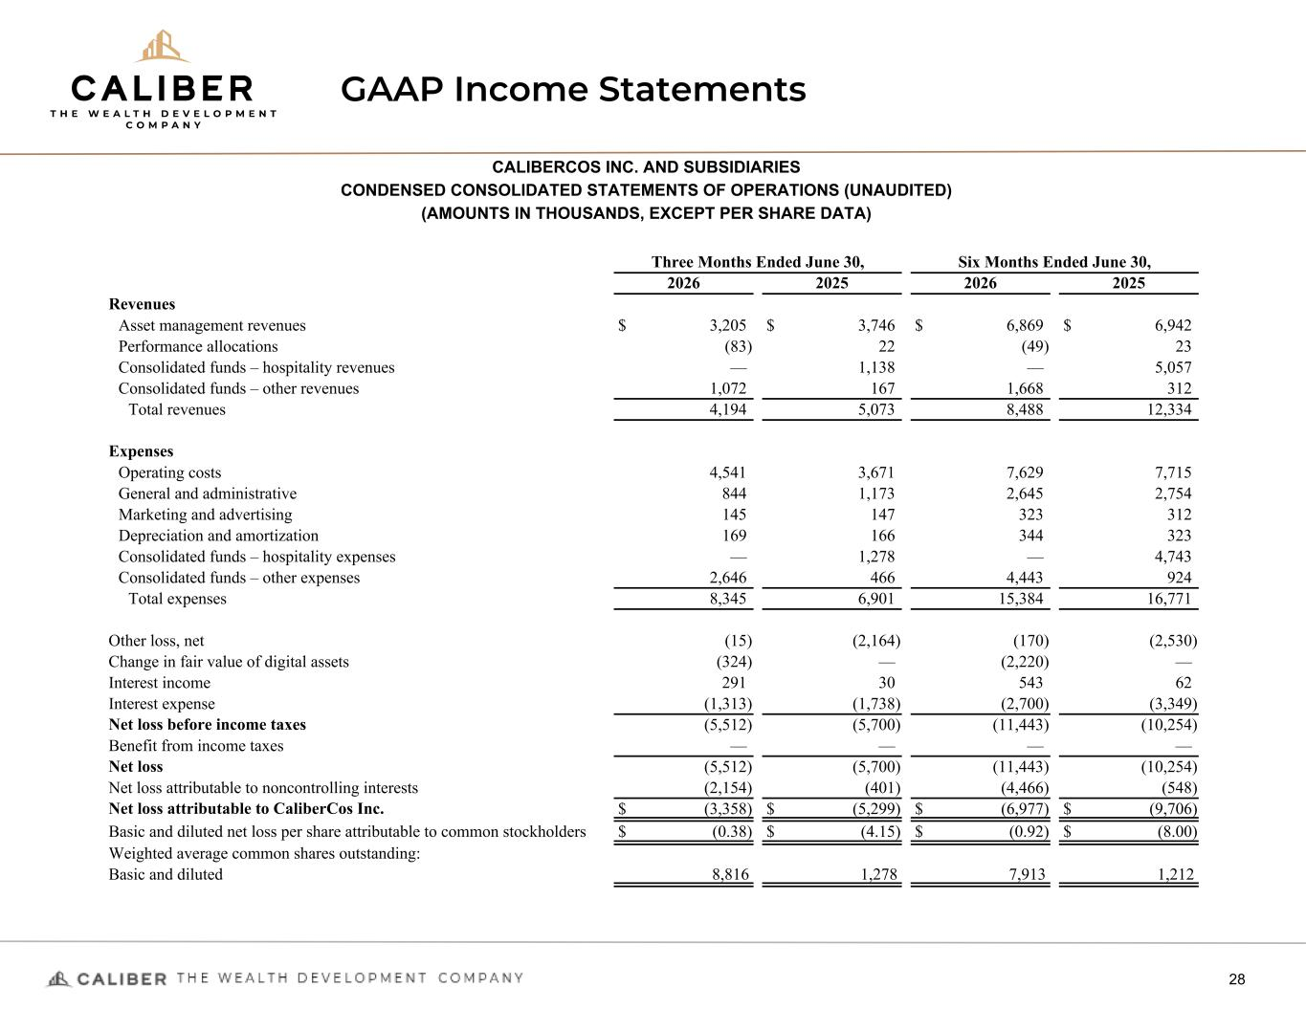
GAAP Income Statements 28 CALIBERCOS INC. AND SUBSIDIARIES CONDENSED CONSOLIDATED STATEMENTS OF OPERATIONS (UNAUDITED) (AMOUNTS IN THOUSANDS, EXCEPT PER SHARE DATA) Three Months Ended June 30, Six Months Ended June 30, 2026 2025 2026 2025 Revenues Asset management revenues $ 3,205 $ 3,746 $ 6,869 $ 6,942 Performance allocations (83) 22 (49) 23 Consolidated funds – hospitality revenues — 1,138 — 5,057 Consolidated funds – other revenues 1,072 167 1,668 312 Total revenues 4,194 5,073 8,488 12,334 Expenses Operating costs 4,541 3,671 7,629 7,715 General and administrative 844 1,173 2,645 2,754 Marketing and advertising 145 147 323 312 Depreciation and amortization 169 166 344 323 Consolidated funds – hospitality expenses — 1,278 — 4,743 Consolidated funds – other expenses 2,646 466 4,443 924 Total expenses 8,345 6,901 15,384 16,771 Other loss, net (15) (2,164) (170) (2,530) Change in fair value of digital assets (324) — (2,220) — Interest income 291 30 543 62 Interest expense (1,313) (1,738) (2,700) (3,349) Net loss before income taxes (5,512) (5,700) (11,443) (10,254) Benefit from income taxes — — — — Net loss (5,512) (5,700) (11,443) (10,254) Net loss attributable to noncontrolling interests (2,154) (401) (4,466) (548) Net loss attributable to CaliberCos Inc. $ (3,358) $ (5,299) $ (6,977) $ (9,706) Basic and diluted net loss per share attributable to common stockholders $ (0.38) $ (4.15) $ (0.92) $ (8.00) Weighted average common shares outstanding: Basic and diluted 8,816 1,278 7,913 1,212

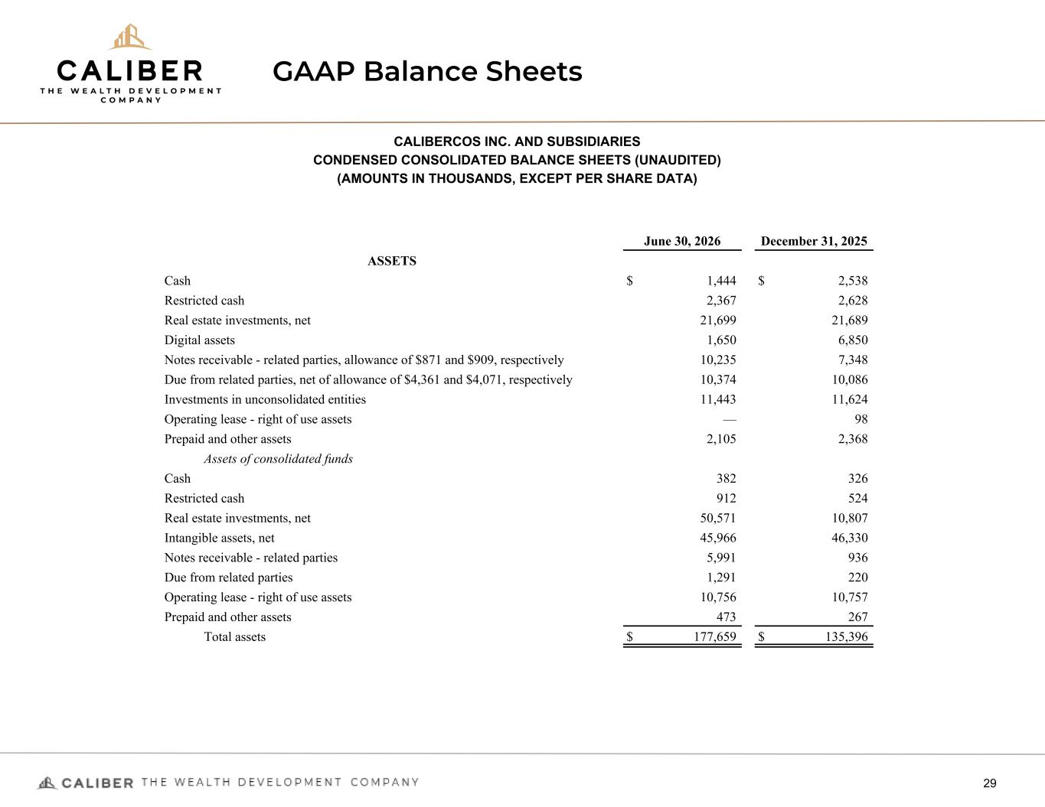
GAAP Balance Sheets 29 CALIBERCOS INC. AND SUBSIDIARIES CONDENSED CONSOLIDATED BALANCE SHEETS (UNAUDITED) (AMOUNTS IN THOUSANDS, EXCEPT PER SHARE DATA) June 30, 2026 December 31, 2025 ASSETS Cash $ 1,444 $ 2,538 Restricted cash 2,367 2,628 Real estate investments, net 21,699 21,689 Digital assets 1,650 6,850 Notes receivable - related parties, allowance of $871 and $909, respectively 10,235 7,348 Due from related parties, net of allowance of $4,361 and $4,071, respectively 10,374 10,086 Investments in unconsolidated entities 11,443 11,624 Operating lease - right of use assets — 98 Prepaid and other assets 2,105 2,368 Assets of consolidated funds Cash 382 326 Restricted cash 912 524 Real estate investments, net 50,571 10,807 Intangible assets, net 45,966 46,330 Notes receivable - related parties 5,991 936 Due from related parties 1,291 220 Operating lease - right of use assets 10,756 10,757 Prepaid and other assets 473 267 Total assets $ 177,659 $ 135,396

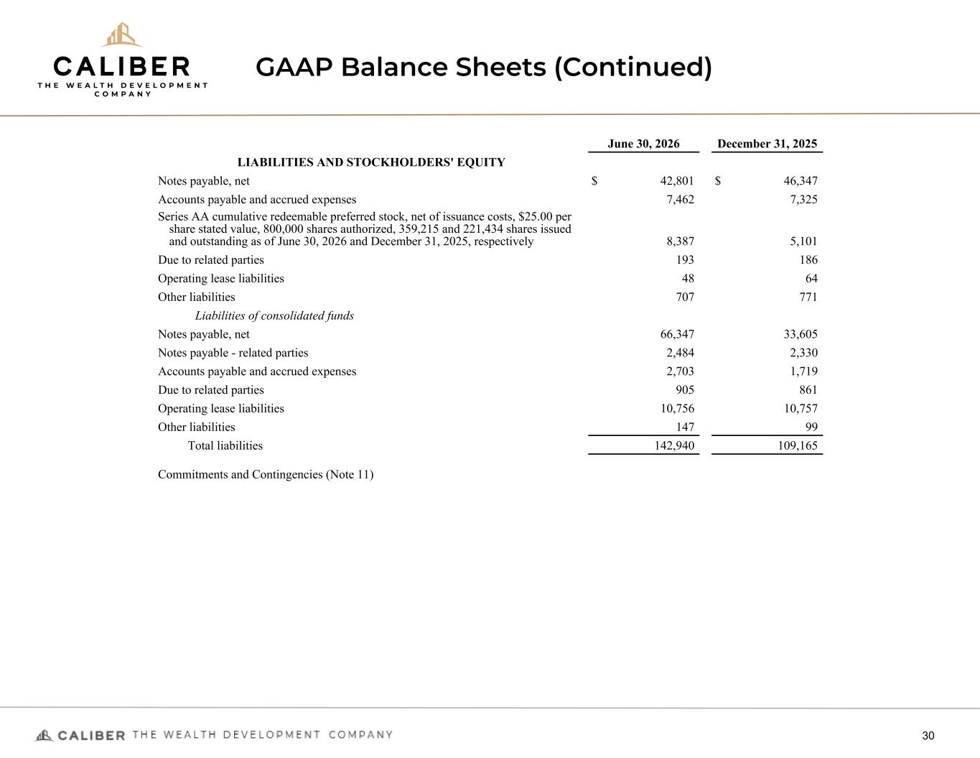
GAAP Balance Sheets (Continued) 30 June 30, 2026 December 31, 2025 LIABILITIES AND STOCKHOLDERS' EQUITY Notes payable, net $ 42,801 $ 46,347 Accounts payable and accrued expenses 7,462 7,325 Series AA cumulative redeemable preferred stock, net of issuance costs, $25.00 per share stated value, 800,000 shares authorized, 359,215 and 221,434 shares issued and outstanding as of June 30, 2026 and December 31, 2025, respectively 8,387 5,101 Due to related parties 193 186 Operating lease liabilities 48 64 Other liabilities 707 771 Liabilities of consolidated funds Notes payable, net 66,347 33,605 Notes payable - related parties 2,484 2,330 Accounts payable and accrued expenses 2,703 1,719 Due to related parties 905 861 Operating lease liabilities 10,756 10,757 Other liabilities 147 99 Total liabilities 142,940 109,165 Commitments and Contingencies (Note 11)

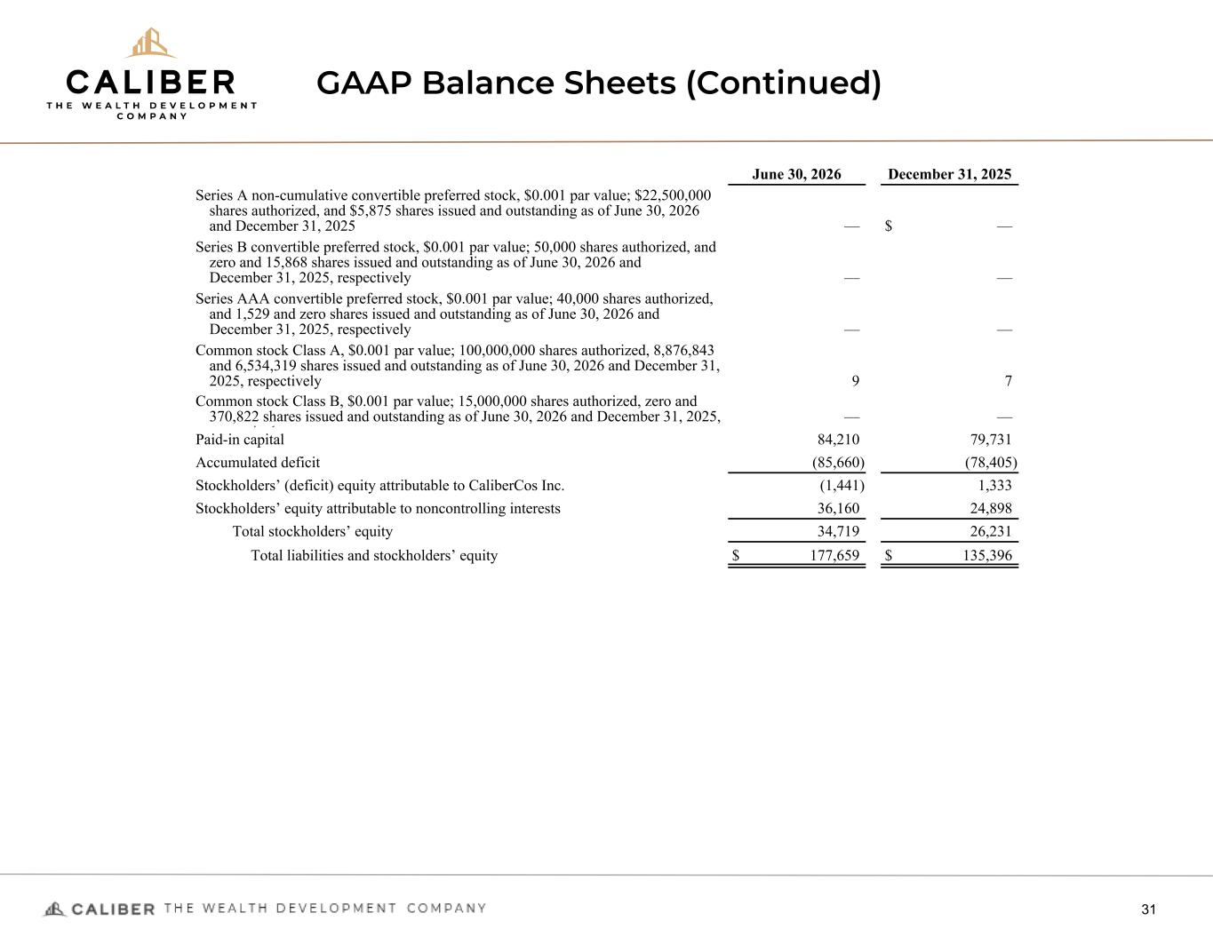
GAAP Balance Sheets (Continued) 31 June 30, 2026 December 31, 2025 Series A non-cumulative convertible preferred stock, $0.001 par value; $22,500,000 shares authorized, and $5,875 shares issued and outstanding as of June 30, 2026 and December 31, 2025 — $ — Series B convertible preferred stock, $0.001 par value; 50,000 shares authorized, and zero and 15,868 shares issued and outstanding as of June 30, 2026 and December 31, 2025, respectively — — Series AAA convertible preferred stock, $0.001 par value; 40,000 shares authorized, and 1,529 and zero shares issued and outstanding as of June 30, 2026 and December 31, 2025, respectively — — Common stock Class A, $0.001 par value; 100,000,000 shares authorized, 8,876,843 and 6,534,319 shares issued and outstanding as of June 30, 2026 and December 31, 2025, respectively 9 7 Common stock Class B, $0.001 par value; 15,000,000 shares authorized, zero and 370,822 shares issued and outstanding as of June 30, 2026 and December 31, 2025, respectively — — Paid-in capital 84,210 79,731 Accumulated deficit (85,660) (78,405) Stockholders’ (deficit) equity attributable to CaliberCos Inc. (1,441) 1,333 Stockholders’ equity attributable to noncontrolling interests 36,160 24,898 Total stockholders’ equity 34,719 26,231 Total liabilities and stockholders’ equity $ 177,659 $ 135,396


Contacts: Chris Loeffler, CEO Chris.Loeffler@CaliberCo.com Ilya Grozovsky, VP of Investor Relations & Corporate Development Ilya.Grozovsky@CaliberCo.com CaliberCos NASDAQ: CWD https://www.caliberco.com/

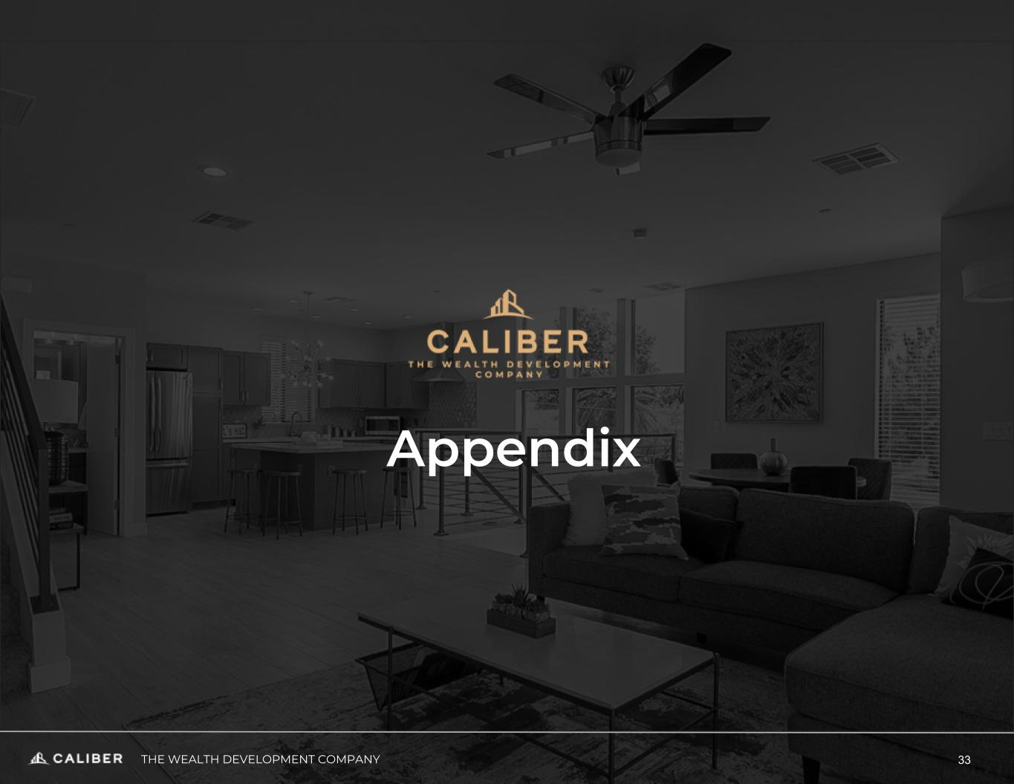
Appendix THE WEALTH DEVELOPMENT COMPANY 33

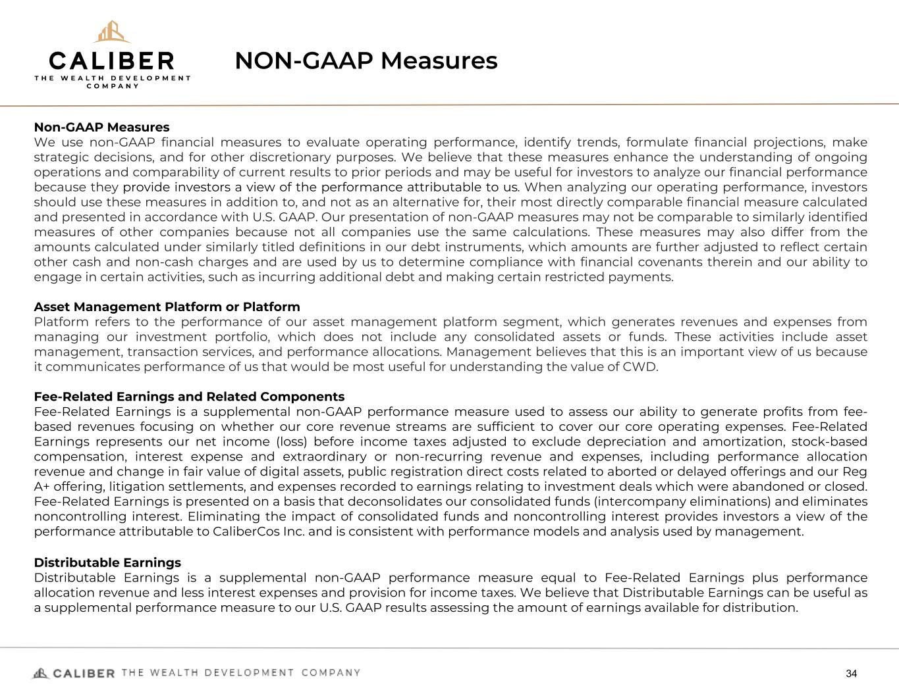
NON-GAAP Measures 34 Non-GAAP Measures We use non-GAAP financial measures to evaluate operating performance, identify trends, formulate financial projections, make strategic decisions, and for other discretionary purposes. We believe that these measures enhance the understanding of ongoing operations and comparability of current results to prior periods and may be useful for investors to analyze our financial performance because they provide investors a view of the performance attributable to us. When analyzing our operating performance, investors should use these measures in addition to, and not as an alternative for, their most directly comparable financial measure calculated and presented in accordance with U.S. GAAP. Our presentation of non-GAAP measures may not be comparable to similarly identified measures of other companies because not all companies use the same calculations. These measures may also differ from the amounts calculated under similarly titled definitions in our debt instruments, which amounts are further adjusted to reflect certain other cash and non-cash charges and are used by us to determine compliance with financial covenants therein and our ability to engage in certain activities, such as incurring additional debt and making certain restricted payments. Asset Management Platform or Platform Platform refers to the performance of our asset management platform segment, which generates revenues and expenses from managing our investment portfolio, which does not include any consolidated assets or funds. These activities include asset management, transaction services, and performance allocations. Management believes that this is an important view of us because it communicates performance of us that would be most useful for understanding the value of CWD. Fee-Related Earnings and Related Components Fee-Related Earnings is a supplemental non-GAAP performance measure used to assess our ability to generate profits from fee- based revenues focusing on whether our core revenue streams are sufficient to cover our core operating expenses. Fee-Related Earnings represents our net income (loss) before income taxes adjusted to exclude depreciation and amortization, stock-based compensation, interest expense and extraordinary or non-recurring revenue and expenses, including performance allocation revenue and change in fair value of digital assets, public registration direct costs related to aborted or delayed offerings and our Reg A+ offering, litigation settlements, and expenses recorded to earnings relating to investment deals which were abandoned or closed. Fee-Related Earnings is presented on a basis that deconsolidates our consolidated funds (intercompany eliminations) and eliminates noncontrolling interest. Eliminating the impact of consolidated funds and noncontrolling interest provides investors a view of the performance attributable to CaliberCos Inc. and is consistent with performance models and analysis used by management. Distributable Earnings Distributable Earnings is a supplemental non-GAAP performance measure equal to Fee-Related Earnings plus performance allocation revenue and less interest expenses and provision for income taxes. We believe that Distributable Earnings can be useful as a supplemental performance measure to our U.S. GAAP results assessing the amount of earnings available for distribution.

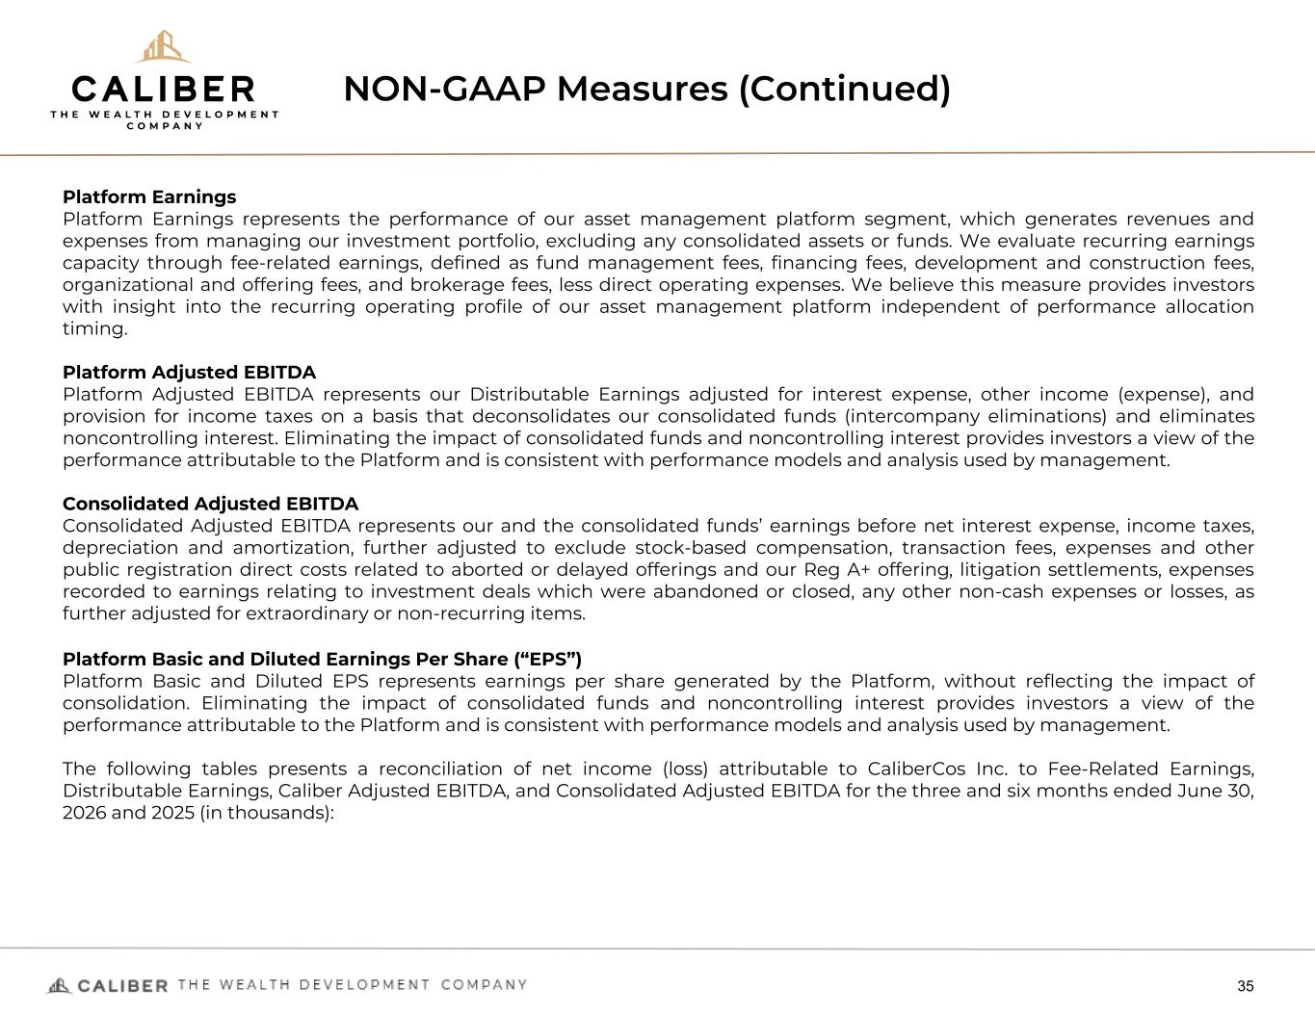
NON-GAAP Measures (Continued) 35 Platform Earnings Platform Earnings represents the performance of our asset management platform segment, which generates revenues and expenses from managing our investment portfolio, excluding any consolidated assets or funds. We evaluate recurring earnings capacity through fee-related earnings, defined as fund management fees, financing fees, development and construction fees, organizational and offering fees, and brokerage fees, less direct operating expenses. We believe this measure provides investors with insight into the recurring operating profile of our asset management platform independent of performance allocation timing. Platform Adjusted EBITDA Platform Adjusted EBITDA represents our Distributable Earnings adjusted for interest expense, other income (expense), and provision for income taxes on a basis that deconsolidates our consolidated funds (intercompany eliminations) and eliminates noncontrolling interest. Eliminating the impact of consolidated funds and noncontrolling interest provides investors a view of the performance attributable to the Platform and is consistent with performance models and analysis used by management. Consolidated Adjusted EBITDA Consolidated Adjusted EBITDA represents our and the consolidated funds’ earnings before net interest expense, income taxes, depreciation and amortization, further adjusted to exclude stock-based compensation, transaction fees, expenses and other public registration direct costs related to aborted or delayed offerings and our Reg A+ offering, litigation settlements, expenses recorded to earnings relating to investment deals which were abandoned or closed, any other non-cash expenses or losses, as further adjusted for extraordinary or non-recurring items. Platform Basic and Diluted Earnings Per Share (“EPS”) Platform Basic and Diluted EPS represents earnings per share generated by the Platform, without reflecting the impact of consolidation. Eliminating the impact of consolidated funds and noncontrolling interest provides investors a view of the performance attributable to the Platform and is consistent with performance models and analysis used by management. The following tables presents a reconciliation of net income (loss) attributable to CaliberCos Inc. to Fee-Related Earnings, Distributable Earnings, Caliber Adjusted EBITDA, and Consolidated Adjusted EBITDA for the three and six months ended June 30, 2026 and 2025 (in thousands):

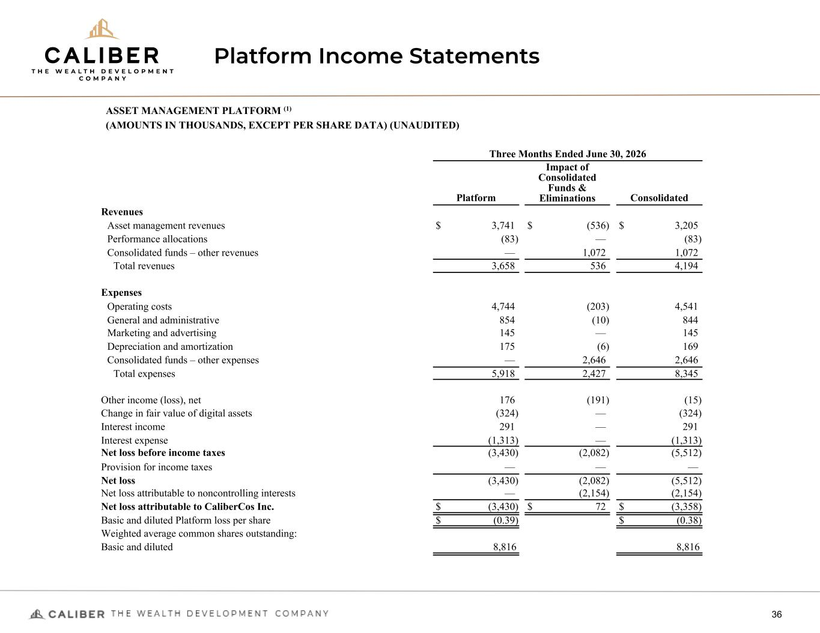
Platform Income Statements 36 ASSET MANAGEMENT PLATFORM (1) (AMOUNTS IN THOUSANDS, EXCEPT PER SHARE DATA) (UNAUDITED) Three Months Ended June 30, 2026 Platform Impact of Consolidated Funds & Eliminations Consolidated Revenues Asset management revenues $ 3,741 $ (536) $ 3,205 Performance allocations (83) — (83) Consolidated funds – other revenues — 1,072 1,072 Total revenues 3,658 536 4,194 Expenses Operating costs 4,744 (203) 4,541 General and administrative 854 (10) 844 Marketing and advertising 145 — 145 Depreciation and amortization 175 (6) 169 Consolidated funds – other expenses — 2,646 2,646 Total expenses 5,918 2,427 8,345 Other income (loss), net 176 (191) (15) Change in fair value of digital assets (324) — (324) Interest income 291 — 291 Interest expense (1,313) — (1,313) Net loss before income taxes (3,430) (2,082) (5,512) Provision for income taxes — — — Net loss (3,430) (2,082) (5,512) Net loss attributable to noncontrolling interests — (2,154) (2,154) Net loss attributable to CaliberCos Inc. $ (3,430) $ 72 $ (3,358) Basic and diluted Platform loss per share $ (0.39) $ (0.38) Weighted average common shares outstanding: Basic and diluted 8,816 8,816

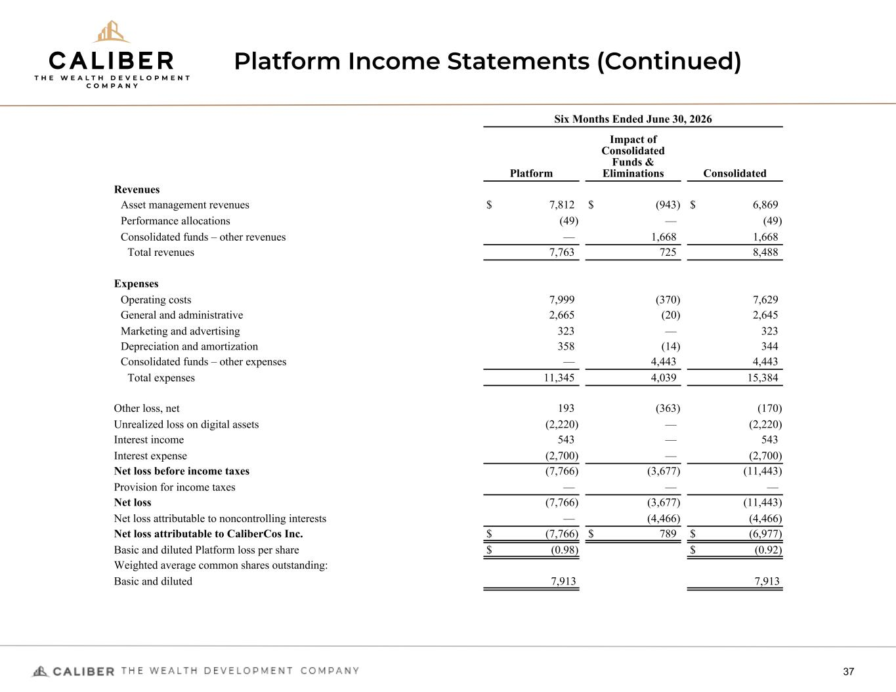
Platform Income Statements (Continued) 37 Six Months Ended June 30, 2026 Platform Impact of Consolidated Funds & Eliminations Consolidated Revenues Asset management revenues $ 7,812 $ (943) $ 6,869 Performance allocations (49) — (49) Consolidated funds – other revenues — 1,668 1,668 Total revenues 7,763 725 8,488 Expenses Operating costs 7,999 (370) 7,629 General and administrative 2,665 (20) 2,645 Marketing and advertising 323 — 323 Depreciation and amortization 358 (14) 344 Consolidated funds – other expenses — 4,443 4,443 Total expenses 11,345 4,039 15,384 Other loss, net 193 (363) (170) Unrealized loss on digital assets (2,220) — (2,220) Interest income 543 — 543 Interest expense (2,700) — (2,700) Net loss before income taxes (7,766) (3,677) (11,443) Provision for income taxes — — — Net loss (7,766) (3,677) (11,443) Net loss attributable to noncontrolling interests — (4,466) (4,466) Net loss attributable to CaliberCos Inc. $ (7,766) $ 789 $ (6,977) Basic and diluted Platform loss per share $ (0.98) $ (0.92) Weighted average common shares outstanding: Basic and diluted 7,913 7,913

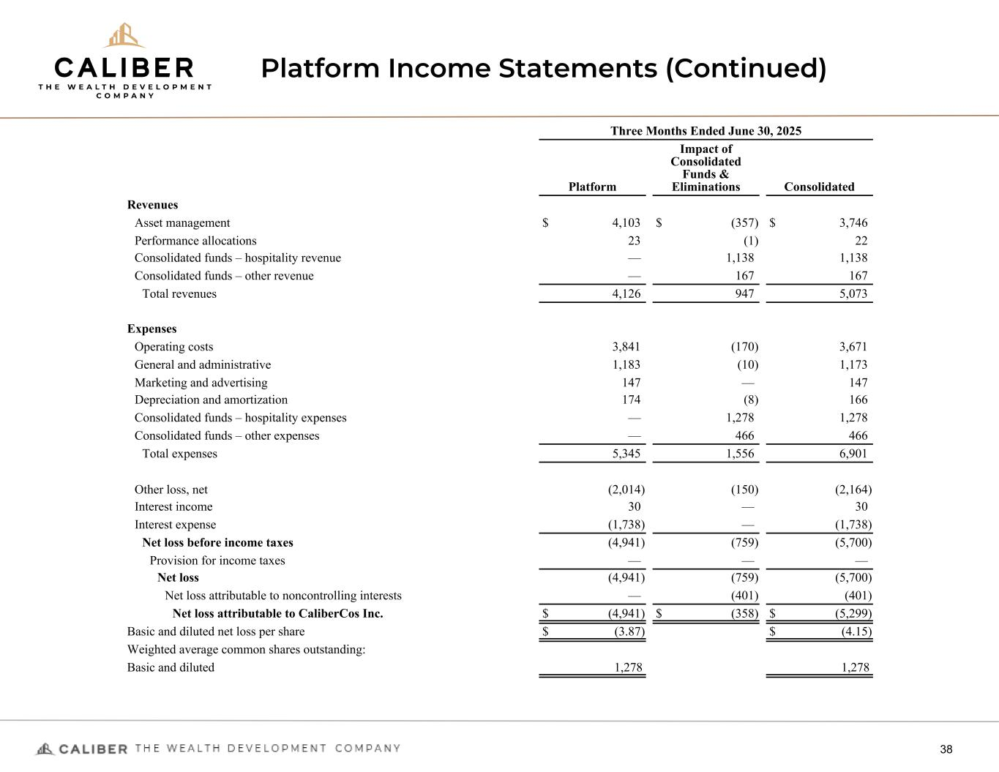
Platform Income Statements (Continued) 38 Three Months Ended June 30, 2025 Platform Impact of Consolidated Funds & Eliminations Consolidated Revenues Asset management $ 4,103 $ (357) $ 3,746 Performance allocations 23 (1) 22 Consolidated funds – hospitality revenue — 1,138 1,138 Consolidated funds – other revenue — 167 167 Total revenues 4,126 947 5,073 Expenses Operating costs 3,841 (170) 3,671 General and administrative 1,183 (10) 1,173 Marketing and advertising 147 — 147 Depreciation and amortization 174 (8) 166 Consolidated funds – hospitality expenses — 1,278 1,278 Consolidated funds – other expenses — 466 466 Total expenses 5,345 1,556 6,901 Other loss, net (2,014) (150) (2,164) Interest income 30 — 30 Interest expense (1,738) — (1,738) Net loss before income taxes (4,941) (759) (5,700) Provision for income taxes — — — Net loss (4,941) (759) (5,700) Net loss attributable to noncontrolling interests — (401) (401) Net loss attributable to CaliberCos Inc. $ (4,941) $ (358) $ (5,299) Basic and diluted net loss per share $ (3.87) $ (4.15) Weighted average common shares outstanding: Basic and diluted 1,278 1,278

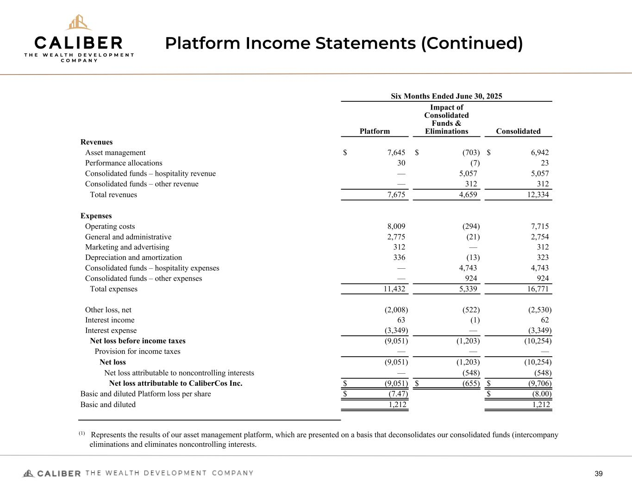
Platform Income Statements (Continued) 39 Six Months Ended June 30, 2025 Platform Impact of Consolidated Funds & Eliminations Consolidated Revenues Asset management $ 7,645 $ (703) $ 6,942 Performance allocations 30 (7) 23 Consolidated funds – hospitality revenue — 5,057 5,057 Consolidated funds – other revenue — 312 312 Total revenues 7,675 4,659 12,334 Expenses Operating costs 8,009 (294) 7,715 General and administrative 2,775 (21) 2,754 Marketing and advertising 312 — 312 Depreciation and amortization 336 (13) 323 Consolidated funds – hospitality expenses — 4,743 4,743 Consolidated funds – other expenses — 924 924 Total expenses 11,432 5,339 16,771 Other loss, net (2,008) (522) (2,530) Interest income 63 (1) 62 Interest expense (3,349) — (3,349) Net loss before income taxes (9,051) (1,203) (10,254) Provision for income taxes — — — Net loss (9,051) (1,203) (10,254) Net loss attributable to noncontrolling interests — (548) (548) Net loss attributable to CaliberCos Inc. $ (9,051) $ (655) $ (9,706) Basic and diluted Platform loss per share $ (7.47) $ (8.00) Basic and diluted 1,212 1,212 (1) Represents the results of our asset management platform, which are presented on a basis that deconsolidates our consolidated funds (intercompany eliminations and eliminates noncontrolling interests.

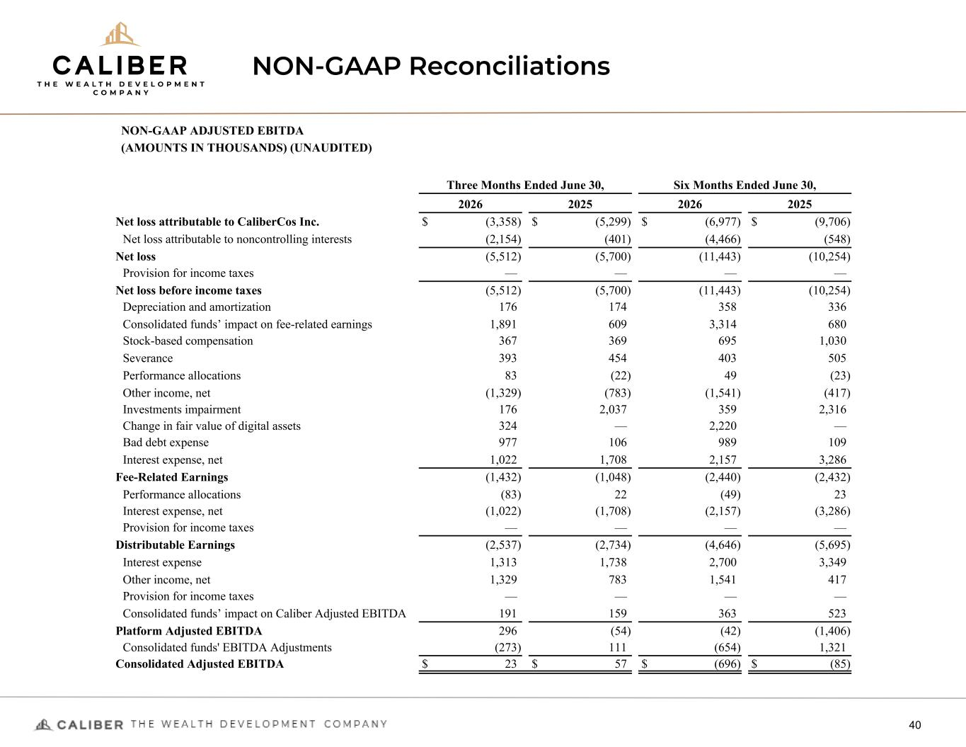
NON-GAAP Reconciliations 40 NON-GAAP ADJUSTED EBITDA (AMOUNTS IN THOUSANDS) (UNAUDITED) Three Months Ended June 30, Six Months Ended June 30, 2026 2025 2026 2025 Net loss attributable to CaliberCos Inc. $ (3,358) $ (5,299) $ (6,977) $ (9,706) Net loss attributable to noncontrolling interests (2,154) (401) (4,466) (548) Net loss (5,512) (5,700) (11,443) (10,254) Provision for income taxes — — — — Net loss before income taxes (5,512) (5,700) (11,443) (10,254) Depreciation and amortization 176 174 358 336 Consolidated funds’ impact on fee-related earnings 1,891 609 3,314 680 Stock-based compensation 367 369 695 1,030 Severance 393 454 403 505 Performance allocations 83 (22) 49 (23) Other income, net (1,329) (783) (1,541) (417) Investments impairment 176 2,037 359 2,316 Change in fair value of digital assets 324 — 2,220 — Bad debt expense 977 106 989 109 Interest expense, net 1,022 1,708 2,157 3,286 Fee-Related Earnings (1,432) (1,048) (2,440) (2,432) Performance allocations (83) 22 (49) 23 Interest expense, net (1,022) (1,708) (2,157) (3,286) Provision for income taxes — — — — Distributable Earnings (2,537) (2,734) (4,646) (5,695) Interest expense 1,313 1,738 2,700 3,349 Other income, net 1,329 783 1,541 417 Provision for income taxes — — — — Consolidated funds’ impact on Caliber Adjusted EBITDA 191 159 363 523 Platform Adjusted EBITDA 296 (54) (42) (1,406) Consolidated funds' EBITDA Adjustments (273) 111 (654) 1,321 Consolidated Adjusted EBITDA $ 23 $ 57 $ (696) $ (85)

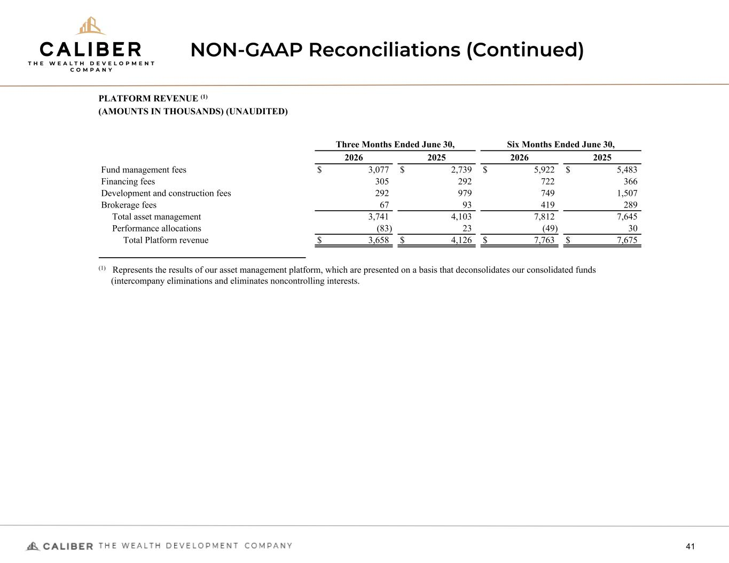
NON-GAAP Reconciliations (Continued) 41 PLATFORM REVENUE (1) (AMOUNTS IN THOUSANDS) (UNAUDITED) Three Months Ended June 30, Six Months Ended June 30, 2026 2025 2026 2025 Fund management fees $ 3,077 $ 2,739 $ 5,922 $ 5,483 Financing fees 305 292 722 366 Development and construction fees 292 979 749 1,507 Brokerage fees 67 93 419 289 Total asset management 3,741 4,103 7,812 7,645 Performance allocations (83) 23 (49) 30 Total Platform revenue $ 3,658 $ 4,126 $ 7,763 $ 7,675 (1) Represents the results of our asset management platform, which are presented on a basis that deconsolidates our consolidated funds (intercompany eliminations and eliminates noncontrolling interests.

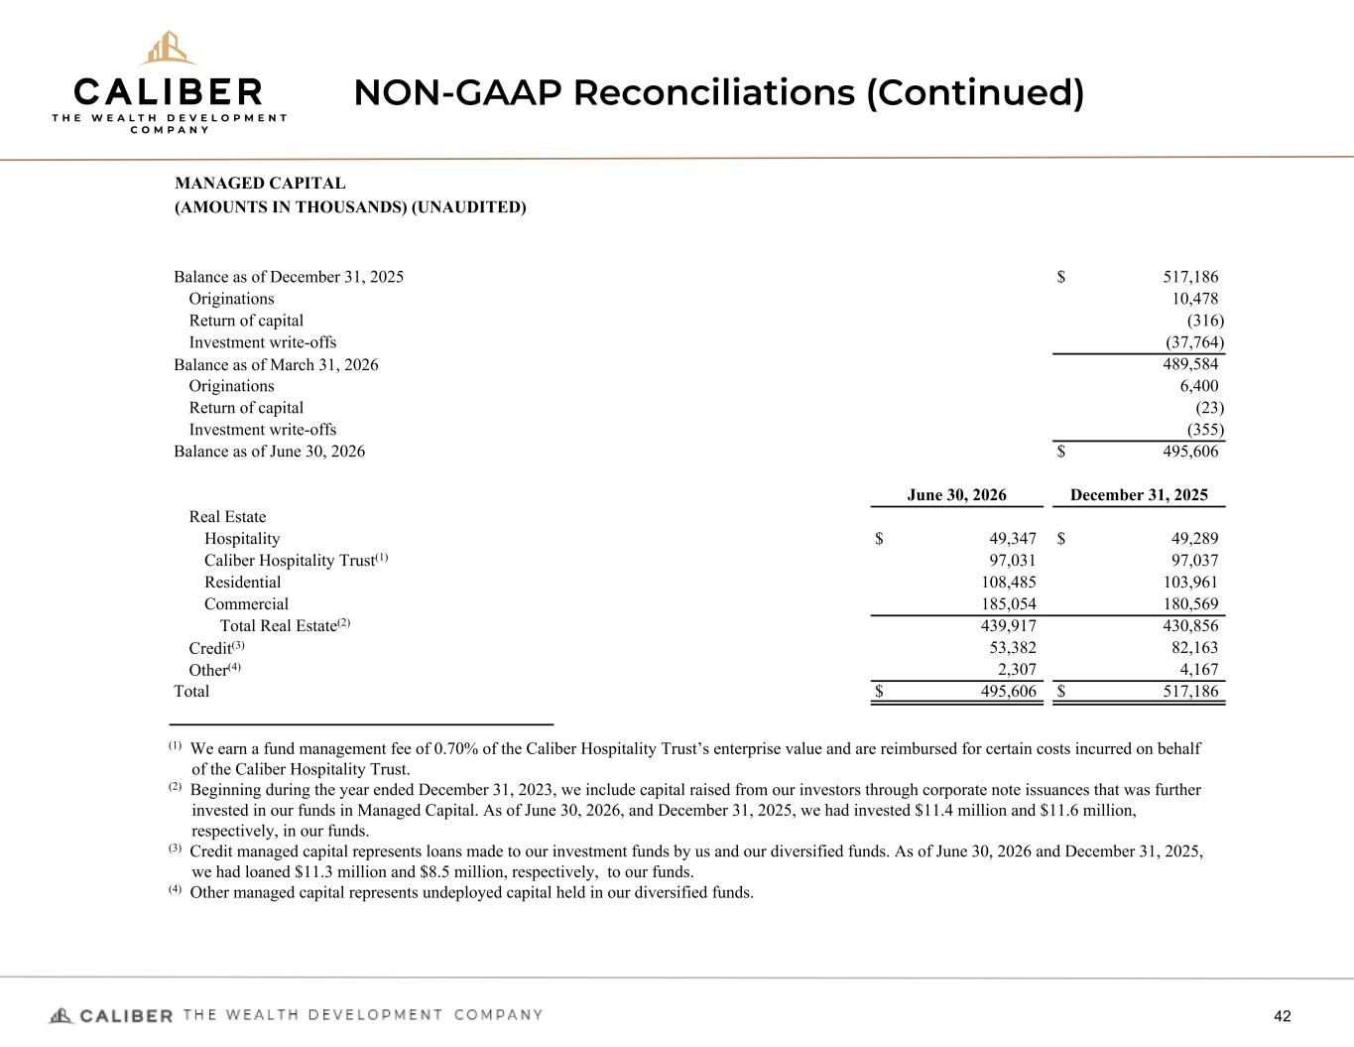
NON-GAAP Reconciliations (Continued) 42 MANAGED CAPITAL (AMOUNTS IN THOUSANDS) (UNAUDITED) Balance as of December 31, 2025 $ 517,186 Originations 10,478 Return of capital (316) Investment write-offs (37,764) Balance as of March 31, 2026 489,584 Originations 6,400 Return of capital (23) Investment write-offs (355) Balance as of June 30, 2026 $ 495,606 June 30, 2026 December 31, 2025 Real Estate Hospitality $ 49,347 $ 49,289 Caliber Hospitality Trust(1) 97,031 97,037 Residential 108,485 103,961 Commercial 185,054 180,569 Total Real Estate(2) 439,917 430,856 Credit(3) 53,382 82,163 Other(4) 2,307 4,167 Total $ 495,606 $ 517,186 (1) We earn a fund management fee of 0.70% of the Caliber Hospitality Trust’s enterprise value and are reimbursed for certain costs incurred on behalf of the Caliber Hospitality Trust. (2) Beginning during the year ended December 31, 2023, we include capital raised from our investors through corporate note issuances that was further invested in our funds in Managed Capital. As of June 30, 2026, and December 31, 2025, we had invested $11.4 million and $11.6 million, respectively, in our funds. (3) Credit managed capital represents loans made to our investment funds by us and our diversified funds. As of June 30, 2026 and December 31, 2025, we had loaned $11.3 million and $8.5 million, respectively, to our funds. (4) Other managed capital represents undeployed capital held in our diversified funds.

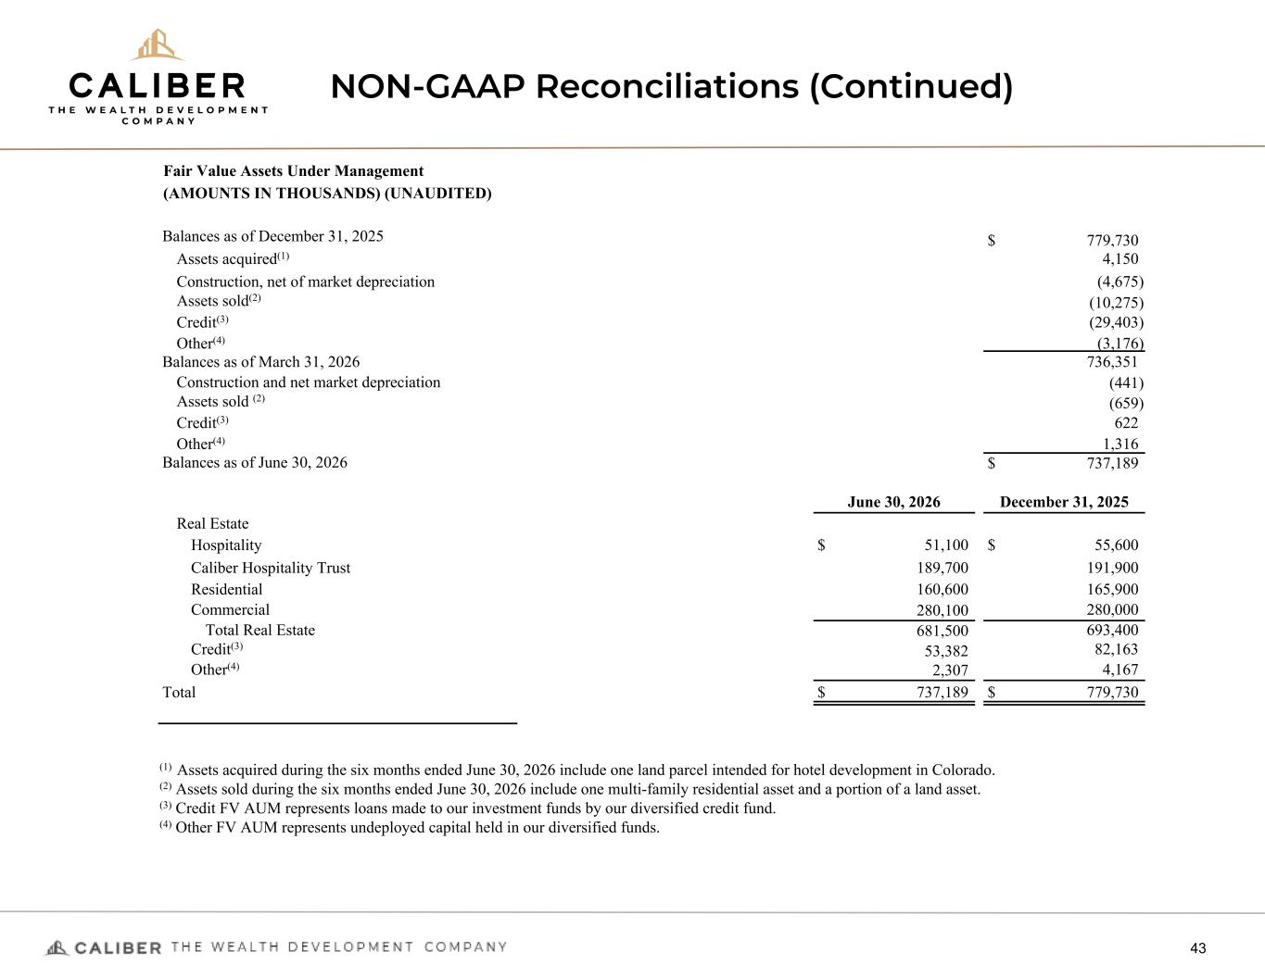
NON-GAAP Reconciliations (Continued) 43 Fair Value Assets Under Management (AMOUNTS IN THOUSANDS) (UNAUDITED) Balances as of December 31, 2025 $ 779,730 Assets acquired(1) 4,150 Construction, net of market depreciation (4,675) Assets sold(2) (10,275) Credit(3) (29,403) Other(4) (3,176) Balances as of March 31, 2026 736,351 Construction and net market depreciation (441) Assets sold (2) (659) Credit(3) 622 Other(4) 1,316 Balances as of June 30, 2026 $ 737,189 June 30, 2026 December 31, 2025 Real Estate Hospitality $ 51,100 $ 55,600 Caliber Hospitality Trust 189,700 191,900 Residential 160,600 165,900 Commercial 280,100 280,000 Total Real Estate 681,500 693,400 Credit(3) 53,382 82,163 Other(4) 2,307 4,167 Total $ 737,189 $ 779,730 (1) Assets acquired during the six months ended June 30, 2026 include one land parcel intended for hotel development in Colorado. (2) Assets sold during the six months ended June 30, 2026 include one multi-family residential asset and a portion of a land asset. (3) Credit FV AUM represents loans made to our investment funds by our diversified credit fund. (4) Other FV AUM represents undeployed capital held in our diversified funds.

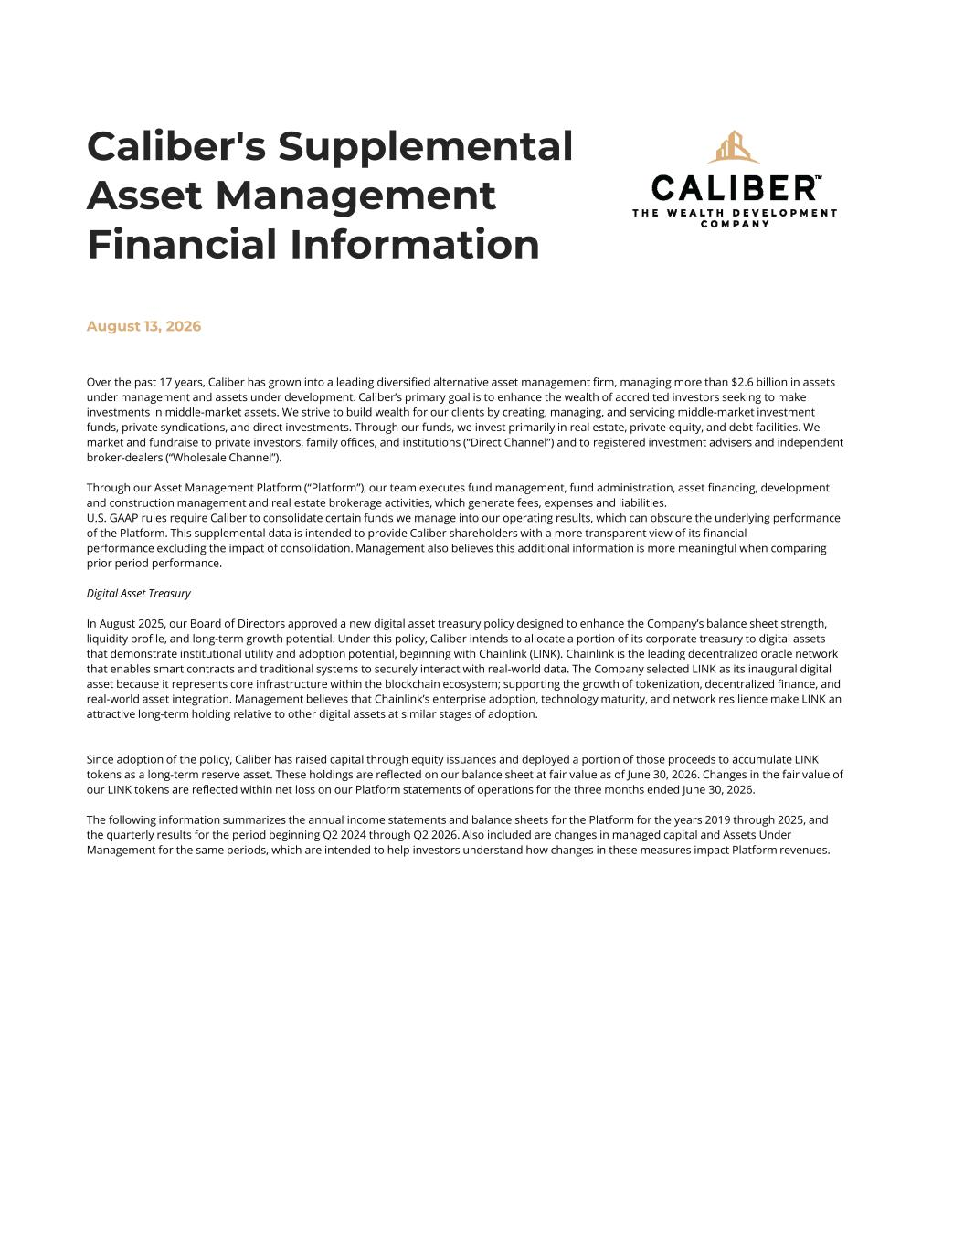
Over the past 17 years, Caliber has grown into a leading diversified alternative asset management firm, managing more than $2.6 billion in assets under management and assets under development. Caliber’s primary goal is to enhance the wealth of accredited investors seeking to make investments in middle-market assets. We strive to build wealth for our clients by creating, managing, and servicing middle-market investment funds, private syndications, and direct investments. Through our funds, we invest primarily in real estate, private equity, and debt facilities. We market and fundraise to private investors, family offices, and institutions (“Direct Channel”) and to registered investment advisers and independent broker-dealers (“Wholesale Channel”). Through our Asset Management Platform (“Platform”), our team executes fund management, fund administration, asset financing, development and construction management and real estate brokerage activities, which generate fees, expenses and liabilities. U.S. GAAP rules require Caliber to consolidate certain funds we manage into our operating results, which can obscure the underlying performance of the Platform. This supplemental data is intended to provide Caliber shareholders with a more transparent view of its financial performance excluding the impact of consolidation. Management also believes this additional information is more meaningful when comparing prior period performance. Digital Asset Treasury In August 2025, our Board of Directors approved a new digital asset treasury policy designed to enhance the Company’s balance sheet strength, liquidity profile, and long-term growth potential. Under this policy, Caliber intends to allocate a portion of its corporate treasury to digital assets that demonstrate institutional utility and adoption potential, beginning with Chainlink (LINK). Chainlink is the leading decentralized oracle network that enables smart contracts and traditional systems to securely interact with real-world data. The Company selected LINK as its inaugural digital asset because it represents core infrastructure within the blockchain ecosystem; supporting the growth of tokenization, decentralized finance, and real-world asset integration. Management believes that Chainlink’s enterprise adoption, technology maturity, and network resilience make LINK an attractive long-term holding relative to other digital assets at similar stages of adoption. Since adoption of the policy, Caliber has raised capital through equity issuances and deployed a portion of those proceeds to accumulate LINK tokens as a long-term reserve asset. These holdings are reflected on our balance sheet at fair value as of June 30, 2026. Changes in the fair value of our LINK tokens are reflected within net loss on our Platform statements of operations for the three months ended June 30, 2026. The following information summarizes the annual income statements and balance sheets for the Platform for the years 2019 through 2025, and the quarterly results for the period beginning Q2 2024 through Q2 2026. Also included are changes in managed capital and Assets Under Management for the same periods, which are intended to help investors understand how changes in these measures impact Platform revenues. Caliber's Supplemental Asset Management Financial Information August 13, 2026

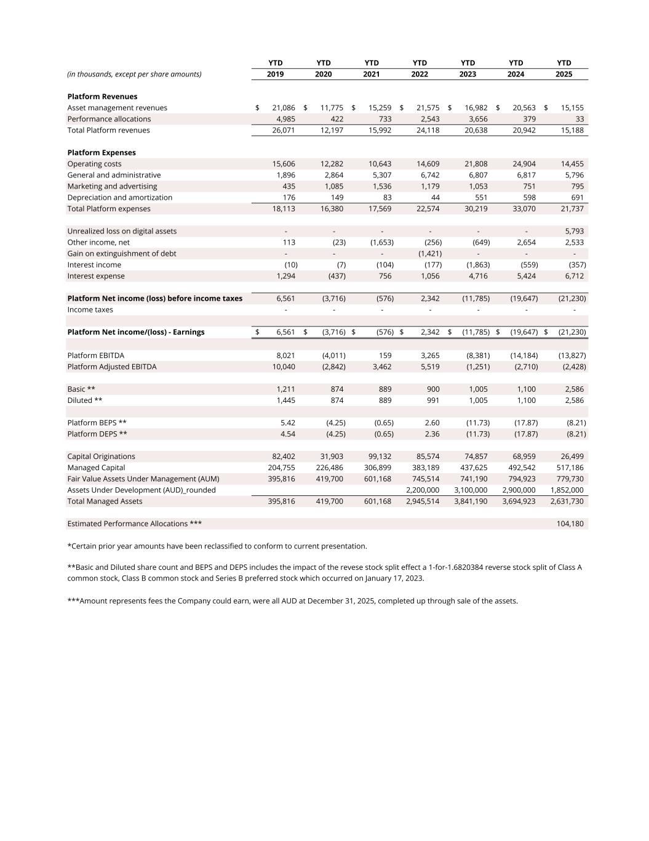
YTD YTD YTD YTD YTD YTD YTD (in thousands, except per share amounts) 2019 2020 2021 2022 2023 2024 2025 Platform Revenues Asset management revenues 21,086$ 11,775$ 15,259$ 21,575$ 16,982$ 20,563$ 15,155$ Performance allocations 4,985 422 733 2,543 3,656 379 33 Total Platform revenues 26,071 12,197 15,992 24,118 20,638 20,942 15,188 Platform Expenses Operating costs 15,606 12,282 10,643 14,609 21,808 24,904 14,455 General and administrative 1,896 2,864 5,307 6,742 6,807 6,817 5,796 Marketing and advertising 435 1,085 1,536 1,179 1,053 751 795 Depreciation and amortization 176 149 83 44 551 598 691 Total Platform expenses 18,113 16,380 17,569 22,574 30,219 33,070 21,737 Unrealized loss on digital assets - - - - - - 5,793 Other income, net 113 (23) (1,653) (256) (649) 2,654 2,533 Gain on extinguishment of debt - - - (1,421) - - - Interest income (10) (7) (104) (177) (1,863) (559) (357) Interest expense 1,294 (437) 756 1,056 4,716 5,424 6,712 Platform Net income (loss) before income taxes 6,561 (3,716) (576) 2,342 (11,785) (19,647) (21,230) Income taxes - - - - - - - Platform Net income/(loss) - Earnings 6,561$ (3,716)$ (576)$ 2,342$ (11,785)$ (19,647)$ (21,230)$ Platform EBITDA 8,021 (4,011) 159 3,265 (8,381) (14,184) (13,827) Platform Adjusted EBITDA 10,040 (2,842) 3,462 5,519 (1,251) (2,710) (2,428) Basic ** 1,211 874 889 900 1,005 1,100 2,586 Diluted ** 1,445 874 889 991 1,005 1,100 2,586 Platform BEPS ** 5.42 (4.25) (0.65) 2.60 (11.73) (17.87) (8.21) Platform DEPS ** 4.54 (4.25) (0.65) 2.36 (11.73) (17.87) (8.21) Capital Originations 82,402 31,903 99,132 85,574 74,857 68,959 26,499 Managed Capital 204,755 226,486 306,899 383,189 437,625 492,542 517,186 Fair Value Assets Under Management (AUM) 395,816 419,700 601,168 745,514 741,190 794,923 779,730 Assets Under Development (AUD)_rounded 2,200,000 3,100,000 2,900,000 1,852,000 Total Managed Assets 395,816 419,700 601,168 2,945,514 3,841,190 3,694,923 2,631,730 Estimated Performance Allocations *** 104,180 *Certain prior year amounts have been reclassified to conform to current presentation. ***Amount represents fees the Company could earn, were all AUD at December 31, 2025, completed up through sale of the assets. **Basic and Diluted share count and BEPS and DEPS includes the impact of the revese stock split effect a 1-for-1.6820384 reverse stock split of Class A common stock, Class B common stock and Series B preferred stock which occurred on January 17, 2023.

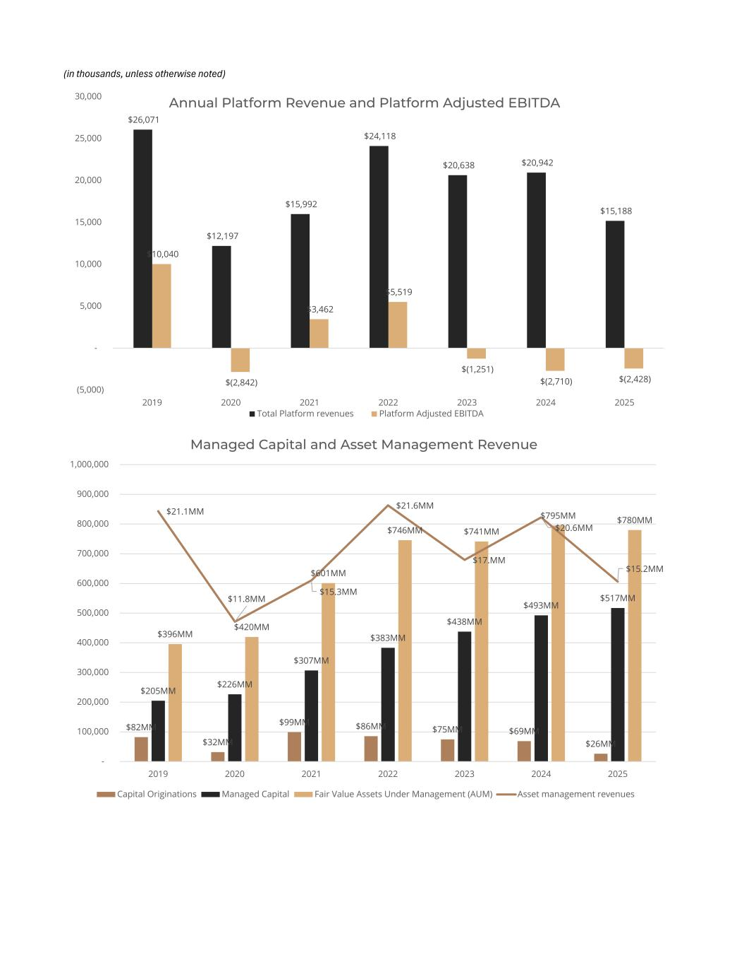
(in thousands, unless otherwise noted) $26,071 $12,197 $15,992 $24,118 $20,638 $20,942 $15,188 $10,040 $(2,842) $3,462 $5,519 $(1,251) $(2,710) $(2,428) (5,000) - 5,000 10,000 15,000 20,000 25,000 30,000 2019 2020 2021 2022 2023 2024 2025 Annual Platform Revenue and Platform Adjusted EBITDA Total Platform revenues Platform Adjusted EBITDA $82MM $32MM $99MM $86MM $75MM $69MM $26MM $205MM $226MM $307MM $383MM $438MM $493MM $517MM $396MM $420MM $601MM $746MM $741MM $795MM $780MM $21.1MM $11.8MM $15.3MM $21.6MM $17.MM $20.6MM $15.2MM - 100,000 200,000 300,000 400,000 500,000 600,000 700,000 800,000 900,000 1,000,000 2019 2020 2021 2022 2023 2024 2025 Managed Capital and Asset Management Revenue Capital Originations Managed Capital Fair Value Assets Under Management (AUM) Asset management revenues

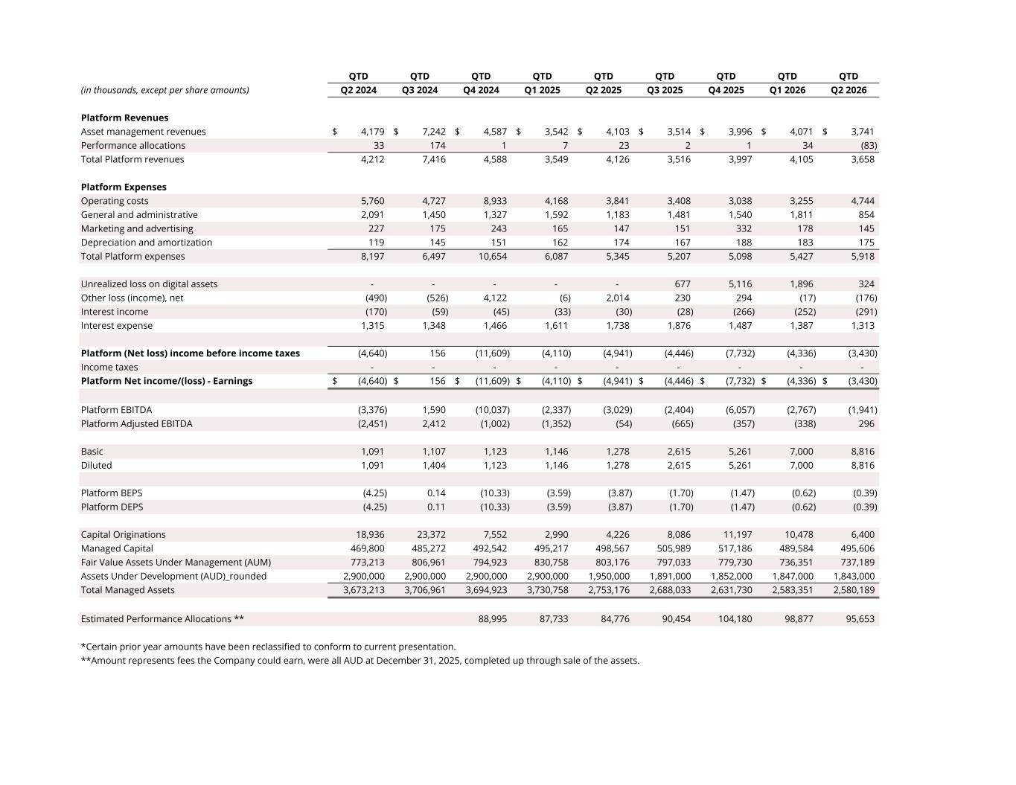
QTD QTD QTD QTD QTD QTD QTD QTD QTD (in thousands, except per share amounts) Q2 2024 Q3 2024 Q4 2024 Q1 2025 Q2 2025 Q3 2025 Q4 2025 Q1 2026 Q2 2026 Platform Revenues Asset management revenues 4,179$ 7,242$ 4,587$ 3,542$ 4,103$ 3,514$ 3,996$ 4,071$ 3,741$ Performance allocations 33 174 1 7 23 2 1 34 (83) Total Platform revenues 4,212 7,416 4,588 3,549 4,126 3,516 3,997 4,105 3,658 Platform Expenses Operating costs 5,760 4,727 8,933 4,168 3,841 3,408 3,038 3,255 4,744 General and administrative 2,091 1,450 1,327 1,592 1,183 1,481 1,540 1,811 854 Marketing and advertising 227 175 243 165 147 151 332 178 145 Depreciation and amortization 119 145 151 162 174 167 188 183 175 Total Platform expenses 8,197 6,497 10,654 6,087 5,345 5,207 5,098 5,427 5,918 Unrealized loss on digital assets - - - - - 677 5,116 1,896 324 Other loss (income), net (490) (526) 4,122 (6) 2,014 230 294 (17) (176) Interest income (170) (59) (45) (33) (30) (28) (266) (252) (291) Interest expense 1,315 1,348 1,466 1,611 1,738 1,876 1,487 1,387 1,313 Platform (Net loss) income before income taxes (4,640) 156 (11,609) (4,110) (4,941) (4,446) (7,732) (4,336) (3,430) Income taxes - - - - - - - - - Platform Net income/(loss) - Earnings (4,640)$ 156$ (11,609)$ (4,110)$ (4,941)$ (4,446)$ (7,732)$ (4,336)$ (3,430)$ Platform EBITDA (3,376) 1,590 (10,037) (2,337) (3,029) (2,404) (6,057) (2,767) (1,941) Platform Adjusted EBITDA (2,451) 2,412 (1,002) (1,352) (54) (665) (357) (338) 296 Basic 1,091 1,107 1,123 1,146 1,278 2,615 5,261 7,000 8,816 Diluted 1,091 1,404 1,123 1,146 1,278 2,615 5,261 7,000 8,816 Platform BEPS (4.25) 0.14 (10.33) (3.59) (3.87) (1.70) (1.47) (0.62) (0.39) Platform DEPS (4.25) 0.11 (10.33) (3.59) (3.87) (1.70) (1.47) (0.62) (0.39) Capital Originations 18,936 23,372 7,552 2,990 4,226 8,086 11,197 10,478 6,400 Managed Capital 469,800 485,272 492,542 495,217 498,567 505,989 517,186 489,584 495,606 Fair Value Assets Under Management (AUM) 773,213 806,961 794,923 830,758 803,176 797,033 779,730 736,351 737,189 Assets Under Development (AUD)_rounded 2,900,000 2,900,000 2,900,000 2,900,000 1,950,000 1,891,000 1,852,000 1,847,000 1,843,000 Total Managed Assets 3,673,213 3,706,961 3,694,923 3,730,758 2,753,176 2,688,033 2,631,730 2,583,351 2,580,189 Estimated Performance Allocations ** 88,995 87,733 84,776 90,454 104,180 98,877 95,653 *Certain prior year amounts have been reclassified to conform to current presentation. **Amount represents fees the Company could earn, were all AUD at December 31, 2025, completed up through sale of the assets.

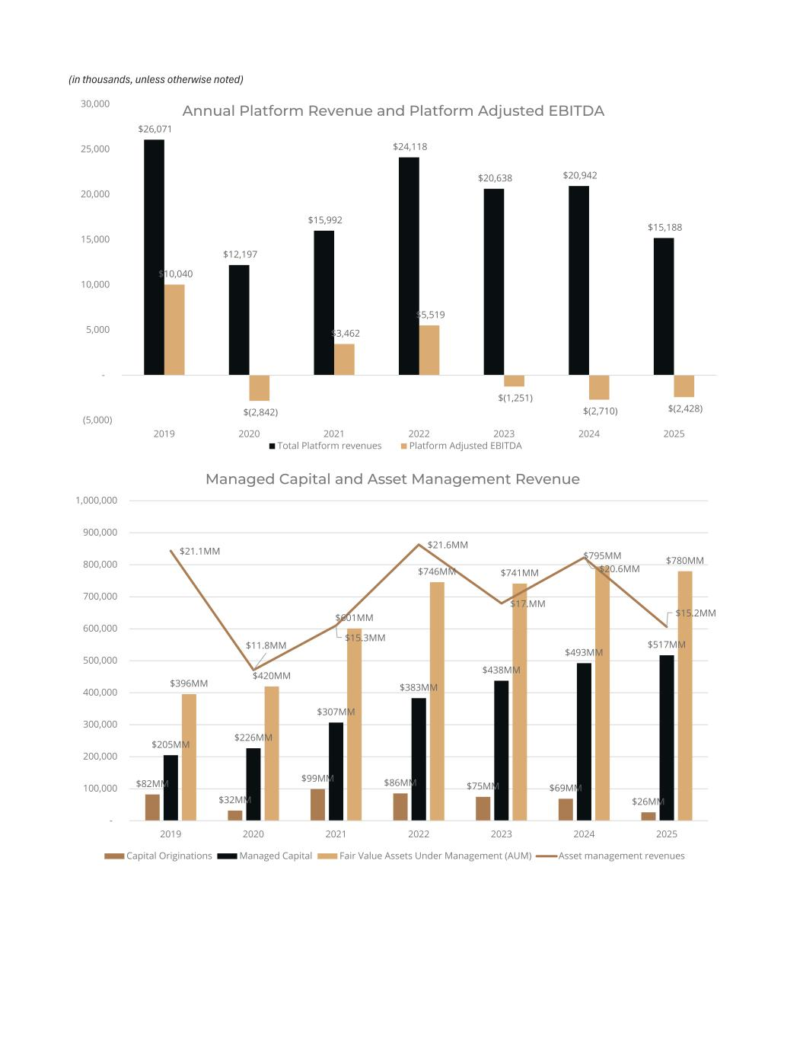
(in thousands, unless otherwise noted) $26,071 $12,197 $15,992 $24,118 $20,638 $20,942 $15,188 $10,040 $(2,842) $3,462 $5,519 $(1,251) $(2,710) $(2,428) (5,000) - 5,000 10,000 15,000 20,000 25,000 30,000 2019 2020 2021 2022 2023 2024 2025 Annual Platform Revenue and Platform Adjusted EBITDA Total Platform revenues Platform Adjusted EBITDA $82MM $32MM $99MM $86MM $75MM $69MM $26MM $205MM $226MM $307MM $383MM $438MM $493MM $517MM $396MM $420MM $601MM $746MM $741MM $795MM $780MM $21.1MM $11.8MM $15.3MM $21.6MM $17.MM $20.6MM $15.2MM - 100,000 200,000 300,000 400,000 500,000 600,000 700,000 800,000 900,000 1,000,000 2019 2020 2021 2022 2023 2024 2025 Managed Capital and Asset Management Revenue Capital Originations Managed Capital Fair Value Assets Under Management (AUM) Asset management revenues

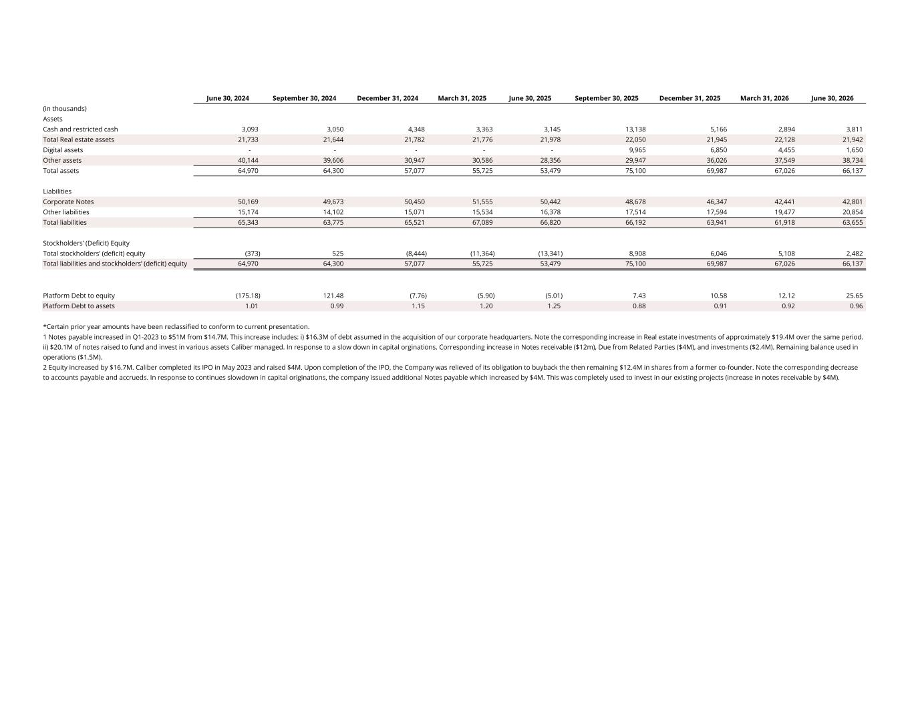
June 30, 2024 September 30, 2024 December 31, 2024 March 31, 2025 June 30, 2025 September 30, 2025 December 31, 2025 March 31, 2026 June 30, 2026 (in thousands) Assets Cash and restricted cash 3,093 3,050 4,348 3,363 3,145 13,138 5,166 2,894 3,811 Total Real estate assets 21,733 21,644 21,782 21,776 21,978 22,050 21,945 22,128 21,942 Digital assets - - - - - 9,965 6,850 4,455 1,650 Other assets 40,144 39,606 30,947 30,586 28,356 29,947 36,026 37,549 38,734 Total assets 64,970 64,300 57,077 55,725 53,479 75,100 69,987 67,026 66,137 Liabilities Corporate Notes 50,169 49,673 50,450 51,555 50,442 48,678 46,347 42,441 42,801 Other liabilities 15,174 14,102 15,071 15,534 16,378 17,514 17,594 19,477 20,854 Total liabilities 65,343 63,775 65,521 67,089 66,820 66,192 63,941 61,918 63,655 Stockholders’ (Deficit) Equity Total stockholders’ (deficit) equity (373) 525 (8,444) (11,364) (13,341) 8,908 6,046 5,108 2,482 Total liabilities and stockholders’ (deficit) equity 64,970 64,300 57,077 55,725 53,479 75,100 69,987 67,026 66,137 Platform Debt to equity (175.18) 121.48 (7.76) (5.90) (5.01) 7.43 10.58 12.12 25.65 Platform Debt to assets 1.01 0.99 1.15 1.20 1.25 0.88 0.91 0.92 0.96 *Certain prior year amounts have been reclassified to conform to current presentation. 1 Notes payable increased in Q1-2023 to $51M from $14.7M. This increase includes: i) $16.3M of debt assumed in the acquisition of our corporate headquarters. Note the corresponding increase in Real estate investments of approximately $19.4M over the same period. ii) $20.1M of notes raised to fund and invest in various assets Caliber managed. In response to a slow down in capital orginations. Corresponding increase in Notes receivable ($12m), Due from Related Parties ($4M), and investments ($2.4M). Remaining balance used in operations ($1.5M). 2 Equity increased by $16.7M. Caliber completed its IPO in May 2023 and raised $4M. Upon completion of the IPO, the Company was relieved of its obligation to buyback the then remaining $12.4M in shares from a former co-founder. Note the corresponding decrease to accounts payable and accrueds. In response to continues slowdown in capital originations, the company issued additional Notes payable which increased by $4M. This was completely used to invest in our existing projects (increase in notes receivable by $4M).

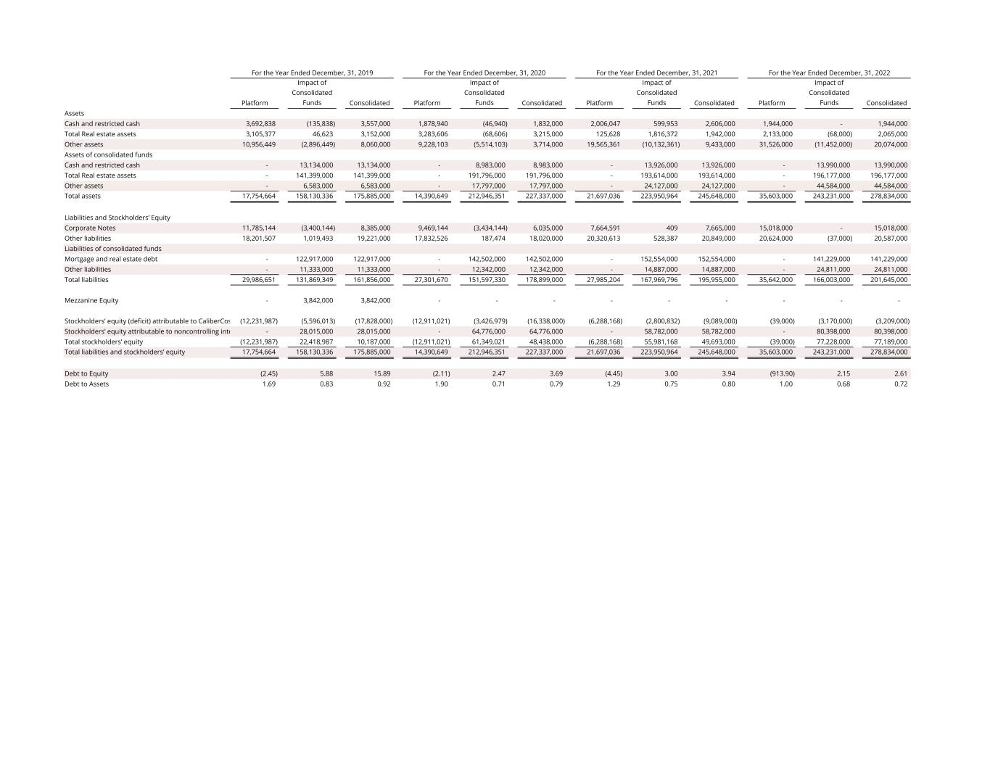
Platform Impact of Consolidated Funds Consolidated Platform Impact of Consolidated Funds Consolidated Platform Impact of Consolidated Funds Consolidated Platform Impact of Consolidated Funds Consolidated Assets Cash and restricted cash 3,692,838 (135,838) 3,557,000 1,878,940 (46,940) 1,832,000 2,006,047 599,953 2,606,000 1,944,000 - 1,944,000 Total Real estate assets 3,105,377 46,623 3,152,000 3,283,606 (68,606) 3,215,000 125,628 1,816,372 1,942,000 2,133,000 (68,000) 2,065,000 Other assets 10,956,449 (2,896,449) 8,060,000 9,228,103 (5,514,103) 3,714,000 19,565,361 (10,132,361) 9,433,000 31,526,000 (11,452,000) 20,074,000 Assets of consolidated funds Cash and restricted cash - 13,134,000 13,134,000 - 8,983,000 8,983,000 - 13,926,000 13,926,000 - 13,990,000 13,990,000 Total Real estate assets - 141,399,000 141,399,000 - 191,796,000 191,796,000 - 193,614,000 193,614,000 - 196,177,000 196,177,000 Other assets - 6,583,000 6,583,000 - 17,797,000 17,797,000 - 24,127,000 24,127,000 - 44,584,000 44,584,000 Total assets 17,754,664 158,130,336 175,885,000 14,390,649 212,946,351 227,337,000 21,697,036 223,950,964 245,648,000 35,603,000 243,231,000 278,834,000 Liabilities and Stockholders’ Equity Corporate Notes 11,785,144 (3,400,144) 8,385,000 9,469,144 (3,434,144) 6,035,000 7,664,591 409 7,665,000 15,018,000 - 15,018,000 Other liabilities 18,201,507 1,019,493 19,221,000 17,832,526 187,474 18,020,000 20,320,613 528,387 20,849,000 20,624,000 (37,000) 20,587,000 Liabilities of consolidated funds Mortgage and real estate debt - 122,917,000 122,917,000 - 142,502,000 142,502,000 - 152,554,000 152,554,000 - 141,229,000 141,229,000 Other liabilities - 11,333,000 11,333,000 - 12,342,000 12,342,000 - 14,887,000 14,887,000 - 24,811,000 24,811,000 Total liabilities 29,986,651 131,869,349 161,856,000 27,301,670 151,597,330 178,899,000 27,985,204 167,969,796 195,955,000 35,642,000 166,003,000 201,645,000 Mezzanine Equity - 3,842,000 3,842,000 - - - - - - - - - Stockholders’ equity (deficit) attributable to CaliberCos (12,231,987) (5,596,013) (17,828,000) (12,911,021) (3,426,979) (16,338,000) (6,288,168) (2,800,832) (9,089,000) (39,000) (3,170,000) (3,209,000) Stockholders’ equity attributable to noncontrolling inte - 28,015,000 28,015,000 - 64,776,000 64,776,000 - 58,782,000 58,782,000 - 80,398,000 80,398,000 Total stockholders’ equity (12,231,987) 22,418,987 10,187,000 (12,911,021) 61,349,021 48,438,000 (6,288,168) 55,981,168 49,693,000 (39,000) 77,228,000 77,189,000 Total liabilities and stockholders’ equity 17,754,664 158,130,336 175,885,000 14,390,649 212,946,351 227,337,000 21,697,036 223,950,964 245,648,000 35,603,000 243,231,000 278,834,000 Debt to Equity (2.45) 5.88 15.89 (2.11) 2.47 3.69 (4.45) 3.00 3.94 (913.90) 2.15 2.61 Debt to Assets 1.69 0.83 0.92 1.90 0.71 0.79 1.29 0.75 0.80 1.00 0.68 0.72 For the Year Ended December, 31, 2019 For the Year Ended December, 31, 2020 For the Year Ended December, 31, 2021 For the Year Ended December, 31, 2022

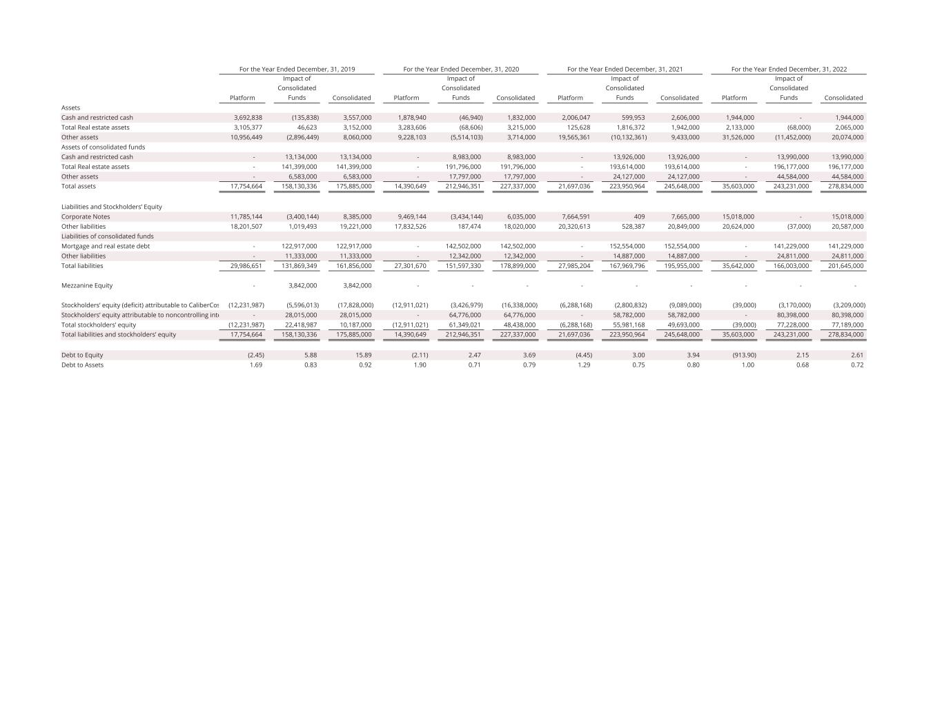
Platform Impact of Consolidated Funds Consolidated Platform Impact of Consolidated Funds Consolidated Platform Impact of Consolidated Funds Consolidated Platform Impact of Consolidated Funds Consolidated Assets Cash and restricted cash 3,692,838 (135,838) 3,557,000 1,878,940 (46,940) 1,832,000 2,006,047 599,953 2,606,000 1,944,000 - 1,944,000 Total Real estate assets 3,105,377 46,623 3,152,000 3,283,606 (68,606) 3,215,000 125,628 1,816,372 1,942,000 2,133,000 (68,000) 2,065,000 Other assets 10,956,449 (2,896,449) 8,060,000 9,228,103 (5,514,103) 3,714,000 19,565,361 (10,132,361) 9,433,000 31,526,000 (11,452,000) 20,074,000 Assets of consolidated funds Cash and restricted cash - 13,134,000 13,134,000 - 8,983,000 8,983,000 - 13,926,000 13,926,000 - 13,990,000 13,990,000 Total Real estate assets - 141,399,000 141,399,000 - 191,796,000 191,796,000 - 193,614,000 193,614,000 - 196,177,000 196,177,000 Other assets - 6,583,000 6,583,000 - 17,797,000 17,797,000 - 24,127,000 24,127,000 - 44,584,000 44,584,000 Total assets 17,754,664 158,130,336 175,885,000 14,390,649 212,946,351 227,337,000 21,697,036 223,950,964 245,648,000 35,603,000 243,231,000 278,834,000 Liabilities and Stockholders’ Equity Corporate Notes 11,785,144 (3,400,144) 8,385,000 9,469,144 (3,434,144) 6,035,000 7,664,591 409 7,665,000 15,018,000 - 15,018,000 Other liabilities 18,201,507 1,019,493 19,221,000 17,832,526 187,474 18,020,000 20,320,613 528,387 20,849,000 20,624,000 (37,000) 20,587,000 Liabilities of consolidated funds Mortgage and real estate debt - 122,917,000 122,917,000 - 142,502,000 142,502,000 - 152,554,000 152,554,000 - 141,229,000 141,229,000 Other liabilities - 11,333,000 11,333,000 - 12,342,000 12,342,000 - 14,887,000 14,887,000 - 24,811,000 24,811,000 Total liabilities 29,986,651 131,869,349 161,856,000 27,301,670 151,597,330 178,899,000 27,985,204 167,969,796 195,955,000 35,642,000 166,003,000 201,645,000 Mezzanine Equity - 3,842,000 3,842,000 - - - - - - - - - Stockholders’ equity (deficit) attributable to CaliberCos (12,231,987) (5,596,013) (17,828,000) (12,911,021) (3,426,979) (16,338,000) (6,288,168) (2,800,832) (9,089,000) (39,000) (3,170,000) (3,209,000) Stockholders’ equity attributable to noncontrolling inte - 28,015,000 28,015,000 - 64,776,000 64,776,000 - 58,782,000 58,782,000 - 80,398,000 80,398,000 Total stockholders’ equity (12,231,987) 22,418,987 10,187,000 (12,911,021) 61,349,021 48,438,000 (6,288,168) 55,981,168 49,693,000 (39,000) 77,228,000 77,189,000 Total liabilities and stockholders’ equity 17,754,664 158,130,336 175,885,000 14,390,649 212,946,351 227,337,000 21,697,036 223,950,964 245,648,000 35,603,000 243,231,000 278,834,000 Debt to Equity (2.45) 5.88 15.89 (2.11) 2.47 3.69 (4.45) 3.00 3.94 (913.90) 2.15 2.61 Debt to Assets 1.69 0.83 0.92 1.90 0.71 0.79 1.29 0.75 0.80 1.00 0.68 0.72 For the Year Ended December, 31, 2019 For the Year Ended December, 31, 2020 For the Year Ended December, 31, 2021 For the Year Ended December, 31, 2022

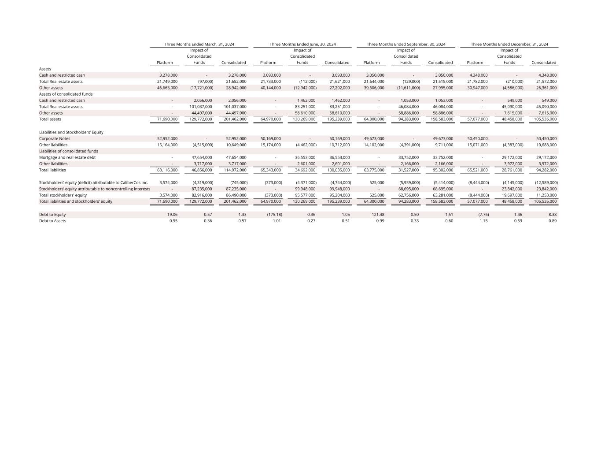
Platform Impact of Consolidated Funds Consolidated Platform Impact of Consolidated Funds Consolidated Platform Impact of Consolidated Funds Consolidated Platform Impact of Consolidated Funds Consolidated Assets Cash and restricted cash 3,278,000 - 3,278,000 3,093,000 - 3,093,000 3,050,000 - 3,050,000 4,348,000 - 4,348,000 Total Real estate assets 21,749,000 (97,000) 21,652,000 21,733,000 (112,000) 21,621,000 21,644,000 (129,000) 21,515,000 21,782,000 (210,000) 21,572,000 Other assets 46,663,000 (17,721,000) 28,942,000 40,144,000 (12,942,000) 27,202,000 39,606,000 (11,611,000) 27,995,000 30,947,000 (4,586,000) 26,361,000 Assets of consolidated funds Cash and restricted cash - 2,056,000 2,056,000 - 1,462,000 1,462,000 - 1,053,000 1,053,000 - 549,000 549,000 Total Real estate assets - 101,037,000 101,037,000 - 83,251,000 83,251,000 - 46,084,000 46,084,000 - 45,090,000 45,090,000 Other assets - 44,497,000 44,497,000 - 58,610,000 58,610,000 - 58,886,000 58,886,000 - 7,615,000 7,615,000 Total assets 71,690,000 129,772,000 201,462,000 64,970,000 130,269,000 195,239,000 64,300,000 94,283,000 158,583,000 57,077,000 48,458,000 105,535,000 Liabilities and Stockholders’ Equity Corporate Notes 52,952,000 - 52,952,000 50,169,000 - 50,169,000 49,673,000 - 49,673,000 50,450,000 - 50,450,000 Other liabilities 15,164,000 (4,515,000) 10,649,000 15,174,000 (4,462,000) 10,712,000 14,102,000 (4,391,000) 9,711,000 15,071,000 (4,383,000) 10,688,000 Liabilities of consolidated funds Mortgage and real estate debt - 47,654,000 47,654,000 - 36,553,000 36,553,000 - 33,752,000 33,752,000 - 29,172,000 29,172,000 Other liabilities - 3,717,000 3,717,000 - 2,601,000 2,601,000 - 2,166,000 2,166,000 - 3,972,000 3,972,000 Total liabilities 68,116,000 46,856,000 114,972,000 65,343,000 34,692,000 100,035,000 63,775,000 31,527,000 95,302,000 65,521,000 28,761,000 94,282,000 Stockholders’ equity (deficit) attributable to CaliberCos Inc. 3,574,000 (4,319,000) (745,000) (373,000) (4,371,000) (4,744,000) 525,000 (5,939,000) (5,414,000) (8,444,000) (4,145,000) (12,589,000) Stockholders’ equity attributable to noncontrolling interests - 87,235,000 87,235,000 - 99,948,000 99,948,000 - 68,695,000 68,695,000 - 23,842,000 23,842,000 Total stockholders’ equity 3,574,000 82,916,000 86,490,000 (373,000) 95,577,000 95,204,000 525,000 62,756,000 63,281,000 (8,444,000) 19,697,000 11,253,000 Total liabilities and stockholders’ equity 71,690,000 129,772,000 201,462,000 64,970,000 130,269,000 195,239,000 64,300,000 94,283,000 158,583,000 57,077,000 48,458,000 105,535,000 Debt to Equity 19.06 0.57 1.33 (175.18) 0.36 1.05 121.48 0.50 1.51 (7.76) 1.46 8.38 Debt to Assets 0.95 0.36 0.57 1.01 0.27 0.51 0.99 0.33 0.60 1.15 0.59 0.89 Three Months Ended March, 31, 2024 Three Months Ended June, 30, 2024 Three Months Ended December, 31, 2024Three Months Ended September, 30, 2024

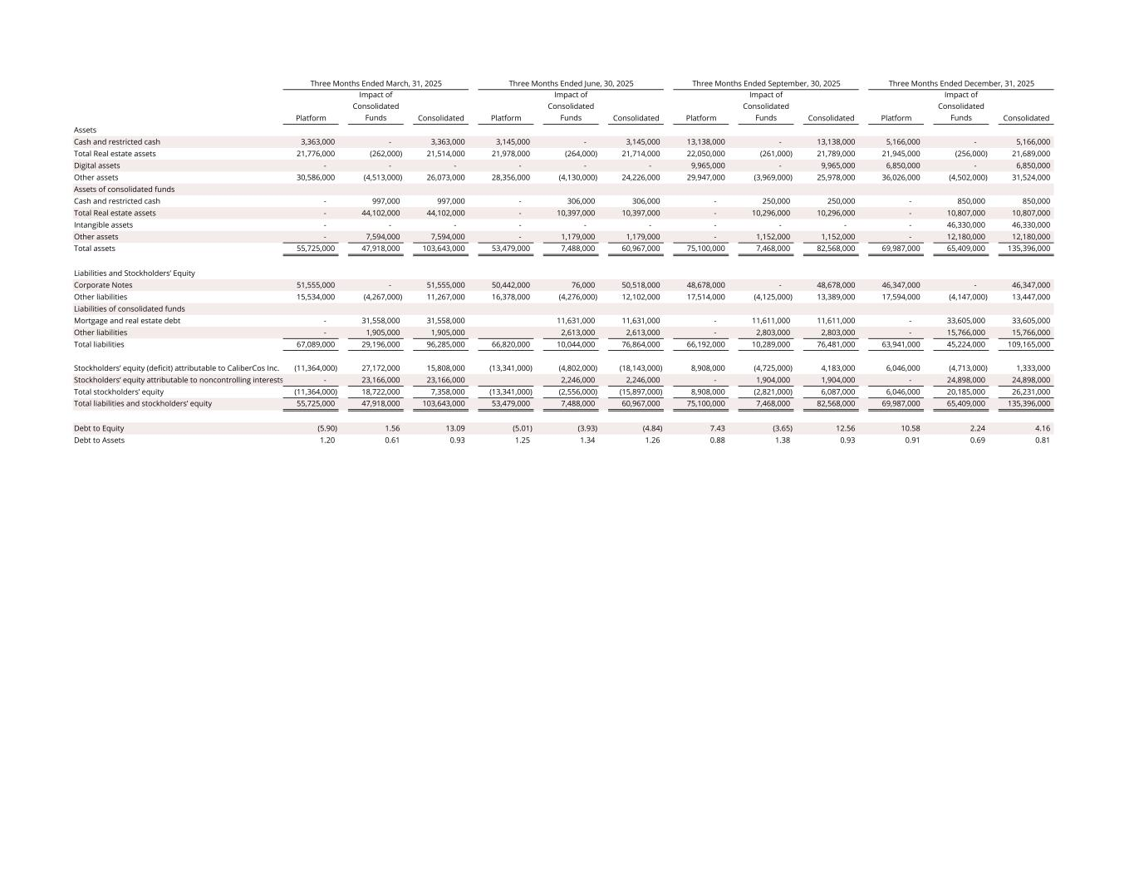
Platform Impact of Consolidated Funds Consolidated Platform Impact of Consolidated Funds Consolidated Platform Impact of Consolidated Funds Consolidated Platform Impact of Consolidated Funds Consolidated Assets Cash and restricted cash 3,363,000 - 3,363,000 3,145,000 - 3,145,000 13,138,000 - 13,138,000 5,166,000 - 5,166,000 Total Real estate assets 21,776,000 (262,000) 21,514,000 21,978,000 (264,000) 21,714,000 22,050,000 (261,000) 21,789,000 21,945,000 (256,000) 21,689,000 Digital assets - - - - - - 9,965,000 - 9,965,000 6,850,000 - 6,850,000 Other assets 30,586,000 (4,513,000) 26,073,000 28,356,000 (4,130,000) 24,226,000 29,947,000 (3,969,000) 25,978,000 36,026,000 (4,502,000) 31,524,000 Assets of consolidated funds Cash and restricted cash - 997,000 997,000 - 306,000 306,000 - 250,000 250,000 - 850,000 850,000 Total Real estate assets - 44,102,000 44,102,000 - 10,397,000 10,397,000 - 10,296,000 10,296,000 - 10,807,000 10,807,000 Intangible assets - - - - - - - - - - 46,330,000 46,330,000 Other assets - 7,594,000 7,594,000 - 1,179,000 1,179,000 - 1,152,000 1,152,000 - 12,180,000 12,180,000 Total assets 55,725,000 47,918,000 103,643,000 53,479,000 7,488,000 60,967,000 75,100,000 7,468,000 82,568,000 69,987,000 65,409,000 135,396,000 Liabilities and Stockholders’ Equity Corporate Notes 51,555,000 - 51,555,000 50,442,000 76,000 50,518,000 48,678,000 - 48,678,000 46,347,000 - 46,347,000 Other liabilities 15,534,000 (4,267,000) 11,267,000 16,378,000 (4,276,000) 12,102,000 17,514,000 (4,125,000) 13,389,000 17,594,000 (4,147,000) 13,447,000 Liabilities of consolidated funds Mortgage and real estate debt - 31,558,000 31,558,000 11,631,000 11,631,000 - 11,611,000 11,611,000 - 33,605,000 33,605,000 Other liabilities - 1,905,000 1,905,000 2,613,000 2,613,000 - 2,803,000 2,803,000 - 15,766,000 15,766,000 Total liabilities 67,089,000 29,196,000 96,285,000 66,820,000 10,044,000 76,864,000 66,192,000 10,289,000 76,481,000 63,941,000 45,224,000 109,165,000 Stockholders’ equity (deficit) attributable to CaliberCos Inc. (11,364,000) 27,172,000 15,808,000 (13,341,000) (4,802,000) (18,143,000) 8,908,000 (4,725,000) 4,183,000 6,046,000 (4,713,000) 1,333,000 Stockholders’ equity attributable to noncontrolling interests - 23,166,000 23,166,000 2,246,000 2,246,000 - 1,904,000 1,904,000 - 24,898,000 24,898,000 Total stockholders’ equity (11,364,000) 18,722,000 7,358,000 (13,341,000) (2,556,000) (15,897,000) 8,908,000 (2,821,000) 6,087,000 6,046,000 20,185,000 26,231,000 Total liabilities and stockholders’ equity 55,725,000 47,918,000 103,643,000 53,479,000 7,488,000 60,967,000 75,100,000 7,468,000 82,568,000 69,987,000 65,409,000 135,396,000 Debt to Equity (5.90) 1.56 13.09 (5.01) (3.93) (4.84) 7.43 (3.65) 12.56 10.58 2.24 4.16 Debt to Assets 1.20 0.61 0.93 1.25 1.34 1.26 0.88 1.38 0.93 0.91 0.69 0.81 Three Months Ended March, 31, 2025 Three Months Ended June, 30, 2025 Three Months Ended September, 30, 2025 Three Months Ended December, 31, 2025

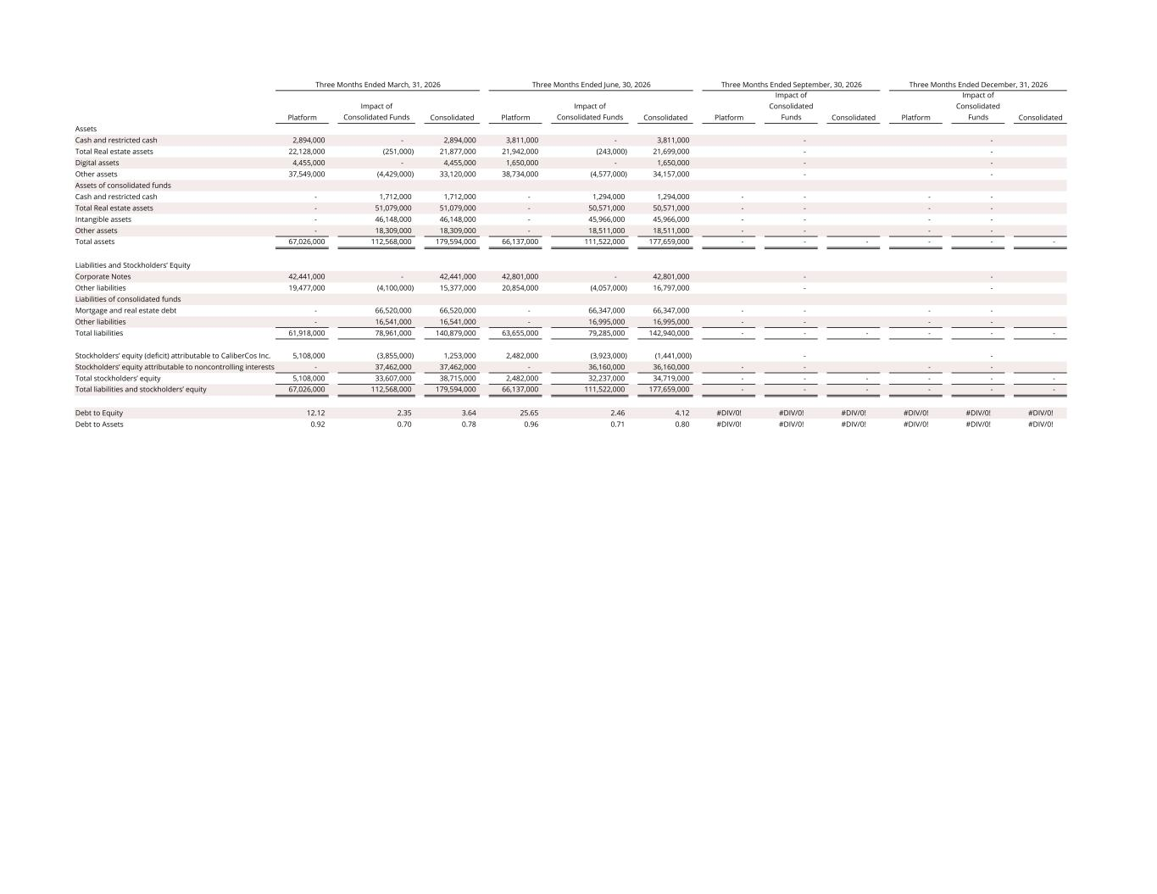
Platform Impact of Consolidated Funds Consolidated Platform Impact of Consolidated Funds Consolidated Platform Impact of Consolidated Funds Consolidated Platform Impact of Consolidated Funds Consolidated Assets Cash and restricted cash 2,894,000 - 2,894,000 3,811,000 - 3,811,000 - - Total Real estate assets 22,128,000 (251,000) 21,877,000 21,942,000 (243,000) 21,699,000 - - Digital assets 4,455,000 - 4,455,000 1,650,000 - 1,650,000 - - Other assets 37,549,000 (4,429,000) 33,120,000 38,734,000 (4,577,000) 34,157,000 - - Assets of consolidated funds Cash and restricted cash - 1,712,000 1,712,000 - 1,294,000 1,294,000 - - - - Total Real estate assets - 51,079,000 51,079,000 - 50,571,000 50,571,000 - - - - Intangible assets - 46,148,000 46,148,000 - 45,966,000 45,966,000 - - - - Other assets - 18,309,000 18,309,000 - 18,511,000 18,511,000 - - - - Total assets 67,026,000 112,568,000 179,594,000 66,137,000 111,522,000 177,659,000 - - - - - - Liabilities and Stockholders’ Equity Corporate Notes 42,441,000 - 42,441,000 42,801,000 - 42,801,000 - - Other liabilities 19,477,000 (4,100,000) 15,377,000 20,854,000 (4,057,000) 16,797,000 - - Liabilities of consolidated funds Mortgage and real estate debt - 66,520,000 66,520,000 - 66,347,000 66,347,000 - - - - Other liabilities - 16,541,000 16,541,000 - 16,995,000 16,995,000 - - - - Total liabilities 61,918,000 78,961,000 140,879,000 63,655,000 79,285,000 142,940,000 - - - - - - Stockholders’ equity (deficit) attributable to CaliberCos Inc. 5,108,000 (3,855,000) 1,253,000 2,482,000 (3,923,000) (1,441,000) - - Stockholders’ equity attributable to noncontrolling interests - 37,462,000 37,462,000 - 36,160,000 36,160,000 - - - - Total stockholders’ equity 5,108,000 33,607,000 38,715,000 2,482,000 32,237,000 34,719,000 - - - - - - Total liabilities and stockholders’ equity 67,026,000 112,568,000 179,594,000 66,137,000 111,522,000 177,659,000 - - - - - - Debt to Equity 12.12 2.35 3.64 25.65 2.46 4.12 #DIV/0! #DIV/0! #DIV/0! #DIV/0! #DIV/0! #DIV/0! Debt to Assets 0.92 0.70 0.78 0.96 0.71 0.80 #DIV/0! #DIV/0! #DIV/0! #DIV/0! #DIV/0! #DIV/0! Three Months Ended March, 31, 2026 Three Months Ended June, 30, 2026 Three Months Ended September, 30, 2026 Three Months Ended December, 31, 2026

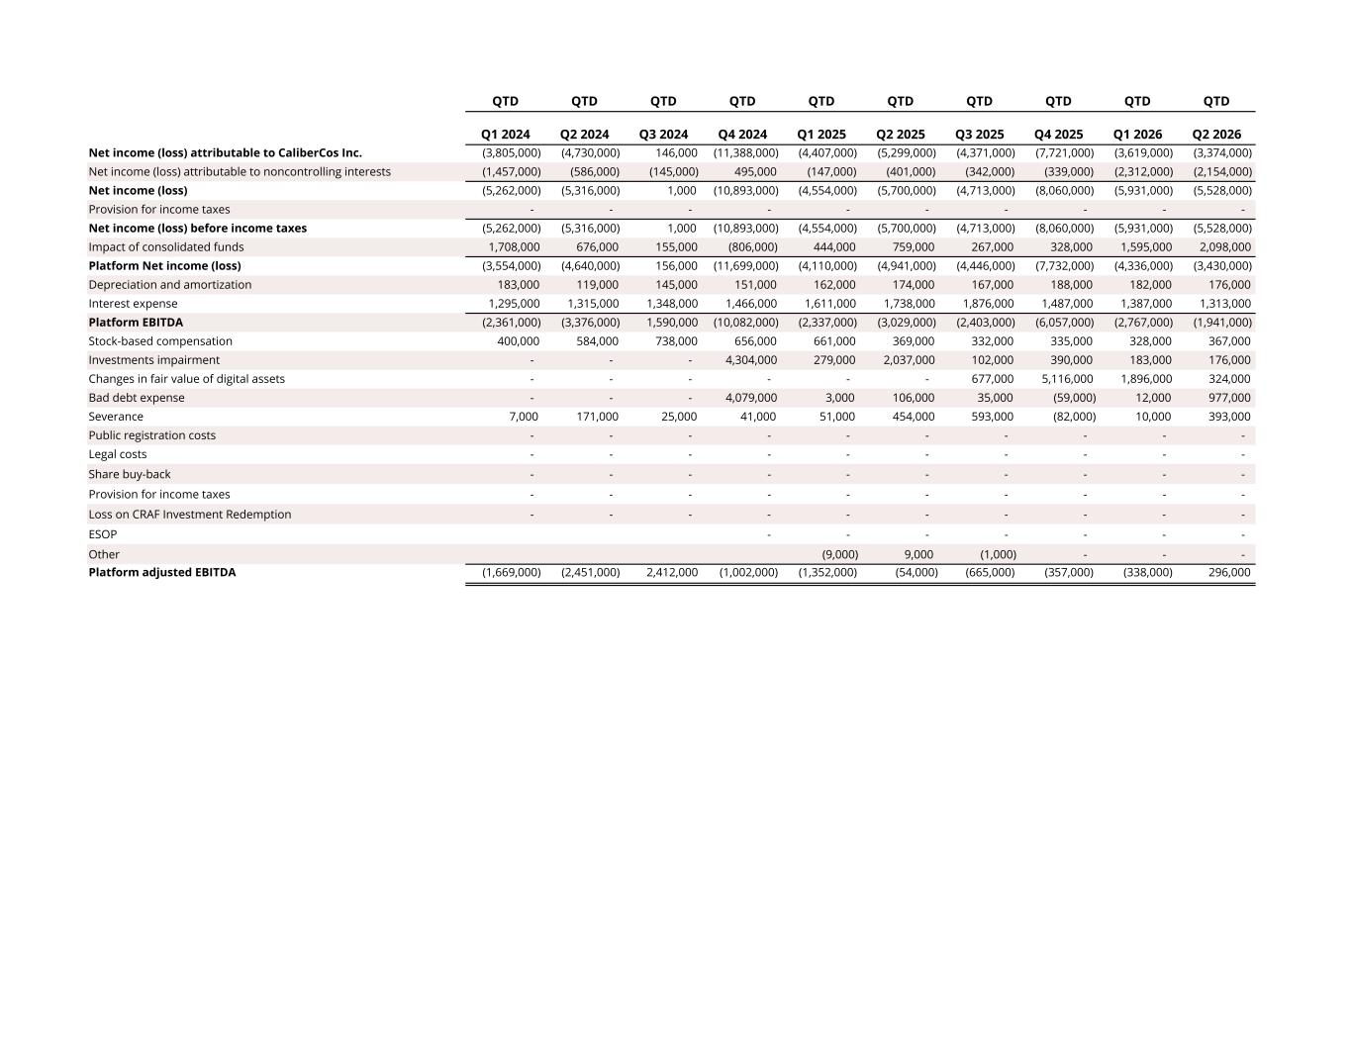
QTD QTD QTD QTD QTD QTD QTD QTD QTD QTD Q1 2024 Q2 2024 Q3 2024 Q4 2024 Q1 2025 Q2 2025 Q3 2025 Q4 2025 Q1 2026 Q2 2026 Net income (loss) attributable to CaliberCos Inc. (3,805,000) (4,730,000) 146,000 (11,388,000) (4,407,000) (5,299,000) (4,371,000) (7,721,000) (3,619,000) (3,374,000) Net income (loss) attributable to noncontrolling interests (1,457,000) (586,000) (145,000) 495,000 (147,000) (401,000) (342,000) (339,000) (2,312,000) (2,154,000) Net income (loss) (5,262,000) (5,316,000) 1,000 (10,893,000) (4,554,000) (5,700,000) (4,713,000) (8,060,000) (5,931,000) (5,528,000) Provision for income taxes - - - - - - - - - - Net income (loss) before income taxes (5,262,000) (5,316,000) 1,000 (10,893,000) (4,554,000) (5,700,000) (4,713,000) (8,060,000) (5,931,000) (5,528,000) Impact of consolidated funds 1,708,000 676,000 155,000 (806,000) 444,000 759,000 267,000 328,000 1,595,000 2,098,000 Platform Net income (loss) (3,554,000) (4,640,000) 156,000 (11,699,000) (4,110,000) (4,941,000) (4,446,000) (7,732,000) (4,336,000) (3,430,000) Depreciation and amortization 183,000 119,000 145,000 151,000 162,000 174,000 167,000 188,000 182,000 176,000 Interest expense 1,295,000 1,315,000 1,348,000 1,466,000 1,611,000 1,738,000 1,876,000 1,487,000 1,387,000 1,313,000 Platform EBITDA (2,361,000) (3,376,000) 1,590,000 (10,082,000) (2,337,000) (3,029,000) (2,403,000) (6,057,000) (2,767,000) (1,941,000) Stock-based compensation 400,000 584,000 738,000 656,000 661,000 369,000 332,000 335,000 328,000 367,000 Investments impairment - - - 4,304,000 279,000 2,037,000 102,000 390,000 183,000 176,000 Changes in fair value of digital assets - - - - - - 677,000 5,116,000 1,896,000 324,000 Bad debt expense - - - 4,079,000 3,000 106,000 35,000 (59,000) 12,000 977,000 Severance 7,000 171,000 25,000 41,000 51,000 454,000 593,000 (82,000) 10,000 393,000 Public registration costs - - - - - - - - - - Legal costs - - - - - - - - - - Share buy-back - - - - - - - - - - Provision for income taxes - - - - - - - - - - Loss on CRAF Investment Redemption - - - - - - - - - - ESOP - - - - - - - Other (9,000) 9,000 (1,000) - - - Platform adjusted EBITDA (1,669,000) (2,451,000) 2,412,000 (1,002,000) (1,352,000) (54,000) (665,000) (357,000) (338,000) 296,000

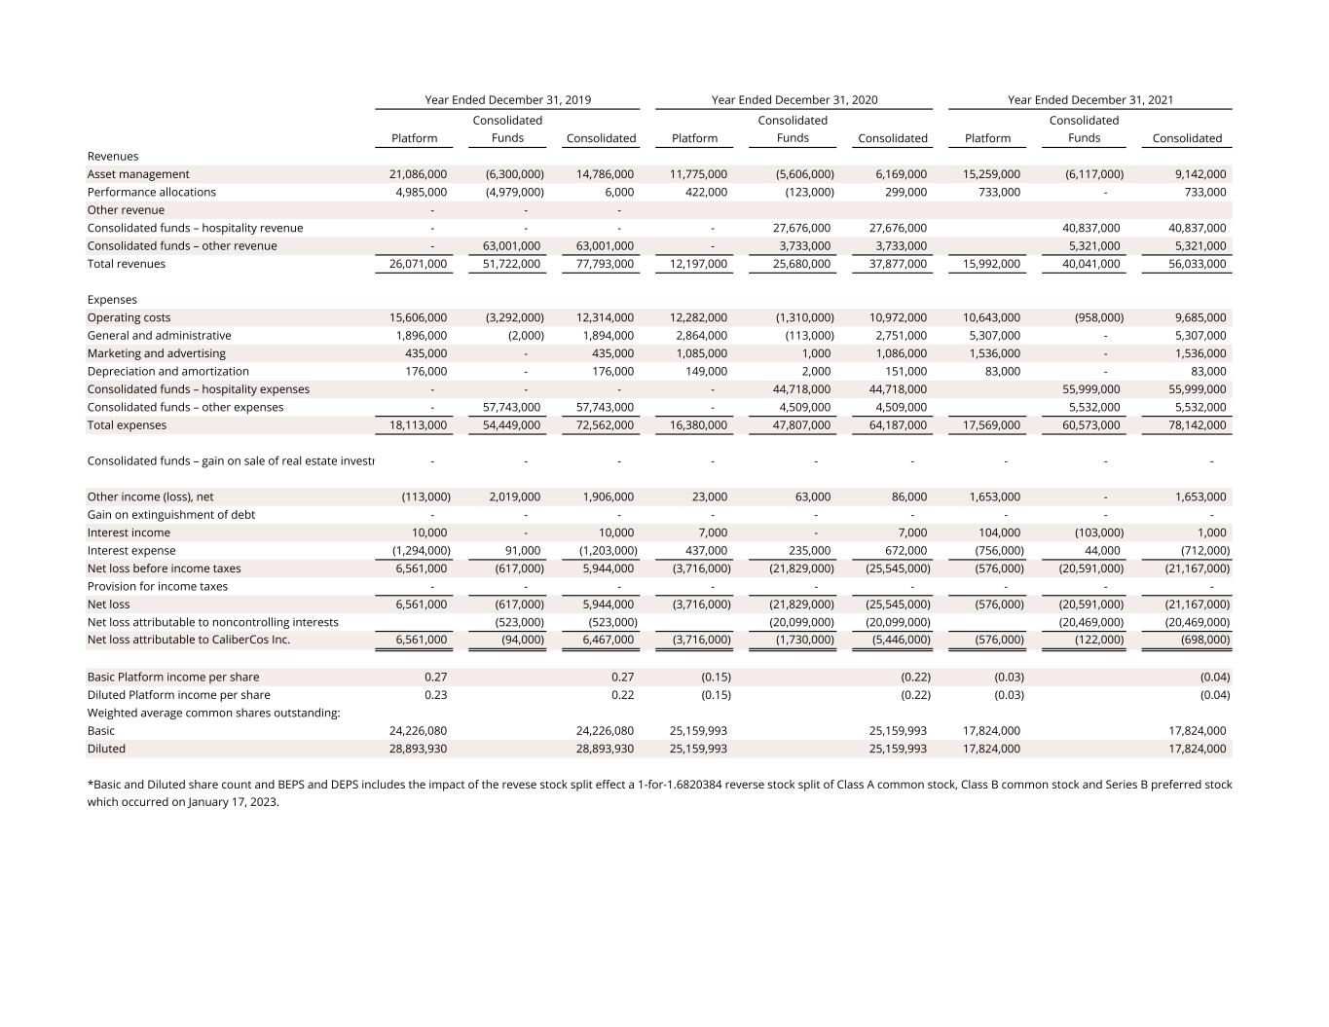
Platform p Consolidated Funds Consolidated Platform p Consolidated Funds Consolidated Platform p Consolidated Funds Consolidated Revenues Asset management 21,086,000 (6,300,000) 14,786,000 11,775,000 (5,606,000) 6,169,000 15,259,000 (6,117,000) 9,142,000 Performance allocations 4,985,000 (4,979,000) 6,000 422,000 (123,000) 299,000 733,000 - 733,000 Other revenue - - - Consolidated funds – hospitality revenue - - - - 27,676,000 27,676,000 40,837,000 40,837,000 Consolidated funds – other revenue - 63,001,000 63,001,000 - 3,733,000 3,733,000 5,321,000 5,321,000 Total revenues 26,071,000 51,722,000 77,793,000 12,197,000 25,680,000 37,877,000 15,992,000 40,041,000 56,033,000 Expenses Operating costs 15,606,000 (3,292,000) 12,314,000 12,282,000 (1,310,000) 10,972,000 10,643,000 (958,000) 9,685,000 General and administrative 1,896,000 (2,000) 1,894,000 2,864,000 (113,000) 2,751,000 5,307,000 - 5,307,000 Marketing and advertising 435,000 - 435,000 1,085,000 1,000 1,086,000 1,536,000 - 1,536,000 Depreciation and amortization 176,000 - 176,000 149,000 2,000 151,000 83,000 - 83,000 Consolidated funds – hospitality expenses - - - - 44,718,000 44,718,000 55,999,000 55,999,000 Consolidated funds – other expenses - 57,743,000 57,743,000 - 4,509,000 4,509,000 5,532,000 5,532,000 Total expenses 18,113,000 54,449,000 72,562,000 16,380,000 47,807,000 64,187,000 17,569,000 60,573,000 78,142,000 Consolidated funds – gain on sale of real estate investm - - - - - - - - - Other income (loss), net (113,000) 2,019,000 1,906,000 23,000 63,000 86,000 1,653,000 - 1,653,000 Gain on extinguishment of debt - - - - - - - - - Interest income 10,000 - 10,000 7,000 - 7,000 104,000 (103,000) 1,000 Interest expense (1,294,000) 91,000 (1,203,000) 437,000 235,000 672,000 (756,000) 44,000 (712,000) Net loss before income taxes 6,561,000 (617,000) 5,944,000 (3,716,000) (21,829,000) (25,545,000) (576,000) (20,591,000) (21,167,000) Provision for income taxes - - - - - - - - - Net loss 6,561,000 (617,000) 5,944,000 (3,716,000) (21,829,000) (25,545,000) (576,000) (20,591,000) (21,167,000) Net loss attributable to noncontrolling interests (523,000) (523,000) (20,099,000) (20,099,000) (20,469,000) (20,469,000) Net loss attributable to CaliberCos Inc. 6,561,000 (94,000) 6,467,000 (3,716,000) (1,730,000) (5,446,000) (576,000) (122,000) (698,000) Basic Platform income per share 0.27 0.27 (0.15) (0.22) (0.03) (0.04) Diluted Platform income per share 0.23 0.22 (0.15) (0.22) (0.03) (0.04) Weighted average common shares outstanding: Basic 24,226,080 24,226,080 25,159,993 25,159,993 17,824,000 17,824,000 Diluted 28,893,930 28,893,930 25,159,993 25,159,993 17,824,000 17,824,000 Year Ended December 31, 2019 Year Ended December 31, 2020 Year Ended December 31, 2021 *Basic and Diluted share count and BEPS and DEPS includes the impact of the revese stock split effect a 1-for-1.6820384 reverse stock split of Class A common stock, Class B common stock and Series B preferred stock which occurred on January 17, 2023.

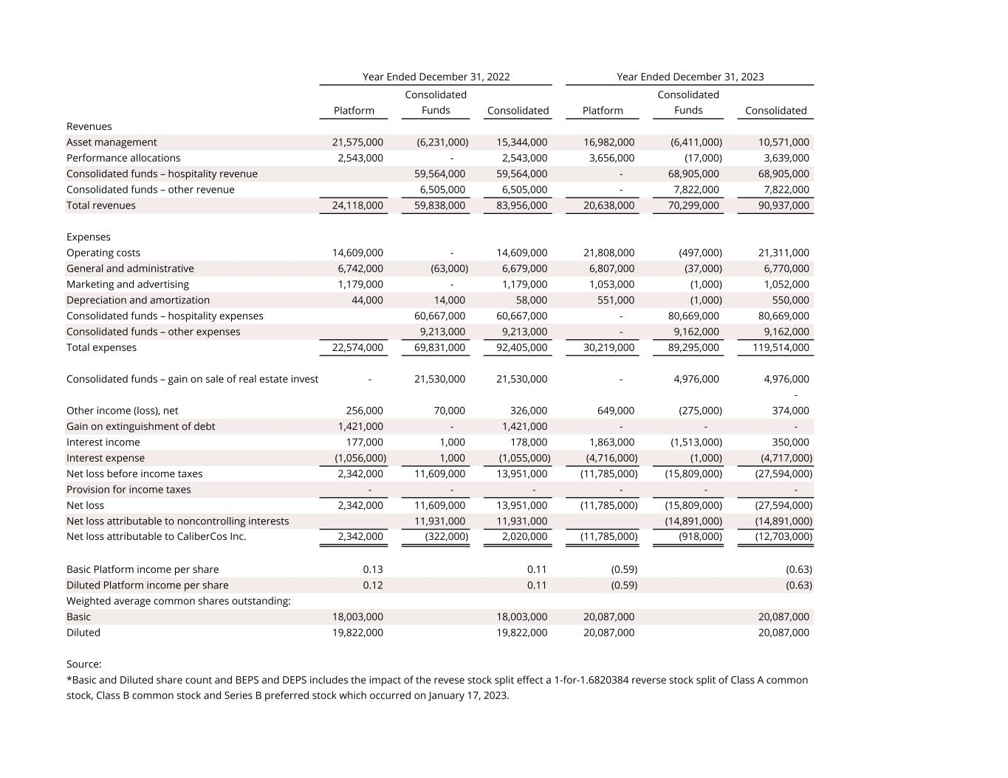
Platform Consolidated Funds Consolidated Platform Consolidated Funds Consolidated Revenues Asset management 21,575,000 (6,231,000) 15,344,000 16,982,000 (6,411,000) 10,571,000 Performance allocations 2,543,000 - 2,543,000 3,656,000 (17,000) 3,639,000 Consolidated funds – hospitality revenue 59,564,000 59,564,000 - 68,905,000 68,905,000 Consolidated funds – other revenue 6,505,000 6,505,000 - 7,822,000 7,822,000 Total revenues 24,118,000 59,838,000 83,956,000 20,638,000 70,299,000 90,937,000 Expenses Operating costs 14,609,000 - 14,609,000 21,808,000 (497,000) 21,311,000 General and administrative 6,742,000 (63,000) 6,679,000 6,807,000 (37,000) 6,770,000 Marketing and advertising 1,179,000 - 1,179,000 1,053,000 (1,000) 1,052,000 Depreciation and amortization 44,000 14,000 58,000 551,000 (1,000) 550,000 Consolidated funds – hospitality expenses 60,667,000 60,667,000 - 80,669,000 80,669,000 Consolidated funds – other expenses 9,213,000 9,213,000 - 9,162,000 9,162,000 Total expenses 22,574,000 69,831,000 92,405,000 30,219,000 89,295,000 119,514,000 Consolidated funds – gain on sale of real estate invest - 21,530,000 21,530,000 - 4,976,000 4,976,000 - Other income (loss), net 256,000 70,000 326,000 649,000 (275,000) 374,000 Gain on extinguishment of debt 1,421,000 - 1,421,000 - - - Interest income 177,000 1,000 178,000 1,863,000 (1,513,000) 350,000 Interest expense (1,056,000) 1,000 (1,055,000) (4,716,000) (1,000) (4,717,000) Net loss before income taxes 2,342,000 11,609,000 13,951,000 (11,785,000) (15,809,000) (27,594,000) Provision for income taxes - - - - - - Net loss 2,342,000 11,609,000 13,951,000 (11,785,000) (15,809,000) (27,594,000) Net loss attributable to noncontrolling interests 11,931,000 11,931,000 (14,891,000) (14,891,000) Net loss attributable to CaliberCos Inc. 2,342,000 (322,000) 2,020,000 (11,785,000) (918,000) (12,703,000) Basic Platform income per share 0.13 0.11 (0.59) (0.63) Diluted Platform income per share 0.12 0.11 (0.59) (0.63) Weighted average common shares outstanding: Basic 18,003,000 18,003,000 20,087,000 20,087,000 Diluted 19,822,000 19,822,000 20,087,000 20,087,000 Source: Year Ended December 31, 2022 Year Ended December 31, 2023 *Basic and Diluted share count and BEPS and DEPS includes the impact of the revese stock split effect a 1-for-1.6820384 reverse stock split of Class A common stock, Class B common stock and Series B preferred stock which occurred on January 17, 2023.

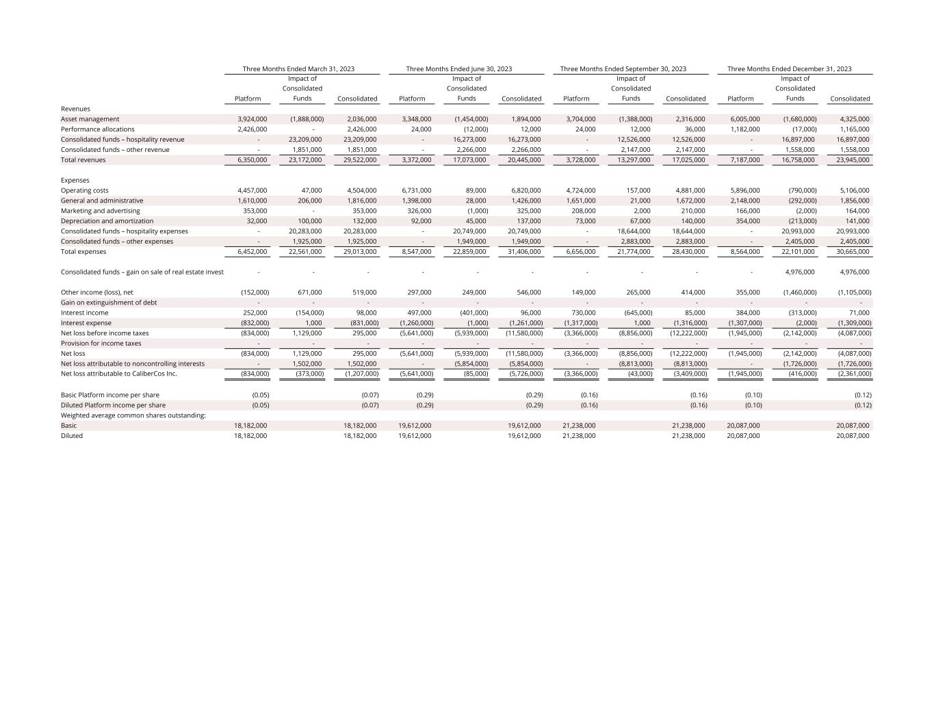
Platform Impact of Consolidated Funds Consolidated Platform Impact of Consolidated Funds Consolidated Platform Impact of Consolidated Funds Consolidated Platform Impact of Consolidated Funds Consolidated Revenues Asset management 3,924,000 (1,888,000) 2,036,000 3,348,000 (1,454,000) 1,894,000 3,704,000 (1,388,000) 2,316,000 6,005,000 (1,680,000) 4,325,000 Performance allocations 2,426,000 - 2,426,000 24,000 (12,000) 12,000 24,000 12,000 36,000 1,182,000 (17,000) 1,165,000 Consolidated funds – hospitality revenue - 23,209,000 23,209,000 - 16,273,000 16,273,000 - 12,526,000 12,526,000 - 16,897,000 16,897,000 Consolidated funds – other revenue - 1,851,000 1,851,000 - 2,266,000 2,266,000 - 2,147,000 2,147,000 - 1,558,000 1,558,000 Total revenues 6,350,000 23,172,000 29,522,000 3,372,000 17,073,000 20,445,000 3,728,000 13,297,000 17,025,000 7,187,000 16,758,000 23,945,000 Expenses Operating costs 4,457,000 47,000 4,504,000 6,731,000 89,000 6,820,000 4,724,000 157,000 4,881,000 5,896,000 (790,000) 5,106,000 General and administrative 1,610,000 206,000 1,816,000 1,398,000 28,000 1,426,000 1,651,000 21,000 1,672,000 2,148,000 (292,000) 1,856,000 Marketing and advertising 353,000 - 353,000 326,000 (1,000) 325,000 208,000 2,000 210,000 166,000 (2,000) 164,000 Depreciation and amortization 32,000 100,000 132,000 92,000 45,000 137,000 73,000 67,000 140,000 354,000 (213,000) 141,000 Consolidated funds – hospitality expenses - 20,283,000 20,283,000 - 20,749,000 20,749,000 - 18,644,000 18,644,000 - 20,993,000 20,993,000 Consolidated funds – other expenses - 1,925,000 1,925,000 - 1,949,000 1,949,000 - 2,883,000 2,883,000 - 2,405,000 2,405,000 Total expenses 6,452,000 22,561,000 29,013,000 8,547,000 22,859,000 31,406,000 6,656,000 21,774,000 28,430,000 8,564,000 22,101,000 30,665,000 Consolidated funds – gain on sale of real estate investm - - - - - - - - - - 4,976,000 4,976,000 Other income (loss), net (152,000) 671,000 519,000 297,000 249,000 546,000 149,000 265,000 414,000 355,000 (1,460,000) (1,105,000) Gain on extinguishment of debt - - - - - - - - - - - - Interest income 252,000 (154,000) 98,000 497,000 (401,000) 96,000 730,000 (645,000) 85,000 384,000 (313,000) 71,000 Interest expense (832,000) 1,000 (831,000) (1,260,000) (1,000) (1,261,000) (1,317,000) 1,000 (1,316,000) (1,307,000) (2,000) (1,309,000) Net loss before income taxes (834,000) 1,129,000 295,000 (5,641,000) (5,939,000) (11,580,000) (3,366,000) (8,856,000) (12,222,000) (1,945,000) (2,142,000) (4,087,000) Provision for income taxes - - - - - - - - - - - - Net loss (834,000) 1,129,000 295,000 (5,641,000) (5,939,000) (11,580,000) (3,366,000) (8,856,000) (12,222,000) (1,945,000) (2,142,000) (4,087,000) Net loss attributable to noncontrolling interests - 1,502,000 1,502,000 - (5,854,000) (5,854,000) - (8,813,000) (8,813,000) - (1,726,000) (1,726,000) Net loss attributable to CaliberCos Inc. (834,000) (373,000) (1,207,000) (5,641,000) (85,000) (5,726,000) (3,366,000) (43,000) (3,409,000) (1,945,000) (416,000) (2,361,000) Basic Platform income per share (0.05) (0.07) (0.29) (0.29) (0.16) (0.16) (0.10) (0.12) Diluted Platform income per share (0.05) (0.07) (0.29) (0.29) (0.16) (0.16) (0.10) (0.12) Weighted average common shares outstanding: Basic 18,182,000 18,182,000 19,612,000 19,612,000 21,238,000 21,238,000 20,087,000 20,087,000 Diluted 18,182,000 18,182,000 19,612,000 19,612,000 21,238,000 21,238,000 20,087,000 20,087,000 Three Months Ended March 31, 2023 Three Months Ended June 30, 2023 Three Months Ended September 30, 2023 Three Months Ended December 31, 2023

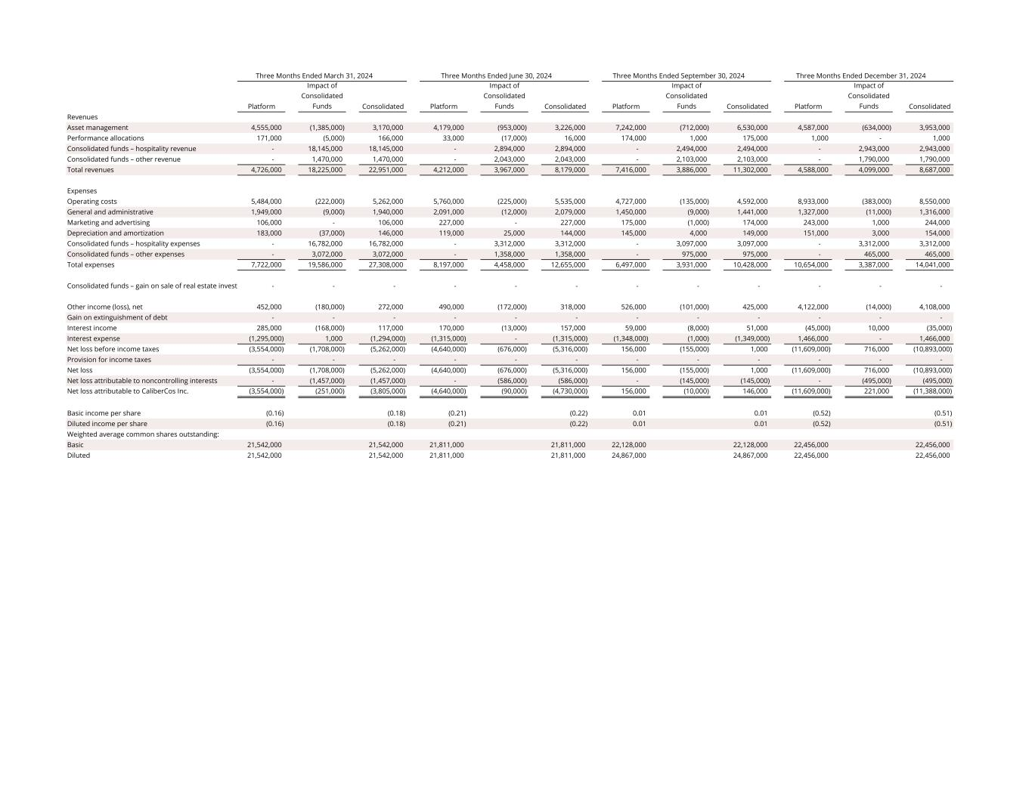
Platform Impact of Consolidated Funds Consolidated Platform Impact of Consolidated Funds Consolidated Platform Impact of Consolidated Funds Consolidated Platform Impact of Consolidated Funds Consolidated Revenues Asset management 4,555,000 (1,385,000) 3,170,000 4,179,000 (953,000) 3,226,000 7,242,000 (712,000) 6,530,000 4,587,000 (634,000) 3,953,000 Performance allocations 171,000 (5,000) 166,000 33,000 (17,000) 16,000 174,000 1,000 175,000 1,000 - 1,000 Consolidated funds – hospitality revenue - 18,145,000 18,145,000 - 2,894,000 2,894,000 - 2,494,000 2,494,000 - 2,943,000 2,943,000 Consolidated funds – other revenue - 1,470,000 1,470,000 - 2,043,000 2,043,000 - 2,103,000 2,103,000 - 1,790,000 1,790,000 Total revenues 4,726,000 18,225,000 22,951,000 4,212,000 3,967,000 8,179,000 7,416,000 3,886,000 11,302,000 4,588,000 4,099,000 8,687,000 Expenses Operating costs 5,484,000 (222,000) 5,262,000 5,760,000 (225,000) 5,535,000 4,727,000 (135,000) 4,592,000 8,933,000 (383,000) 8,550,000 General and administrative 1,949,000 (9,000) 1,940,000 2,091,000 (12,000) 2,079,000 1,450,000 (9,000) 1,441,000 1,327,000 (11,000) 1,316,000 Marketing and advertising 106,000 - 106,000 227,000 - 227,000 175,000 (1,000) 174,000 243,000 1,000 244,000 Depreciation and amortization 183,000 (37,000) 146,000 119,000 25,000 144,000 145,000 4,000 149,000 151,000 3,000 154,000 Consolidated funds – hospitality expenses - 16,782,000 16,782,000 - 3,312,000 3,312,000 - 3,097,000 3,097,000 - 3,312,000 3,312,000 Consolidated funds – other expenses - 3,072,000 3,072,000 - 1,358,000 1,358,000 - 975,000 975,000 - 465,000 465,000 Total expenses 7,722,000 19,586,000 27,308,000 8,197,000 4,458,000 12,655,000 6,497,000 3,931,000 10,428,000 10,654,000 3,387,000 14,041,000 Consolidated funds – gain on sale of real estate invest - - - - - - - - - - - - Other income (loss), net 452,000 (180,000) 272,000 490,000 (172,000) 318,000 526,000 (101,000) 425,000 4,122,000 (14,000) 4,108,000 Gain on extinguishment of debt - - - - - - - - - - - - Interest income 285,000 (168,000) 117,000 170,000 (13,000) 157,000 59,000 (8,000) 51,000 (45,000) 10,000 (35,000) Interest expense (1,295,000) 1,000 (1,294,000) (1,315,000) - (1,315,000) (1,348,000) (1,000) (1,349,000) 1,466,000 - 1,466,000 Net loss before income taxes (3,554,000) (1,708,000) (5,262,000) (4,640,000) (676,000) (5,316,000) 156,000 (155,000) 1,000 (11,609,000) 716,000 (10,893,000) Provision for income taxes - - - - - - - - - - - - Net loss (3,554,000) (1,708,000) (5,262,000) (4,640,000) (676,000) (5,316,000) 156,000 (155,000) 1,000 (11,609,000) 716,000 (10,893,000) Net loss attributable to noncontrolling interests - (1,457,000) (1,457,000) - (586,000) (586,000) - (145,000) (145,000) - (495,000) (495,000) Net loss attributable to CaliberCos Inc. (3,554,000) (251,000) (3,805,000) (4,640,000) (90,000) (4,730,000) 156,000 (10,000) 146,000 (11,609,000) 221,000 (11,388,000) Basic income per share (0.16) (0.18) (0.21) (0.22) 0.01 0.01 (0.52) (0.51) Diluted income per share (0.16) (0.18) (0.21) (0.22) 0.01 0.01 (0.52) (0.51) Weighted average common shares outstanding: Basic 21,542,000 21,542,000 21,811,000 21,811,000 22,128,000 22,128,000 22,456,000 22,456,000 Diluted 21,542,000 21,542,000 21,811,000 21,811,000 24,867,000 24,867,000 22,456,000 22,456,000 Three Months Ended March 31, 2024 Three Months Ended June 30, 2024 Three Months Ended December 31, 2024 Three Months Ended September 30, 2024

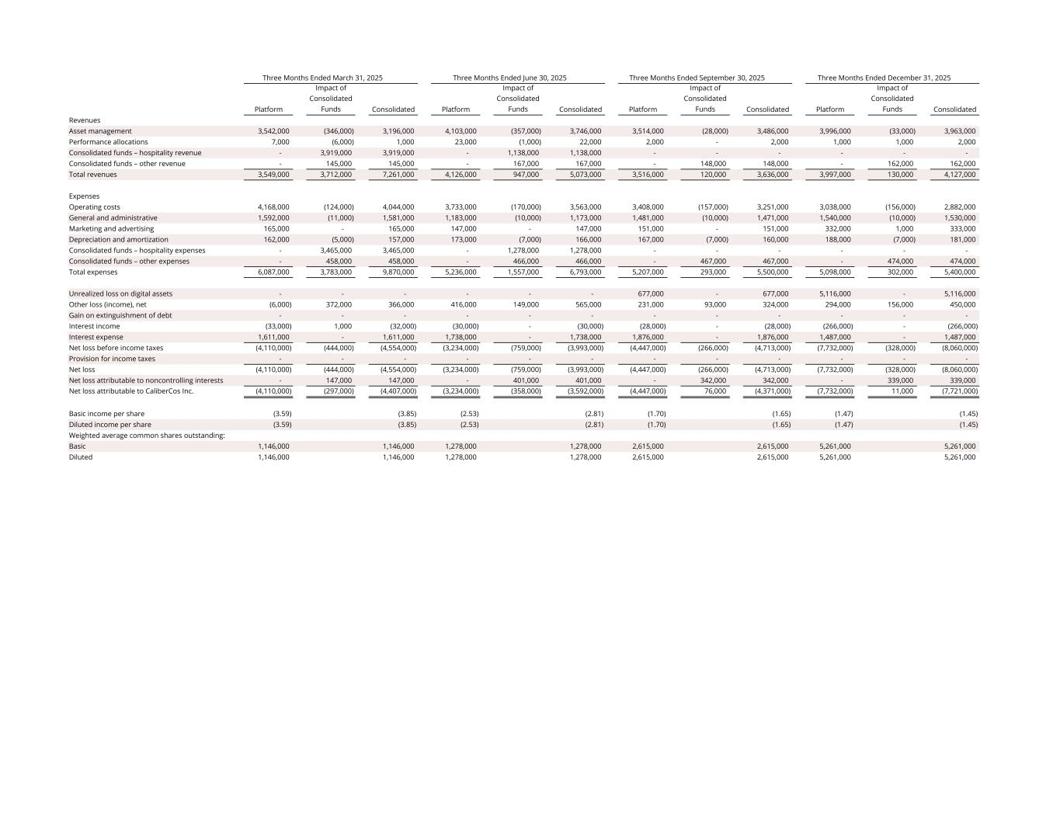
Platform Impact of Consolidated Funds Consolidated Platform Impact of Consolidated Funds Consolidated Platform Impact of Consolidated Funds Consolidated Platform Impact of Consolidated Funds Consolidated Revenues Asset management 3,542,000 (346,000) 3,196,000 4,103,000 (357,000) 3,746,000 3,514,000 (28,000) 3,486,000 3,996,000 (33,000) 3,963,000 Performance allocations 7,000 (6,000) 1,000 23,000 (1,000) 22,000 2,000 - 2,000 1,000 1,000 2,000 Consolidated funds – hospitality revenue - 3,919,000 3,919,000 - 1,138,000 1,138,000 - - - - - - Consolidated funds – other revenue - 145,000 145,000 - 167,000 167,000 - 148,000 148,000 - 162,000 162,000 Total revenues 3,549,000 3,712,000 7,261,000 4,126,000 947,000 5,073,000 3,516,000 120,000 3,636,000 3,997,000 130,000 4,127,000 Expenses Operating costs 4,168,000 (124,000) 4,044,000 3,733,000 (170,000) 3,563,000 3,408,000 (157,000) 3,251,000 3,038,000 (156,000) 2,882,000 General and administrative 1,592,000 (11,000) 1,581,000 1,183,000 (10,000) 1,173,000 1,481,000 (10,000) 1,471,000 1,540,000 (10,000) 1,530,000 Marketing and advertising 165,000 - 165,000 147,000 - 147,000 151,000 - 151,000 332,000 1,000 333,000 Depreciation and amortization 162,000 (5,000) 157,000 173,000 (7,000) 166,000 167,000 (7,000) 160,000 188,000 (7,000) 181,000 Consolidated funds – hospitality expenses - 3,465,000 3,465,000 - 1,278,000 1,278,000 - - - - - - Consolidated funds – other expenses - 458,000 458,000 - 466,000 466,000 - 467,000 467,000 - 474,000 474,000 Total expenses 6,087,000 3,783,000 9,870,000 5,236,000 1,557,000 6,793,000 5,207,000 293,000 5,500,000 5,098,000 302,000 5,400,000 Unrealized loss on digital assets - - - - - - 677,000 - 677,000 5,116,000 - 5,116,000 Other loss (income), net (6,000) 372,000 366,000 416,000 149,000 565,000 231,000 93,000 324,000 294,000 156,000 450,000 Gain on extinguishment of debt - - - - - - - - - - - - Interest income (33,000) 1,000 (32,000) (30,000) - (30,000) (28,000) - (28,000) (266,000) - (266,000) Interest expense 1,611,000 - 1,611,000 1,738,000 - 1,738,000 1,876,000 - 1,876,000 1,487,000 - 1,487,000 Net loss before income taxes (4,110,000) (444,000) (4,554,000) (3,234,000) (759,000) (3,993,000) (4,447,000) (266,000) (4,713,000) (7,732,000) (328,000) (8,060,000) Provision for income taxes - - - - - - - - - - - - Net loss (4,110,000) (444,000) (4,554,000) (3,234,000) (759,000) (3,993,000) (4,447,000) (266,000) (4,713,000) (7,732,000) (328,000) (8,060,000) Net loss attributable to noncontrolling interests - 147,000 147,000 - 401,000 401,000 - 342,000 342,000 - 339,000 339,000 Net loss attributable to CaliberCos Inc. (4,110,000) (297,000) (4,407,000) (3,234,000) (358,000) (3,592,000) (4,447,000) 76,000 (4,371,000) (7,732,000) 11,000 (7,721,000) Basic income per share (3.59) (3.85) (2.53) (2.81) (1.70) (1.65) (1.47) (1.45) Diluted income per share (3.59) (3.85) (2.53) (2.81) (1.70) (1.65) (1.47) (1.45) Weighted average common shares outstanding: Basic 1,146,000 1,146,000 1,278,000 1,278,000 2,615,000 2,615,000 5,261,000 5,261,000 Diluted 1,146,000 1,146,000 1,278,000 1,278,000 2,615,000 2,615,000 5,261,000 5,261,000 Three Months Ended March 31, 2025 Three Months Ended June 30, 2025 Three Months Ended September 30, 2025 Three Months Ended December 31, 2025

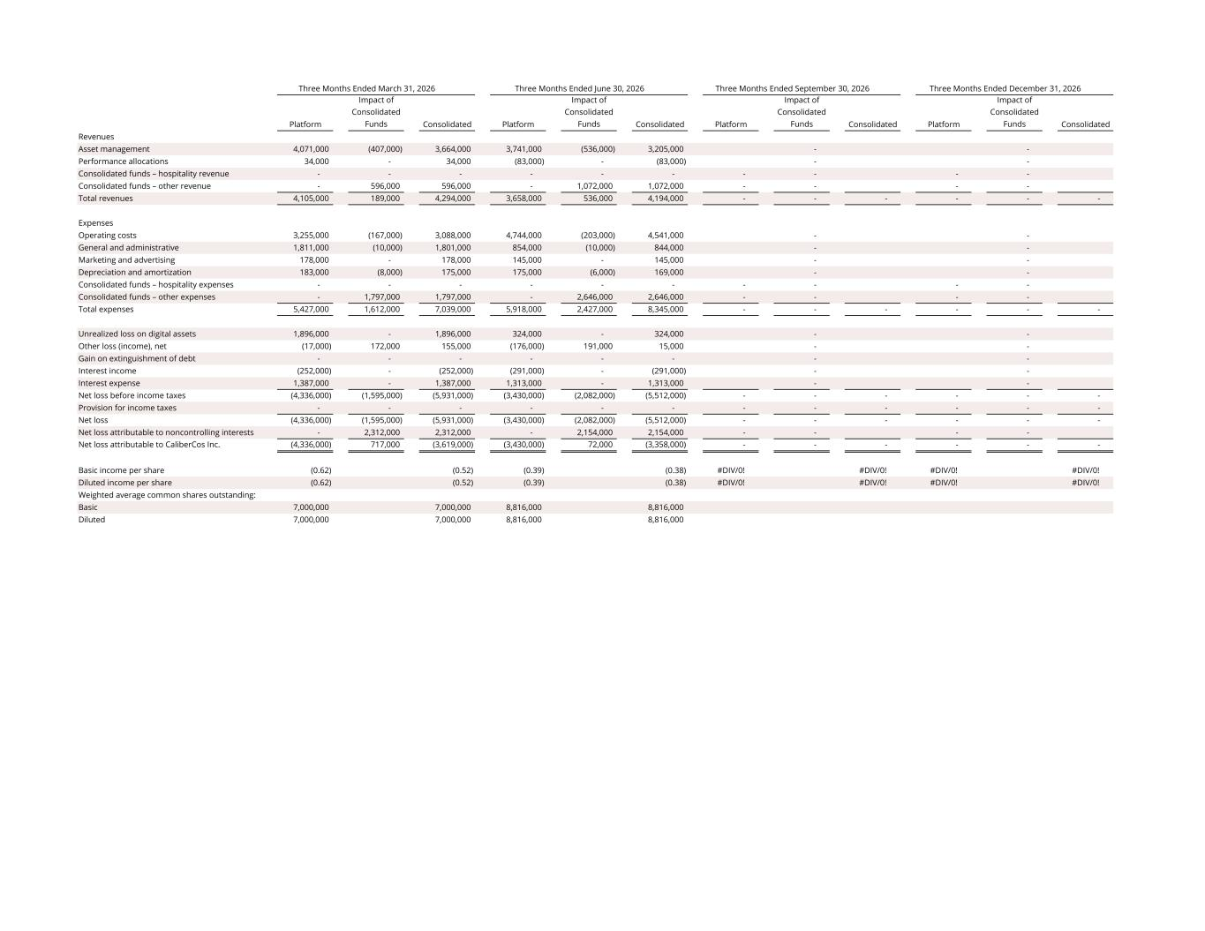
Platform Impact of Consolidated Funds Consolidated Platform Impact of Consolidated Funds Consolidated Platform Impact of Consolidated Funds Consolidated Platform Impact of Consolidated Funds Consolidated Revenues Asset management 4,071,000 (407,000) 3,664,000 3,741,000 (536,000) 3,205,000 - - Performance allocations 34,000 - 34,000 (83,000) - (83,000) - - Consolidated funds – hospitality revenue - - - - - - - - - - Consolidated funds – other revenue - 596,000 596,000 - 1,072,000 1,072,000 - - - - Total revenues 4,105,000 189,000 4,294,000 3,658,000 536,000 4,194,000 - - - - - - Expenses Operating costs 3,255,000 (167,000) 3,088,000 4,744,000 (203,000) 4,541,000 - - General and administrative 1,811,000 (10,000) 1,801,000 854,000 (10,000) 844,000 - - Marketing and advertising 178,000 - 178,000 145,000 - 145,000 - - Depreciation and amortization 183,000 (8,000) 175,000 175,000 (6,000) 169,000 - - Consolidated funds – hospitality expenses - - - - - - - - - - Consolidated funds – other expenses - 1,797,000 1,797,000 - 2,646,000 2,646,000 - - - - Total expenses 5,427,000 1,612,000 7,039,000 5,918,000 2,427,000 8,345,000 - - - - - - Unrealized loss on digital assets 1,896,000 - 1,896,000 324,000 - 324,000 - - Other loss (income), net (17,000) 172,000 155,000 (176,000) 191,000 15,000 - - Gain on extinguishment of debt - - - - - - - - Interest income (252,000) - (252,000) (291,000) - (291,000) - - Interest expense 1,387,000 - 1,387,000 1,313,000 - 1,313,000 - - Net loss before income taxes (4,336,000) (1,595,000) (5,931,000) (3,430,000) (2,082,000) (5,512,000) - - - - - - Provision for income taxes - - - - - - - - - - - - Net loss (4,336,000) (1,595,000) (5,931,000) (3,430,000) (2,082,000) (5,512,000) - - - - - - Net loss attributable to noncontrolling interests - 2,312,000 2,312,000 - 2,154,000 2,154,000 - - - - Net loss attributable to CaliberCos Inc. (4,336,000) 717,000 (3,619,000) (3,430,000) 72,000 (3,358,000) - - - - - - Basic income per share (0.62) (0.52) (0.39) (0.38) #DIV/0! #DIV/0! #DIV/0! #DIV/0! Diluted income per share (0.62) (0.52) (0.39) (0.38) #DIV/0! #DIV/0! #DIV/0! #DIV/0! Weighted average common shares outstanding: Basic 7,000,000 7,000,000 8,816,000 8,816,000 Diluted 7,000,000 7,000,000 8,816,000 8,816,000 Three Months Ended March 31, 2026 Three Months Ended June 30, 2026 Three Months Ended September 30, 2026 Three Months Ended December 31, 2026

